**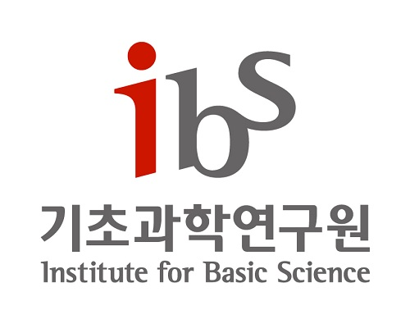  
POSTDOCTORAL FELLOWSHIPS  
 IN DATA SCIENCE, IBS**

The IBS Data Science Group in Daejeon, South Korea, invites applications for several postdoctoral research fellowship positions. The expected starting date is **September 1, 2020**. The candidate should have a Ph.D. by the start date.

The Data Science Group launched on January 1, 2019, at the [Institute for Basic Science](https://www.ibs.re.kr/) (IBS), led by Chief Investigator (CI) Prof. Meeyoung Cha. Data Science Group is located at the headquarters of the Institute for Basic Science (IBS) in Daejeon, South Korea, a city of 1.5 million people.

We seek talented, highly motivated researchers. Successful candidates for this position will be new or recent Ph.D. graduates with outstanding research potential in the fields of **computer science and related fields of data science.** Our research group strives to advance the data science research field via developing new ways of computing using machine learning and deep learning methods to analyze real-world data about society. Our projects leverage massive-scale datasets, computational models, as well as theories from sociology, communication, cognitive science, network science, econometrics, etc.

**Preferences**

1. Research experience in the following areas: machien learning, deep learning, natural language processing, computer vision, human-computer interaction, remote sensing, complex networks.
2. Research experience handling large-scale datasets
3. Proficiency in computer programming using major programming languages   
   (e.g., high-level languages commonly used in the scientific community such as *Python*, *R, and Scala*, as well as related machine learning and deep learning tools such as *PyTorch*, *TensorFlow, and scikit-learn*)
4. Strong knowledge in social and behavioral disciplines.
5. Effective communication, collaboration, and organizational skills.

**Position Minimum Qualifications:**The successful candidates must have a Ph.D. degree (or receive it soon) from an accredited university in a relevant discipline, such as computer science, statistics, statistical physics, computational social sciences, or a closely related discipline. Candidates should be Ph.D. degree holders by the appointment date.

**The position and Remuneration:**

The current position is a non-tenure track appointment for 2 or 3 years, and the starting salary is KRW 57,000,000 or above. The appointment is one time renewable up to 4 years in total contingent upon the outstanding performance of the researcher. A low-cost economy flight will be supported to overseas applicants.

**Application Process and Requirement:**For those who are eligible and interested, please submit your application package that includes:  
 1. Curriculum vitae (CV) including the publication list (PDF format)  
 2. Research statement (up to 2 pages, PDF format)  
 3. A minimum of 2 recommendation letters   
 4. PDF version of one key publication as the 1st or corresponding author   
  
We are required to obtain the user's **consent to collect and use personal information** as a rule. This form will be sent out to candidates upon receiving applications.

Applications should be received by **July 15, 2020, at 11:59 pm KST (Korea Standard Time).** Recommendations letters forwarded by an applicant directly will not be considered. Applications can be submitted via email: *[dscig@ibs.re.kr](mailto:dscig@ibs.re.kr)*.

For more information about the research group, please visit the following weblink: <https://www.ibs.re.kr/datascience/>

*For Korean citizens who have not yet completed their military duty: IBS는 병역특례지정기관입니다. IBS is a designated institute for alternative military service.*

**[Attachment]** Consent to Collection and Use of Personal Information