Tailor-made Synthesis of Multilayered Trimetallocyclophanes via Transannula π−π Interactions

Ok-Sang Jung*
Department of Chemistry, Pusan National University, Pusan 609-735, Korea
*oksjung@pusan.ac.kr

Abstract
Synthesis and operation of a nano-demension 24 × 24 × 15 Å³ “left and right ball-joint-type host-guest system” via one π∙∙∙π interaction and three NH∙∙∙O=C hydrogen-bonds along with the combined helicity are described. The system consists of unprecedented conglomerate aggregates of two distinct helical metallacyclophanes, chiral isomer (P)-[Pd₃X₆(L₁)₂]@(M)-[Pd₃X₆(L₁)(L₂)] and its enantiomer (M)-[Pd₃X₆(L₁)₂]@(P)- [Pd₃X₆(L₁)(L₂)] are described. Successive reactions afford desirable four-layered metallacyclophanes via tailor-made procedure. Synthesis and operation of a nano-demension size multilayered metallacyclophane system via one π∙∙∙π interaction along with the combined helicity are described. A synthetic strategy of generation of new molecular species utilizing a provision of nature has been reported: nano-dimensional (23(2) × 21(1) × 16(1) Å³) hetero four-layered trimetalla-cyclophanes via the proof-of-concept experiments that utilize a suitable combination of π∙∙∙π interactions between the central aromatic rings, tailor-made short/long spacer tridentate donors, and the combined helicity are constructed. The unprecedented four-layered metallacyclophane system’s behavior offers a landmark in the development of new molecular system.

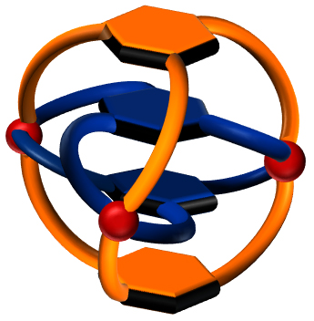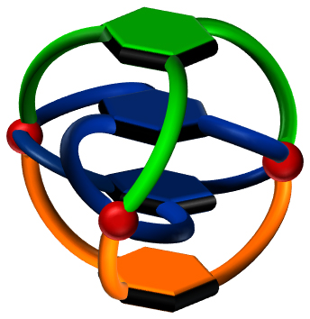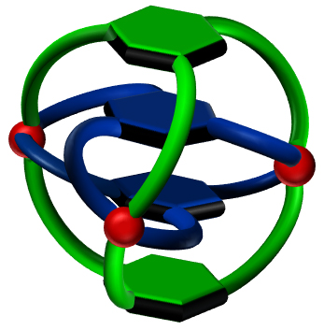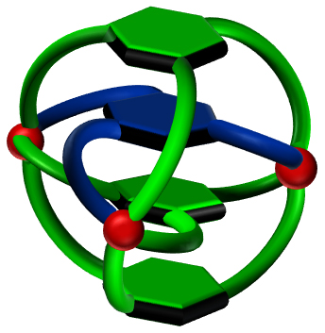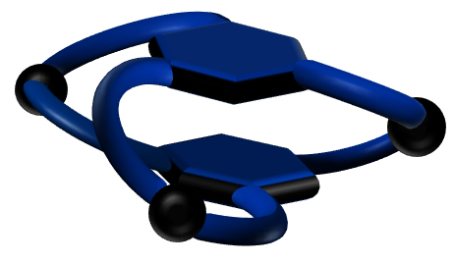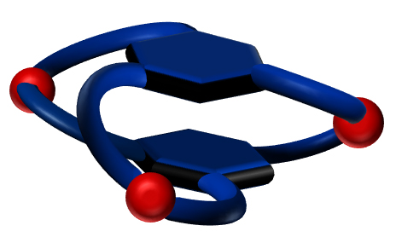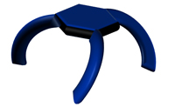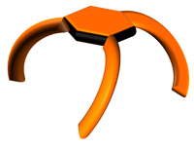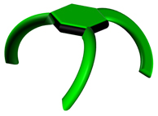
Scheme 1. Construction of hetero four-layered tripalladium(II)cyclophanes through consecutive, substitution, and direct reactions.
L^{LA}
L^{LE}
L^{LA}
L^{SA}
4₀
4₁
4₂
4₃
+ 2 L^{LE}
2 L^{SA}
+ 2 L^{LA}
2 L^{SA}
+ 3 L^{LA}
1 L^{SA}
≡ [Pd²⁺](NO₃⁻)₂
2 L^{LE}
2 L^{LA}
3 L^{LA}
L^{SA}

≡ [PdCl₂]
AgNO₃
AgCl
≡
≡
≡
L^{SA}
L^{LE}
L^{LA}

