Nanoparticle Plasmonics for Single-Molecule Chemistry and Infrared Nanoscopy

Zee Hwan Kim
Department of Chemistry, Seoul National University, Seoul, Korea

I will present an introductory overview on the nano-plasmonics, and also the current research topics of my research group at SNU. I will present an overview on: (1) electromagnetic principles behind the surface plasmons; (2) generation and propagation of surface plasmons; (3) interaction between two or more plasmons; (4) interaction between plasmons and molecular quantum states; (5) ultra-sensitive chemical sensing with plasmon resonance-shifts and (6) active control of plasmon propagation and resonances for high-speed opto-electronic devices. I will also I will present my research group’s recent investigation on how the localized plasmon of a nanoparticle interacts with another plasmon, and with nearby molecules. First, I will demonstrate the use of scattering-type scanning near-field microscopy (s-SNOM) to directly visualize the capacitive / conductive coupling in dimeric nanoparticles and heterometallic nanorods. Second, I will talk about the use of gap-plasmons to locally induce photochemical reactions, and to follow chemical kinetics of individual organic molecules using the gap-plasmons. As a last topic, I will talk about the use of near-field coupling between a scanning probe and graphenes to visualize / identify the stacking domains (e. g., ABA versus ABC-type stacking in triple layer) hidden in multilayer graphenes.
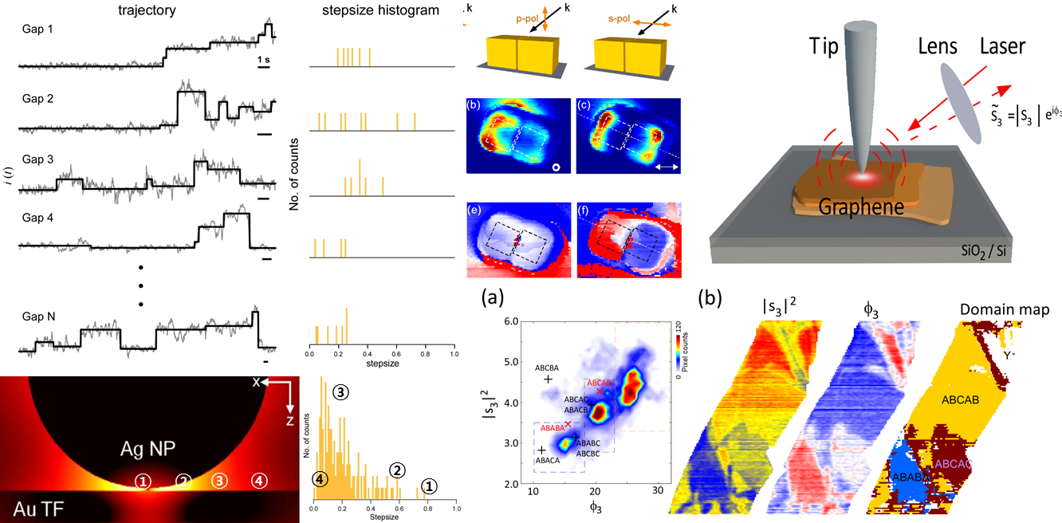
(left) Single molecule SERS trajectories of dimercaptoazobenzene molecules produced by photochemical reactions of 4-nitrobenzenethiols; (middle) near-field image of a dimeric Au nanocube; (right) infrared nanoscopy of multilayer grapehenes.

