Gwangju Institute of Science and Technology

Official Press Release (https://www.gist.ac.kr/)

Section of Hyo Jung Kim Nayeong Lee
Public Relations Section Chief Senior Administrator
(+82) 62-715-2061 (+82) 62-715-2062

Contact Person Kyung-hwa Kim, Administrator
for this Article Section of Academic Affairs
062-715-2042

Release Date 2020.08.14

GIST holds graduation ceremony
for the second half of 2020

□ GIST (Gwangju Institute of Science and Technology, President Kiseon Kim) 'graduation ceremony for the second half of 2020' was held on August 14, 2020, at Oryong Hall with about 50 people in attendance, including staff, award recipients, and representatives of graduates.

∘ A total of 160 degrees were conferred at the ceremony, including 59 Ph.D.'s, 67 master's degrees, and 34 bachelor's degrees.

□ In particular, to prevent the spread of COVID-19, the graduation ceremony produced and screened video messages from foreign guests, teachers and students, and selected representatives of the graduates through a lottery to reduce the number of participants to small-scale events.

∘ Degree recipients and parents who could not attend the event were able to watch the graduation ceremony in real time through online streaming on YouTube.

□ The number of papers published by the 59 doctoral degree recipients in SCI (Science Citation Index) journals during their enrollment averaged to about 7 papers per graduate.

∘ During their Ph.D. program, the graduates published an average of 2.54 papers as first author and 4.08 papers as co-authors, averaging to about 7 papers published in SCI journals per graduate.

□ Dr. Yongryun Cho (adviser Professor Bong Joong Kim) of the School of Materials Science and Engineering published a total of 36 SCI papers, including 8 as first author and 28 as a co-author, achieving the best research achievements among the Ph.D. graduates. In particular, four of the papers were published in excellent journals with IF 10 or higher.

□ President Kiseon Kim said at the ceremony, "I hope you remember that today's graduation is not the end of your efforts but another new beginning. I hope that you will become a heart-warming science and technology individuals who actively considers and practices the values of respect and ethics with the competence and pride gained from GIST."

□ Meanwhile, GIST was ranked 4th in the world in 2020 (No. 1 in Korea for 13 consecutive years) in the field of 'citations per faculty' that shows the GIST's research capabilities and academic influence. In addition, GIST has taken a key role in the project to create an AI cluster in Gwangju, faithfully carrying out its goal of establishing a national mission for the development of science and technology, including the establishment of an AI graduate school and an energy convergence graduate school while leading the local economy.

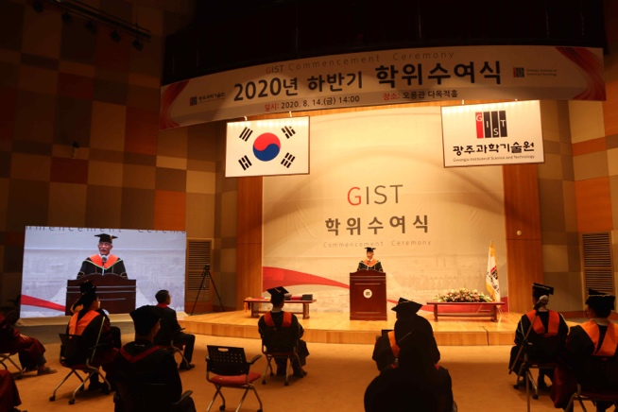
▲ [Photo] GIST holds graduation ceremony for the second half of 2020

