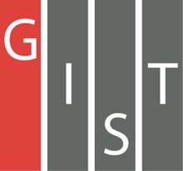
Gwangju Institute of Science and Technology

Official Press Release (https://www.gist.ac.kr/)

Section of Mi-Yeon Kim Nayeong Lee
Public Affairs Section Chief Senior Administrator
(+82) 62-715-2020 (+82) 62-715-2024

Contact Person Hye-jin Lee, Administrator
for this Article Section of Public Affairs
(+82) 62-715-2022

Release Date 2018.07.24

GIST Social Contribution Team hosts
the GIST Science Outreach Program (GSOP)

□ GIST (President Seung Hyeon Moon) – On July 20, 2018, the GIST Social Contribution Team hosted the GIST Science Outreach Program (GSOP) to discover gifted students who are interested in science and technology and to help them become excellent engineers.

□ The GSOP program is a program in which GIST students become mentors and provide math and science instruction twice a month to about 30 middle and high school students in Gwangju and Jeonnam.

∘ GSOP is supported by GIST Social Contribution Team, which had been cooperating with the Korea Science Outreach Program (KSOP) since 2017.

□ The 2018 GSOP Summer Camp was organized by GIST College Professor Chi-Ok Hwang and included four GIST student mentors with 22 middle school and high school students who participated in a topics, such as understanding multiple dimensions.

□ Participants said the summer camp program was a very beneficial educational experience for learning about four dimensional mathematics, and that they are also looking forward to learning more math and science in the second session in September.

□ Professor Chi-Ok Hwang said, "We will continue to support good programs at GIST in order to provide middle school and high school students who are interested in science and technology with more creative educational opportunities."

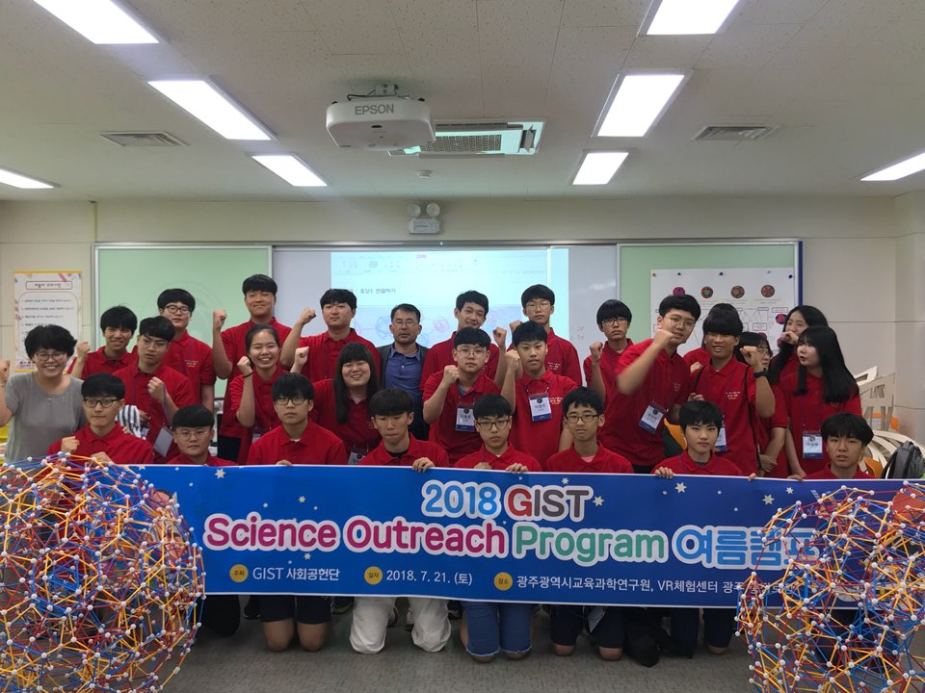
▲ 2018 GSOP Summer Camp

