Gwangju Institute of Science and Technology

Official Press Release (https://www.gist.ac.kr/)

Section of Mi-Yeon Kim Nayeong Lee
Public Affairs Section Chief Senior Administrator
(+82) 62-715-2020 (+82) 62-715-2024

Contact Person Hye-jin Lee, Administrator
for this Article Section of Public Affairs
(+82) 62-715-2022

Release Date 2018.12.05

[25th Anniversary Celebration]
2018 GIST Vision Concert held

□ GIST (President Seung Hyeon Moon) held the '2018 GIST Vision Concert' on November 30, 2018, for the sponsors, local residents, and GIST members who have supported the 25th anniversary celebration.

∘ In particular, this concert was held to announce GIST's vision for the next 25 years and to share various social outreach projects (GIST's Learning Zone, science school, science camp, science book donation, wishful writing, GSOP, etc.) with the community.

□ The event was held in three parts: ▲ Part 1 welcome event: GIST promotion video screening, welcoming remarks, congratulatory remarks ▲ Part 2 GIST 25 + 25: vision declaration, dinner ▲ Part 3 Concerts: G-Melos Trio, and humanities Opera (M-Culture).

∘ "GIST has contributed greatly to the development of local communities by cultivating world-class research achievements and outstanding human resources over the past 25 years," said Chairman Jung-joo Chung of Na Young Industry during the welcoming ceremony. "It is a great honor to be together in the meaningful year of the 25th anniversary of GIST, and I will work with GIST to contribute to the revitalization of regional economic development."

∘ Part 2 GIST 25+25 described the future vision of President Seung Hyeon Moon for the next 25 years of GIST, and there was a talk show with Jin-young Park, an honorary ambassador for public relations.

∘ Part 3 consists of G-Melos Trio's sweetened classical guitar performance including Professor Jong-hyun Lee of GIST and M-Culture's opera performance. The opera's humanities performance was reinterpreted by Geum-ho Shin, the president of the opera company, and presented opera and classical music with interesting humanities motifs.

□ President Seung Hyeon Moon said, "We have prepared the event today with thanks to all those who have supported GIST with unwavering heart. I promise you that the GIST and the community will have the best opportunity. I hope this will be a meaningful opportunity to start a new history together, marking the 25th anniversary of the future."

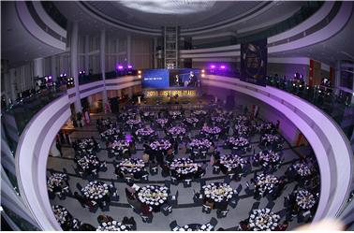
2018 GIST Vision Concert

