Gwangju Institute of Science and Technology

Official Press Release (https://www.gist.ac.kr/)

Section of Mi-Yeon Kim Nayeong Lee
Public Affairs Section Chief Senior Administrator
(+82) 62-715-2020 (+82) 62-715-2024

Contact Person Chang-hoon Choi, Section Chief
for this Article Section of Research Support
(+82) 62-715-2931

Release Date 2018.11.16

[25th Anniversary Celebration] International joint research workshop with Caltech

□ GIST (President Seung Hyeon Moon) hosted an international joint research workshop with Caltech at Oryong Hall from November 12 to 13.

∘ The event was attended by Professor Kaushik Bhattacharya, who is the vice provost of Caltech, and a total of 10 faculty members from both universities participated in oral presentations and video conferences to share their research results and to present new research plans.

□ In particular, this international joint workshop was hosted by Vice Provost Kaushik Bhattacharya who is the director of research at Caltech, which has produced 35 Nobel Prize winners. It is expected that the excellent research result will be derived based on the joint research between the two countries through the in-depth discussion on exchanges and cooperation between GIST and Caltech.

□ 'GIST-Caltech collaborative research' is composed of professors from the both universities working one to one to form a research group that conducts pre-determined joint research projects for a period of time and publishes the results in high-impact journals.

∘ As of 2018, joint research projects are being selected and implemented in various fields such as electrical engineering and computer science, mechanical engineering, new materials, biotechnology, physics, and chemistry. GIST is the only partner in Korea with whom the world-renowned science and technology university Caltech conducts one-to-one joint research projects.

□ Professor Robert H. Grubbs of Caltech, who won the Nobel Prize for Chemistry in 2005, collaborated with GIST Professor Jae-suk Lee (School of Materials Science and Engineering) in 2016 and established the Nobel Grubbs Catalyst Polymerization Research Center.

∘ In fact, the joint research between the two schools has resulted in a paper published in Nano Letters in 2017, and this year excellent research results have also been achieved, including papers published in top 10% of JCR journals.

□ Dean of Research Inchan Kwon (School of Materials Science and Engineering) said, "Through joint research with Caltech, one of the top research universities in the world, we will conduct creative and revolutionary research to create synergy and to develop research projects that are representative of GIST."

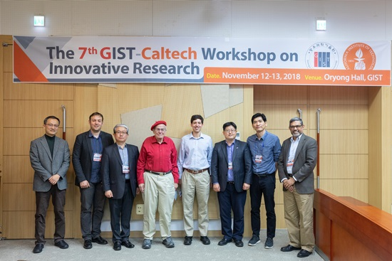
▲ From left: GIST Professor Yong-Joo Doh, Caltech Professor Stevan Nadj-Perge, GIST Professor Yong Chul Kim, Caltech Professor William A. Goddard III, Caltech Professor Austin J. Minnich, GIST Dean of Research Inchan Kwon, GIST Professor Young-Dahl Jho,
and Caltech Vice Provost Kaushik Bhattacharya

