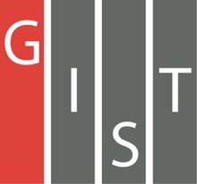
Gwangju Institute of Science and Technology

Official Press Release (https://www.gist.ac.kr/)

Section of Hyo Jung Kim Nayeong Lee
Public Relations Section Chief Senior Administrator
(+82) 62-715-2061 (+82) 62-715-2062

Contact Person Jung-gon Kim, Administrator
for this Article GIST Business Incubator
062-715-2593

Release Date 2020.08.31

GIST partners with Microsoft to help small and medium-sized businesses enter the global market

□ GIST (Gwangju Institute of Science and Technology, President Kiseon Kim) is supporting the 2020 Startup Leap Package Support Project with Microsoft the entry of small and medium-sized AI enterprises into the global market through Microsoft's 'Welcome' program.*

* Welcome Program: using the initial letter of ‘Ma’ (Microsoft) and ‘Small’ 9small and medium-sized AI enterprises) to emphasize that Microsoft welcomes Korean start-ups who wish to cooperate with them

∘ GST plans to support 30 excellent AI-related start-up companies in collaboration with Microsoft, a global company, with a total project cost of 61.5 billion won in 2020.

□ GIST formed a dedicated organization to support start-up companies for efficient business execution, forming an investment organization, securing investment funds, and supporting the growth of start-up companies through technology transfer and education using the school infrastructure. Microsoft plans to provide support with education, product enhancement, consulting, and attracting investment from the U.S.

∘ It provides up to 300 million won (17 million won on average) in commercialization funds and up to 400 million won (2 years) in research and development funds linked to R&D start-up companies that want to enter the global market, and provides services necessary for the growth of start-up companies such as education, consulting, and networking.

∘ In addition, the GIST Business Incubator provides an opportunity for selected companies to scale-up to the next level by utilizing GIST's AI infrastructure and operating specialized programs with GIST's unique features and strengths.

□ Currently, GIST has been operating the Startup Leap Package Support Project for five consecutive years since 2016, and in 2019, 16 companies were selected and supported with 20 billion won in investments attracted through the activities of the GIST Business Incubator.

∘ In particular, the GIST Business Incubator has been highly praised by companies for its active investment attraction activities through business agreements with leading domestic investment institutions to attract customized investments.

□ GIST Business Incubator Director Sung-Keun Ki said, "The GIST Business Incubator will systematically support start-up companies to grow to the next level by discovering promising companies with technological prowess through active collaboration with Microsoft and will help accelerate the entry of overseas markets by attracting investments."

∘ Start-ups that wish to participate in the welcome program can apply online from August 21 (Fri) to September 17 (Thu) through the K-Startup website during the announcement period. A business briefing is scheduled to be held online on August 28 through the YouTube channel. For more information, please check the K-Startup website at www.k-startup.go.kr.

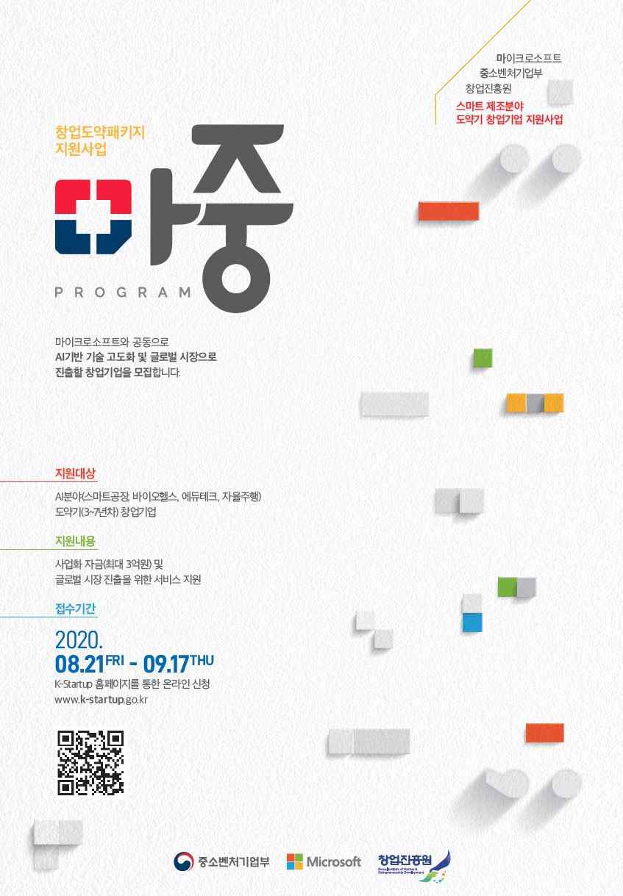
▲ Poster for the Welcome Program currently being used on the K-startup site

