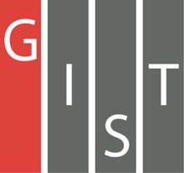
Gwangju Institute of Science and Technology

Official Press Release (https://www.gist.ac.kr/)

Section of Hyo Jung Kim Nayeong Lee
Public Relations Section Chief Senior Administrator
(+82) 62-715-2061 (+82) 62-715-2062

Contact Person Deuk-jo Kong, Senior Researcher
for this Article Artificial Intelligence Research Institute
+(82) 62-715-2934

Release Date 2020.06.24

GIST promotes education and competition projects
to cultivate AI startup entrepreneurs

□ Under the supervision of the Artificial Intelligence Industry Convergence Project (Director Dae-sik Lim), GIST (Gwangju Institute of Science and Technology, President Kiseon Kim) and the Artificial Intelligence Research Institute (Director JongWon Kim) will carry out education and promotion work to foster AI preliminary entrepreneurship for the "Artificial Intelligence-centered Industrial Convergence Complex Project."

∘ According to the cooperation structure of the Ministry of Science and ICT, Gwangju Metropolitan City, and the National IT Industry Promotion Agency (NIPA), this education and promotion project conducted by the Artificial Intelligence Industry Convergence Project and conducted by the GIST AI Research Institute is designed to identify and clarify business items and team building for the purpose of supporting and fostering pre-entrepreneurs in the idea formation stage (Stand-Up stage) by sequentially conducting start-up mentoring, item research and development, and linking with customers.

□ First, for the AI-specific training program, which will be customized according to the individual entrepreneur's capabilities, it is divided into types (Data, AI, Management) and step-by-step (beginner, intermediate, and advanced) to provide AI-oriented entrepreneurship training.

∘ Starting in July, AI-specific education programs recruit trainees for a total of three sessions and provide customized education on-off-Mix through the latest AI practice environment. Trainees will complete D.A.M. (Data/AI/Management) for X-specific training and will obtain AI education certificates. It is also expected to be a very special opportunity for AI prospective entrepreneurs as they can prepare for the preliminary start-up team building while receiving mentoring from AI experts, including networking with domestic and foreign AI experts.

□ In October and November, an AI competition for 'Dreams Come True' will be held. The competition will hold preliminary rounds for various AI events prepared in cooperation with foreign companies such as NVIDIA, Intel, Siemens Industry Software Korea, and other local/investment companies such as KEPCO, KDN, and Saltlux.

∘ After completing the preliminary competition to evaluate the ability of prospective entrepreneurs to demonstrate convergence services for each AI event, the teams from the top of the preliminary round will be invited to evaluate their ability to design comprehensive AI convergence services and verification of start-up/joint cooperation items by competition. In particular, the company will add ha competitive event to solve the problems of traditional manufacturing industries in Gwangju to help boost the local economy.

∘ A total of 230 million won will be awarded through the competition, and selected outstanding teams will be given benefits such as commercialization and start-up consulting, support for prototype production, matching demand companies and setting up start-up spaces.

□ GIST Artificial Intelligence Research Institute Director JongWon Kim said, "Dreaming Children (AI) is designed to provide many people with a 'joyful playground' that fulfills the first step toward their dream of starting a business using AI technology. For the Stand-Up stage, where young children stand up on their own feet, companies are expected to present practical problems, and participants in education and promotion expect to exchange various start-up ideas if they combine them with AI to find creative solutions."

□ Meanwhile, GIST plans to offer a variety of AI play programs on the weekends to help local citizens easily access AI.

∘ Through easy and interesting classes such as "AI Drone Class with Friends" and "AI coding with Dad," citizens will feel closer to artificial intelligence, freely communicate about artificial intelligence topics, and discover new ideas, lowering the threshold for the use of human-centered AI technology and contributing to Gwangju's leap into an artificial intelligence-oriented city.

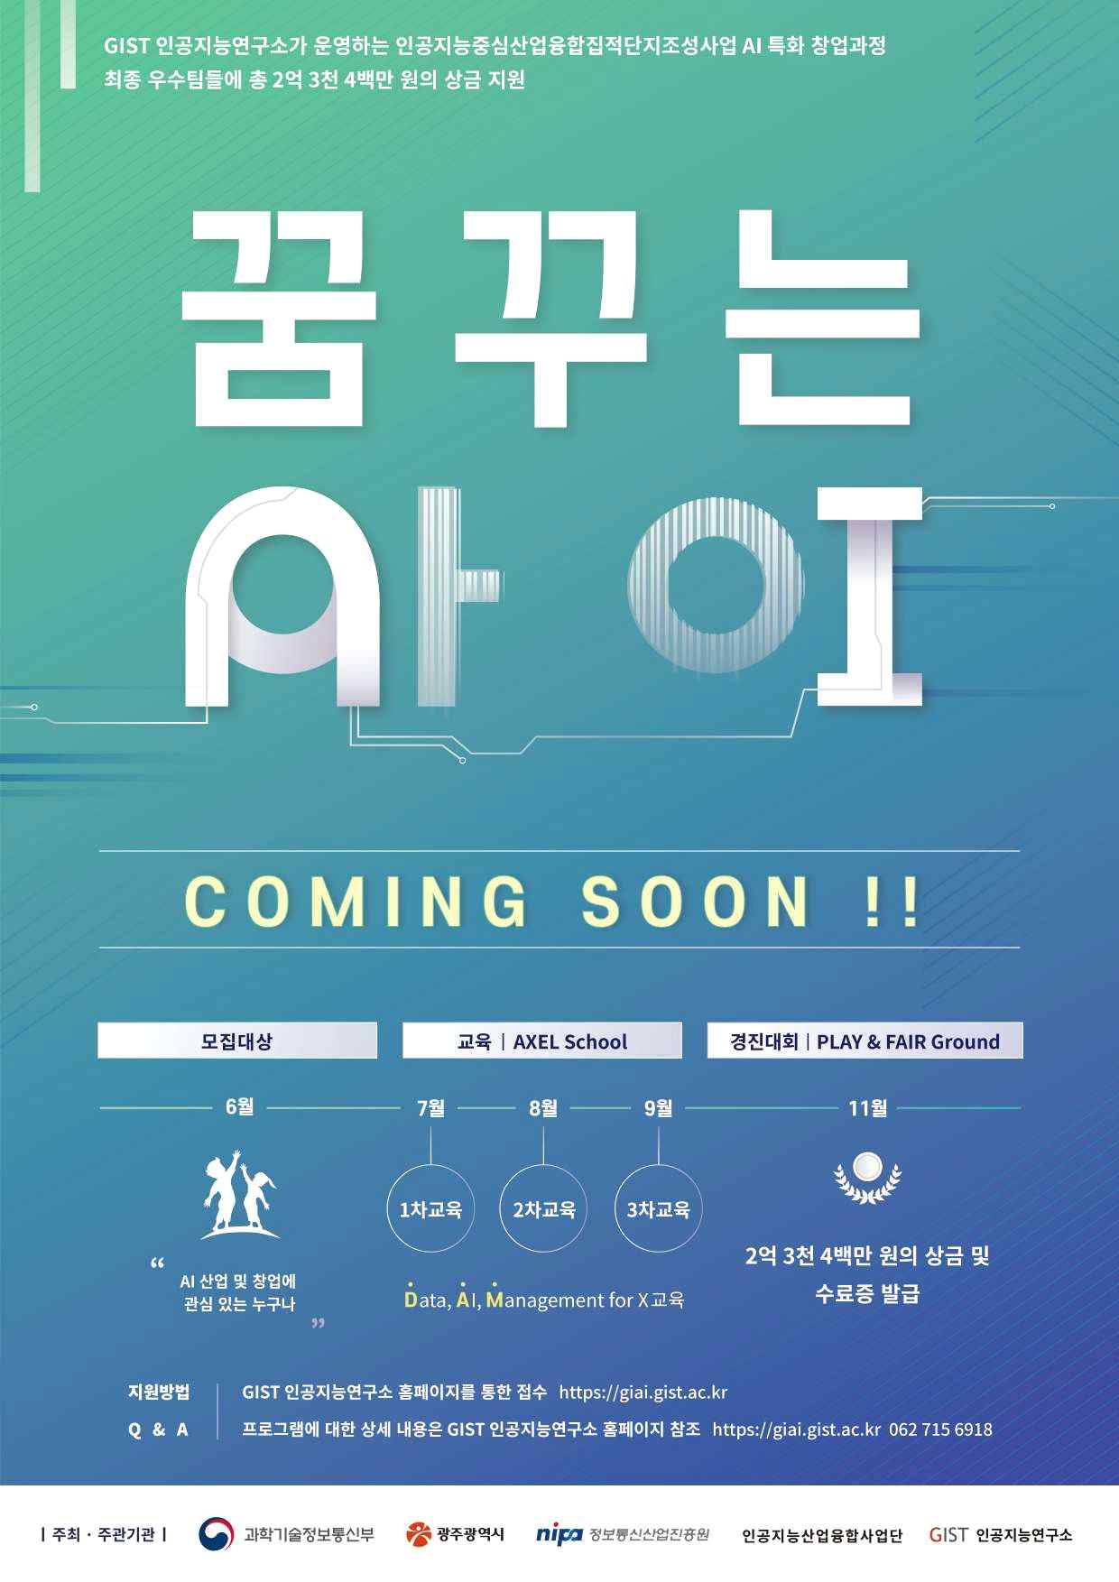
▲ Artificial Intelligence Industry Convergence Project promotional poster

