Gwangju Institute of Science and Technology

Official Press Release (https://www.gist.ac.kr/)

Section of Hyo Jung Kim Nayeong Lee
Public Relations Section Chief Senior Administrator
(+82) 62-715-2061 (+82) 62-715-2062

Contact Person Section of Public Relations
for this Article (=82) 62-715-2061~3

Release Date COVID-19 changed the landscape of GIST

COVID-19 has changed the landscape of GIST

□ The prolonged COVID-19 pandemic has had a profound impact not only on Korea but also on the entire world. The campus at the Gwangju Institute of Science and Technology (GIST, President Kiseon Kim) looks very different from before.

∘ First, the start date of the new semester in March is about two weeks later than previous years, and all available lectures are currently being conducted online. GIST College students' entry into the dormitories has been delayed until the end of April and further extensions are being discussed.

□ In particular, the regular GIST board meeting held on March 24 was conducted through an online video conference for the first time to prevent the spread of COVID-19 and to implement social distancing.

∘ Instead of face-to-face meetings, GIST held an online video conference using Zoom, resulting in a budget savings of about 3 million won when compared to face-to-face meetings.

□ Also, from this week until the end of the COVID-19 situation, changes to the lunchtime schedule are in effect. Students' lunchtime is from 11:30 to 12:30 and other members' lunchtime is from 12:30 to 13:30 to practice social distance due to the national emergency.

∘ In addition, official notices and guidance are sent out to members to inform them of the recommendation to wear a mask and keep a distance of two meters or more from others, not to sit facing others, and to use hand sanitizer and disposable gloves.

□ GIST Vice President Jong-In Song said, "Although the landscape of GIST's campus has changed a lot this spring from the previous year, there has been some positive aspects, such as reducing unnecessary outside activities and strengthening internal affairs. In the meantime, we will do our best to quickly overcome COVID-19 and prepare for new opportunities to leap forward when the domestic and international situation stabilizes."

□ Meanwhile, GIST distributed flower pots as a small gift to students to remind them of spring despite COVID-19. In addition, GIST will for the time being strengthen access control for outsiders on campus until COVID-19 subsides.

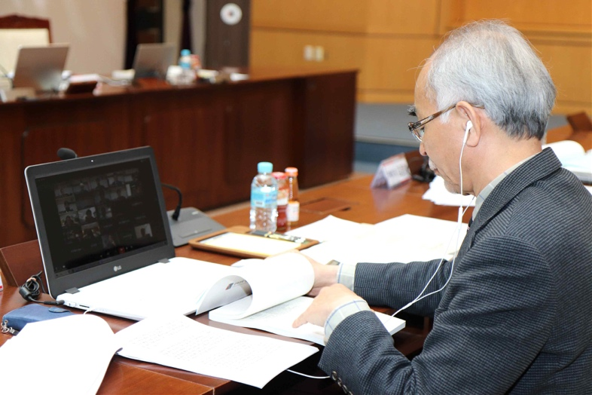
▲ GIST regular board meeting held online

