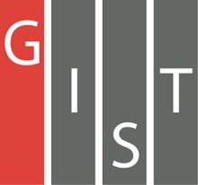
Gwangju Institute of Science and Technology

Official Press Release (https://www.gist.ac.kr/)

Section of Hyo Jung Kim Nayeong Lee
Public Relations Section Chief Senior Administrator
(+82) 62-715-2061 (+82) 62-715-2062

Contact Person Tae-wan Kim, Administrator
for this Article Business Support Center
062-715-6302

Release Date 2020.10.12

Junction, Europe's largest global hackathon event, was held for the second time in Korea with the participation of GIST College students

□ GIST (Gwangju Institute of Science and Technology, President Kiseon Kim) – Shift, a non-profit organization consisting of university students with various majors and interests, including university students from GIST, successfully licensed "JunctionX Seoul 2020," Europe's largest hackathon.

∘ JunctionX Seoul 2020 is the second hackathon competition held in Korea since last year, and, due to the global pandemic, this event was held in Seoul for two nights and three days from October 9 (Friday) to 11 (Sunday) using YouTube live-streaming, Zoom, and Slack programs.

□ Unlike the traditional hackathon method of solving one big topic, the competition was conducted as a track-challenge method in which participants could freely select and solve some of the various topics. Each topic was also presented in areas where companies wanted to get fresh ideas.

∘ This year the competition had four company tracks: ▲ NAVER Z's 'Zepeto-render API HACK' ▲ Microsoft's 'Develop for collaboration and remote productivity' ▲ Rakuten RapidAPI's 'API Hack' ▲ SI Analytics's 'Satelite Image Analysis.'

∘ Sponsoring organizations included: GIST Business Support Center, GIST Innovation Entrepreneur Education Center, KAIST Startup Support Office, DGIST Technology Startup Education Center, UNIST Startup Promotion Center, POSTECH Entrepreneurship Center, Gwangju University Startup Support Group, and Gwangju Creative Economy Innovation Center.

□ Before the start of the hackathon, global planners, developers, and designers performed team building missions, and, as side events, yoga classes, interviews with participants, track workshops, and Naver D2 entrepreneurship webinars were held in a 1:1 meeting format.

∘ So-yeon Kim, a graduate from GIST College (currently attending KAIST Graduate School) and who is hosting the event, said, "Through the hackathon event, participants can gain entrepreneurial experiences with problems faced by companies, new technologies, and new businesses while providing opportunities for companies to get new ideas and have exchanges with future specialists. The new ideas of the winners of each track are expected to develop into more advanced technologies and ideas through active collaborations with corporate managers."

□ The non-profit organization "Shift" was created by university students with various majors and interests to establish a student-centered start-up ecosystem, with most of its members having actual start-up and start-up work experiences. It was established under the leadership of GIST college students (Dae-wook Song in mechanical engineering, So-yeon Kim in chemistry, Jin-woo Kim in electrical engineering and computer science, Min-suk Kim in liberal arts and sciences), and students from other universities such as Seoul National University, POSTECH, etc., including Bo-ra Nam, a business administration major at Ewha Womans University, Jae-in Kim, a convergence contents major at Ewha Womans University, Hyun-se Lee, a technical management major at Konkuk University, Seoul National University construction environment engineering major Da-eun Kim, POSTECH electronic electrical engineering major Young-chae Kim, and Yonsei University visual design major Sang-wook Park.

∘ Shift aims to become Korea's Aalto ES (Aalto Entrepreneurship Society) through benchmarking Finland's Aalto ES and plans to lead a student-centered entrepreneurial ecosystem and culture.

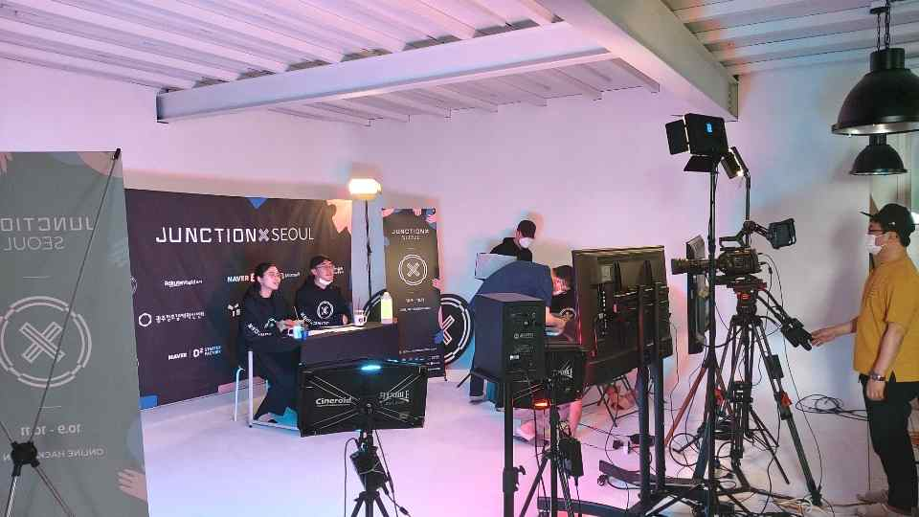

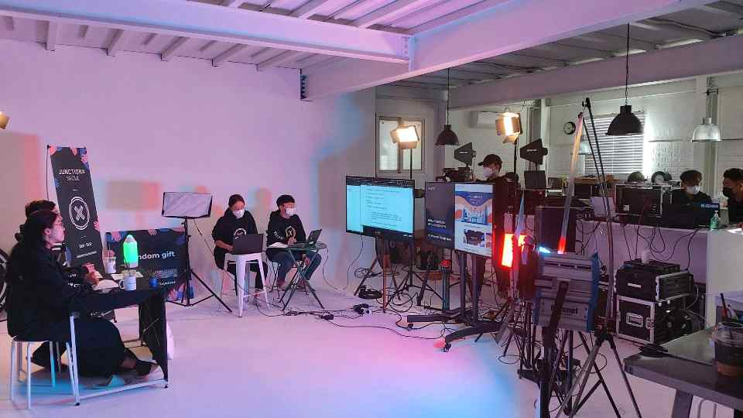
▲ Broadcasting site in Seoul FVA Studio

