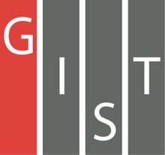
Gwangju Institute of Science and Technology

Official Press Release (https://www.gist.ac.kr/)

Section of Hyo Jung Kim Nayeong Lee
Public Affairs Section Chief Senior Administrator
(+82) 62-715-2061 (+82) 62-715-2062

Contact Person Eun-joo Lee, Administrator
for this Article Section of Library Services
(+82) 62-715-2085

Release Date 2019.11.05

[GIST Science and Culture Week]
GIST Movie Day with local residents

□ GIST (President Kiseon Kim) will hold a film festival with local resdisidents on November 6, 2019, on the second floor of the GIST Library, which has set up a stage with ultra-large monitors and state-of-the-art surround sound.

□ The event is the second of its kind since last May to mark the GIST Science and Culture Week, and the animated movie Big Hero (directed by Don Hall and Chris Williams in 2014) * is about robot science that can be enjoyed by the whole family.

* Big Hero is an animated version of Marvel Comics, and Baymax in the movie is developed for healthcare but is upgraded to a superhero to fight against villains for Hiro. Big Hero includes Disney's first Korean character to appear, and it has provided more spectacular attractions by utilizing programs like Hyperion and Denison. It won the 87th Academy Award for Best Animated Picture. Source: [Naver Knowledge Encyclopedia]

∘ Admission is free of charge at the festival, and a variety of souvenirs and events, including face painting and sweepstakes, will be offered from 5:30 pm. After the film ends, a media facade show, a feast of light that utilizes the entire exterior wall of the GIST Library will be shown.

□ Office of Library and Information Resources Dean Min-Gon Kim (Department of Chemistry professor) said, "This GIST Movie Day should be more interesting than the previous one because we have prepared more science-related events for local residents."

∘ The previous GIST Movie Day have more than 800 attendees, including GIST members and local residents.

※ GIST Movie Day inquiries: Section of Library Services 062-715-2085

□ GIST Library is running beneficial cultural programs such as cultural lectures, free performances, and exhibitions by opening a community communication program called "GIST Culture Salon" to grow together with the local community and become a diverse community hub.

※ GIST Culture Salon inquiries: Library website (https://library.gist.ac.kr) 062-715-2097

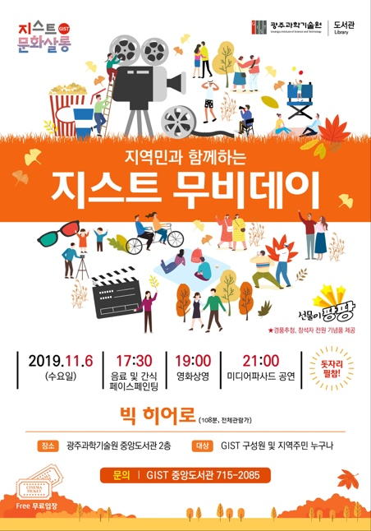
Poster

