Gwangju Institute of Science and Technology

Official Press Release (https://www.gist.ac.kr/)

Section of Mi-Yeon Kim Nayeong Lee
Public Affairs Section Chief Senior Administrator
(+82) 62-715-2020 (+82) 62-715-2024

Contact Person Soo Jung Park, Administrator
for this Article Section of International Cooperation
(+82) 62-715-2062

Release Date 2018.09.12

GIST celebrates 25th anniversary with a concert performance by the University of Stuttgart Orchestra

□ GIST (President Seung Hyeon Moon) – In celebration of GIST's 25th anniversary, a concert performance by the University of Stuttgart Orchestra will be held at Oryong Hall at 6:30 pm on September 17, 2018.

∘ The concert will open with a performance of "B Rossette" by the GIST College Orchestra Club Ak-Dong, and the University of Stuttgart Orchestra will perform Prokofiev: Violin Concerto No.1 and Mendelssohn: Symphony No.4. The concert will conclude with a joint orchestral performance of Bizet: Carmen Overture by both schools.

□ The University of Stuttgart is a technology-oriented public university that was established in Stuttgart, Germany, in 1829 and has developed into a research hub that is renowned for its engineering and natural sciences. The University of Stuttgart Choir and Orchestra has a tradition of more than 60 years and are invited to perform concerts throughout Baden-Württemberg and Germany.

∘ The 70-member orchestra has performed concerts in almost every European country as well as Brazil, the Philippines, Australia, the United States (Oregon), China, Taiwan, and South Africa. They have also performed in Tallinn (Estonia), Helsinki (Finland), and Saint Petersburg (Russia).

□ GIST President Seung Hyeon Moon said, "I hope that this concert will serve as an opportunity to further develop cultural ties and friendship between GIST and the University of Stuttgart through the beautiful and rich harmonies of the music that our schools perform together."

□ This concert is open to all GIST members and the local community (children must be older than 8 years to attend). Tickets will be available from 10:00 am to 5:00 pm on Friday, September 14 (excluding lunch hours from 12:00 to 1:00) at the first-floor information desk in the GIST Administrative Building (S2). A maximum of 4 free tickets will be given to one person on a first come first served basis.

※ Inquiries ☎ 062-715-2062
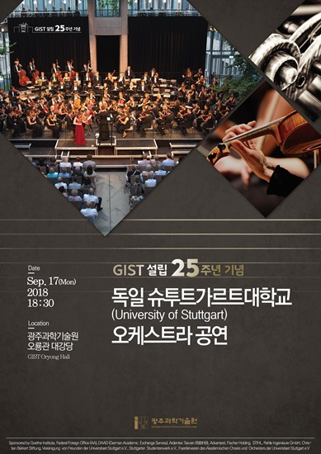
□ GIST, which celebrates its 25th anniversary this year, will hold large and small events until the official November foundation date when there will be various booths, events, festivals, exhibitions, and activities.

