Gwangju Institute of Science and Technology

Official Press Release (https://www.gist.ac.kr/)

Section of Hyo Jung Kim Nayeong Lee
Public Affairs Section Chief Senior Administrator
(+82) 62-715-2061 (+82) 62-715-2062

Contact Person Na-rae Park, Administrator
for this Article Korea Culture Technology Institute
(+82) 62-715-4921

Release Date 2019.10.25

GIST Korea Culture Technology Institute
to operate AR Docent pilot service

□ GIST (President Kiseon Kim) Korea Culture Technology Institute (Director Moongu Jeon, School of Electrical Engineering and Computer Science professor) will operate an "AR Docent" pilot service at the National Museum of Korea from October 28 to November 3, 2019.

∘ This service provides exhibition contents experience with wearable augmented reality technology through AR glass (holo lens). Visitors can wear AR glasses, experience various augmented reality contents about Silla era artifacts, and enhance their understanding of history.

□ AR Docent delivers new cultural and artistic experiences to visitors by conveying the context and information of artifacts through augmented reality (AR) by going beyond the space-time constraints of art galleries and museums and the limitations of existing docent services. The results of leading cultural technology research will be introduced to actual exhibition spaces and visitors, and the results will be further supplemented and improved by receiving on-site feedback and evaluations by users.

∘ AR Docent is the result of the Ministry of Culture, Sports and Tourism's 2019 Culture Technology R & D Support Project <Development of Intelligent UI/UX Technology for AR Glass-Based Docent Management> with the research and development of the GIST Korea Culture Technology Institute, GIST Convergence Technology, Vernet, and Perfect Storm Co., Ltd.

□ This pilot service increased user engagement by designing visitor-led interactions. By applying intelligent chatbot technology and lip-syncing technology, natural conversation with people in history is possible.

∘ Visitors can experience various types of AR contents such as touching relics, viewing information on relics, restoring original objects, interacting with people in history, sharing experiences with other visitors, and leaving with a good impression.

□ AR Docent is the application of culture technology that is specialized in exhibition environment such as museums and art galleries. In the era of the 4th Industrial Revolution, it is expected to become a future cultural service with high timeliness and high usability.

∘ AR Docent is a pioneering example of applying AR technology that is tailored to the needs of a site, in line with the direction of the 3rd R & D Basic Plan for the Cultural Technology R & D (Ministry of Culture, Sports and Tourism 2019.1), which aims to build a realistic cultural enjoyment infrastructure through the VR and AR contents of public cultural resources. The project is expected to be widely used in various exhibition environments in the future.

□ GIST Professor Kyoobin Lee (research supervisor) of the School of Integrated Technology said, "Recently, the latest technology such as artificial intelligence, augmented reality, and digital twin are also being actively applied in the cultural and artistic fields. In addition to these latest technologies, the pilot service focused on the augmented reality and interactive artificial intelligence technologies that help viewers more immersed in the artifacts and gain interesting information."

□ GIST and the National Museum of Korea are planning to formally launch AR Docent services in the first half of next year after the pilot service.

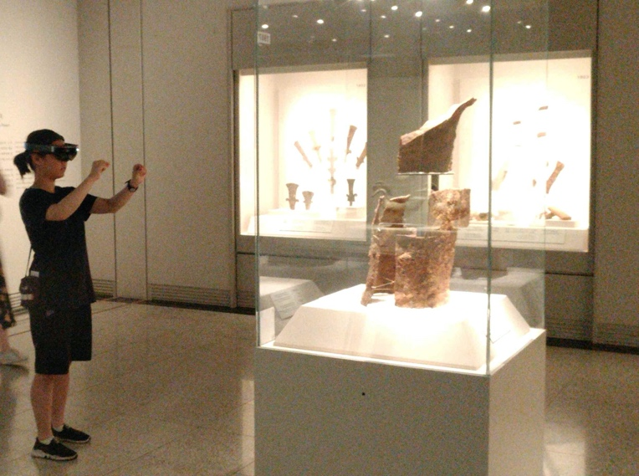
▲ [Photo 1] Visitors wear AR glasses and experience AR Docent service

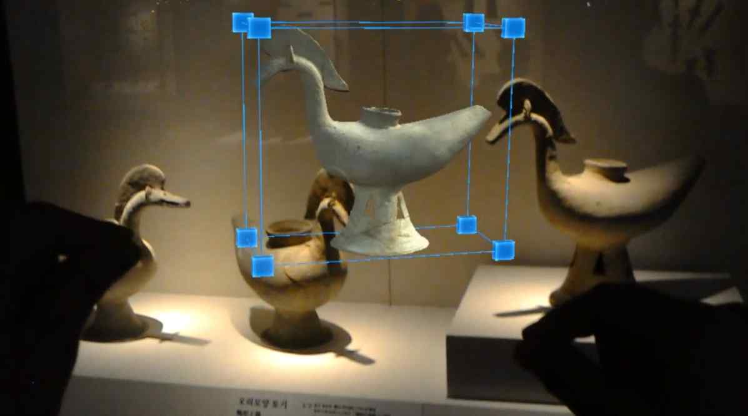
▲ [Photo 2] AR Docent experience screen to hold and move the 3D model of an object by hand

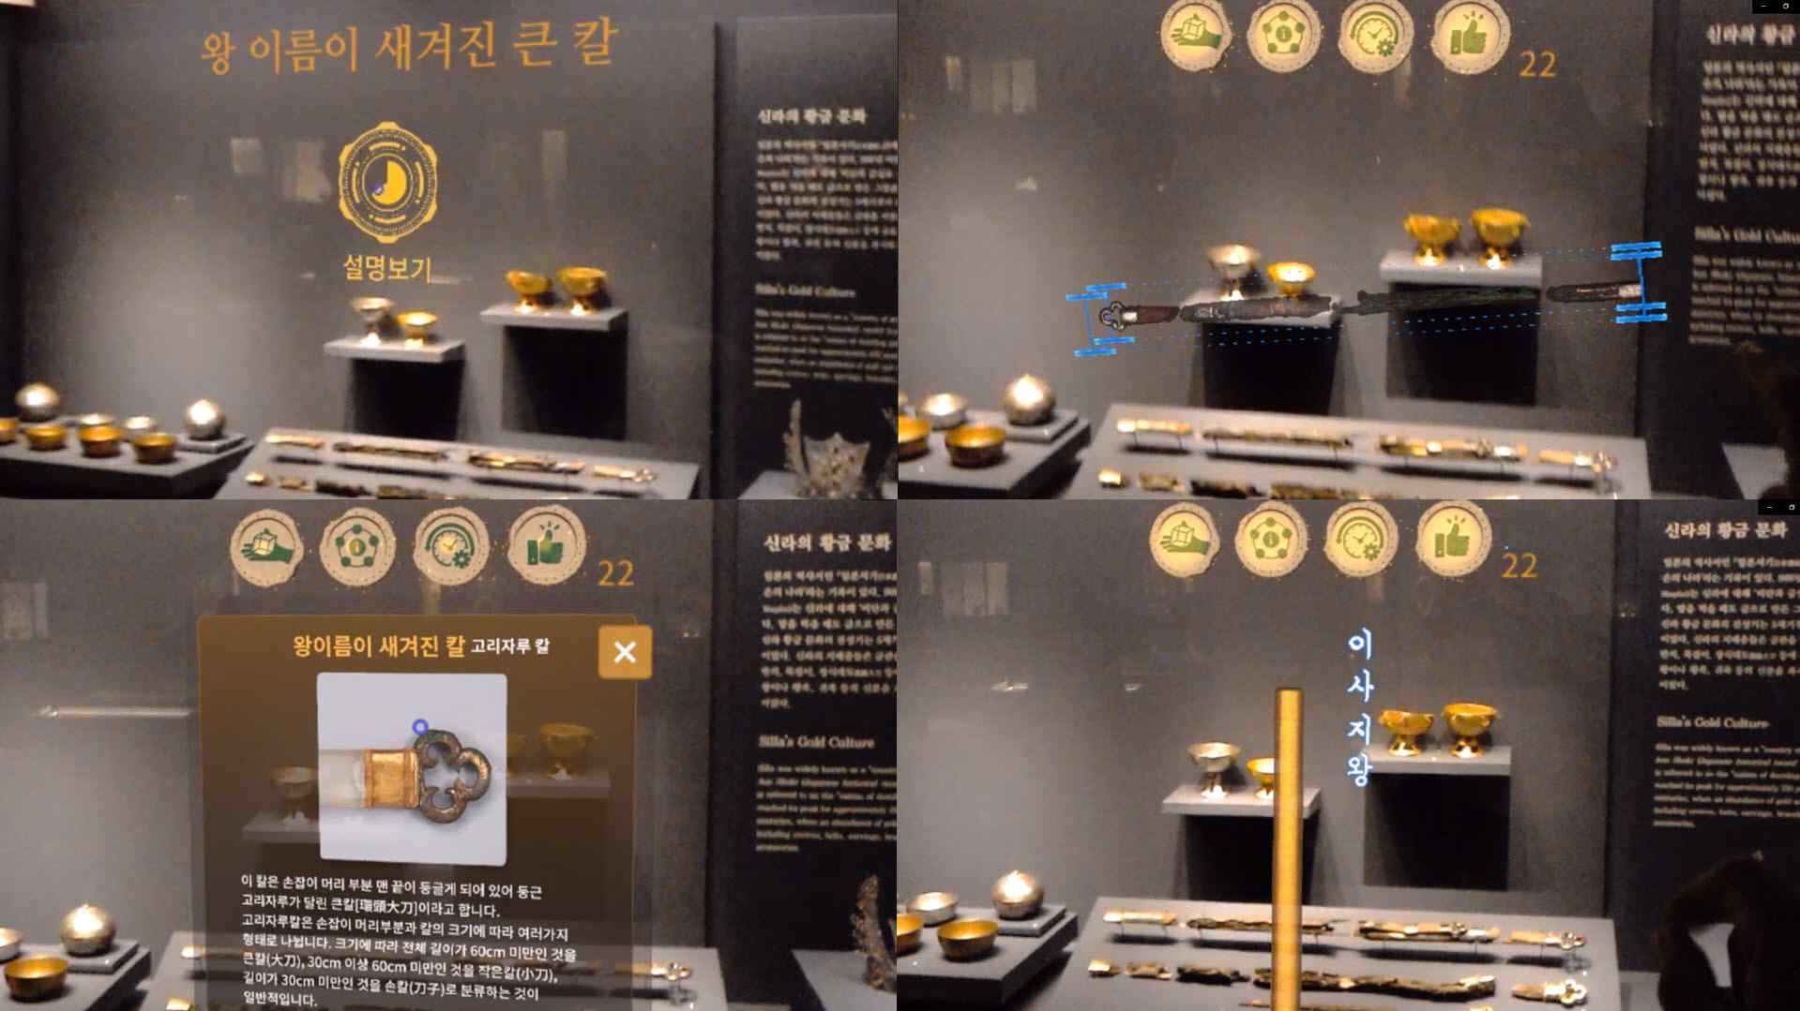
▲ [Photo 3] Various augmented reality content screens during AR Docent experience

