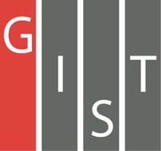
Gwangju Institute of Science and Technology

Official Press Release (https://www.gist.ac.kr/)

Section of Mi-Yeon Kim Nayeong Lee
Public Affairs Section Chief Senior Administrator
(+82) 62-715-2020 (+82) 62-715-2024

Contact Person Professor Gi-hoon Lee
for this Article Center for Security Science and Technology
(+82) 62-715-5208

Release Date 2018.10.29

GIST Center for Security Science and Technology signs MoU with the Air Force Education Command to utilize future national defense technologies

□ GIST (President Seung Hyeon Moon) Center for Security Science and Technology (Director Hyyong Suk) signed a memorandum of understanding (MoU) on October 25, 2018, with the Air Force Education Command, 3rd Training Wing, in Sacheon City, Gyeongsang Province, to apply future GIST defense technologies (electronic warfare, laser, artificial intelligence, VR/AR, etc.) to the air force education and training systems.

□ Representatives from both organizations attended the signing ceremony, including GIST President Seung Hyeon Moon, Center for Security Science and Technology Director Hyyong Suk, and Air Force Lieutenant General Hyun-gook Choi. The agreement includes: ▲ GIST Center for Security Science and Technology and Air Force will co-plan and operate future defense technology related education programs ▲ sonsult and cooperate for the development of Air Force education and training systems ▲ exchange information and explore projects for future research and development ▲ share personnel and facilities.

∘ Currently, 2 to 30 Air Force officers have been attending programs and special lectures at GIST once a quarter but in the future will be short term (one night and two days). Training is also scheduled to take place on a regular basis.

□ A cooperation agreement was signed in April 2017 between GIST and the Air Force to develop advanced technologies such as cyber and electronic warfare capabilities, laser weapons, laser communications, and artificial technologies.

∘ It is especially meaningful that GIST has established a practical opportunity to utilize its world-class research capabilities in electronic warfare and lasers to develop future technologies.

□ The Center for Security Science and Technology Director Hyyong Suk said, "GIST recognizes the roles and responsibilities of supporting national security with superior technology and technology, and with this cooperation agreement, both organizations will actively pursue technical and human exchanges and set a model example for civilian-military cooperation."

□ GIST established the Center for Security Science and Technology in late 2016 to recognize the importance of the role of state-of-the-art science and technology for national security and to actively cooperate with the world-renowned institutions.

∘ In 2016, GIST was selected as a specialized research institute for the Defense Agency in the fields of electronic warfare, high-performance lasers, next-generation energy, military communication and networks, and GIST has a high-tech photonics research institute, which is a world-class laser research institute, as well as a specialized research center for the electronics industry.

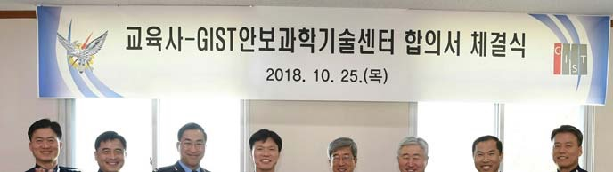
Photo of the GIST Center for Security Science and Technology
and the Air Force Education Command signing ceremony

