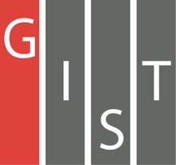
Gwangju Institute of Science and Technology

Official Press Release (https://www.gist.ac.kr/)

Section of Hyo Jung Kim Nayeong Lee
Public Relations Section Chief Senior Administrator
(+82) 62-715-2061 (+82) 62-715-2062

Contact Person Chang-sung Kang, Administrator
for this Article GIST Business Incubator
(+82) 62-715-6303

Release Date 2020.04.23

GIST selected for the 2020 Gwangju
Creative Experience Center

□ GIST (Gwangju Institute of Science and Technology, President Kiseon Kim) was selected for the 2020 Gwangju Creative Experience Center by the Ministry of Education and the Gwangju Metropolitan City Institute of Education Research and Information.

∘ The Regional Creative Experience Center is a project that utilizes the infrastructure of the community to operate a specialized entrepreneurship experience program, support school entrepreneurship experience training, and build a network in the region. It will establish a systematic cooperative system inside and outside the school and actively support students to grow into future innovative talents through valuable experiences.

∘ 17 cities and provinces across the country were selected for the project, but Gwangju Metropolitan City has never been selected, and GIST will play this role for the first time. The operation period lasts for about 9 months from April 2020 to December, and it is supported with a budget of 40 million won.

□ GIST will operate various programs such as entrepreneurship training, design thinking, business model development, prototype production and mentoring, and 3D printing training by utilizing the entrepreneurship support infrastructure and will focus on entrepreneurship training and infrastructure and network construction in the region.

∘ Through the spread of entrepreneurship and start-up mindset among youths in Gwangju, innovative future specialists with creativity and challenging spirits will be fostered, the foundation of startups will be expanded, and start-up education will be provided to help them set career paths and foster entrepreneurship.

∘ Regarding participation in the program, a separate notice will be made to local schools in consultation with the Gwangju Metropolitan City Education Research and Information Service, and schools can participate through the "Dream Path" site operated by the Ministry of Education.

□ GIST Business Incubator Director Byung-kwon Cho said, "As an organization that serves as a hub for supporting startups in the region, GIST will utilize its start-up support infrastructure to provide students with various creative education and career experience opportunities. GIST will actively contribute to the revitalization of the local economy and the inflow of talented people by intensively fostering AI startups and discovering successful models through business expansion for prospective entrepreneurs and local residents as well as education for local youths."

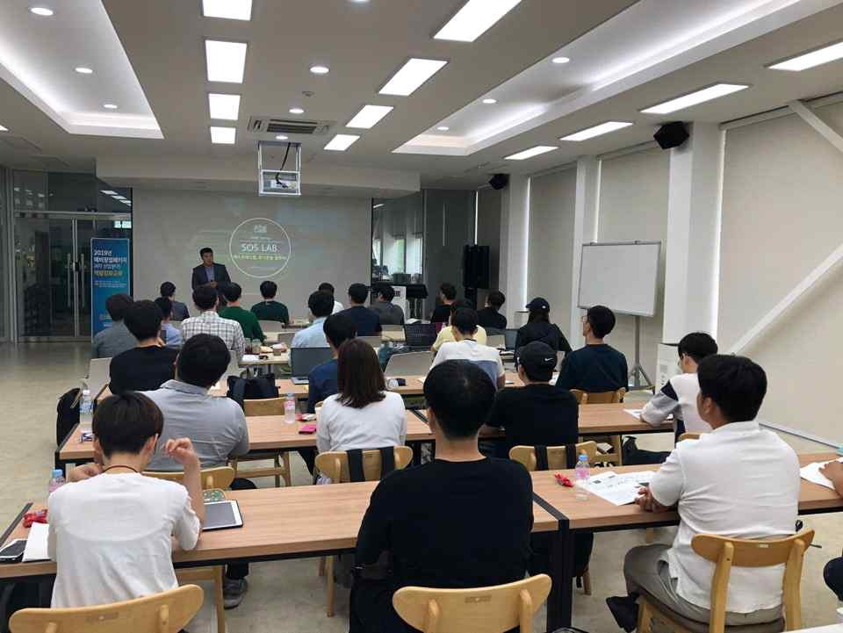
▲ The GIST Business Incubator provides various educational programs for prospective entrepreneurs. (Photo: a preliminary start-up package conducted by the GIST Business Incubator in 2019 for youth education)

