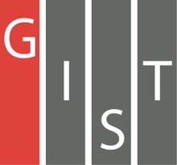
Gwangju Institute of Science and Technology

Official Press Release (https://www.gist.ac.kr/)

Section of Hyo Jung Kim Nayeong Lee
Public Affairs Section Chief Senior Administrator
(+82) 62-715-2061 (+82) 62-715-2062

Contact Person Seung Yun Lee, Administrator
for this Article Institute for Artificial Intelligence
(+82) 62-715-6852

Release Date 2019.10.28

2019 AI Day ends successfully

□ GIST (President Kiseon Kim) Institute for Artifical Intelligence (Director Hyuk Lim, School of Electrical Engineering and Computer Science professor) successfully held the 2019 GIST AI Day with lectures from international scholars and GIST professors on October 26, 2019, under the theme of AI computer vision *.

* AI computer vision: an interdisciplinary scientific field that deals with how computers can be made to gain high-level understanding from digital images or videos through artificial intelligence

∘ This year's AI Day event includes international experts in AI, such as Professor Larry Davis (University of Maryland), Researcher Ming You Liu (Anbi Dia), Professor Anjo Kanazawa (UC Berkeley), Professor Philip Isola (MIT), and Dr. Mohammed (XNOR.AI). GIST Professors Hae-Gon Jeon, Kang Il Kim, and Prof. Jonghyun Choi will attend and discuss the latest research trends and technologies in the field of computer vision, which is an area of artificial intelligence.

∘ Presentations following the lectures included artificial intelligence/deep learning algorithms for ultra-compact devices, visual recognition algorithms that produce high-dimensional results, and the latest research trends and technologies of the world's highest performance generative adversarial network (GAN). The meeting was followed by questions and answers from the 250 audience participants.

□ GIST Institute for Artifical Intelligence Director Hyuk Lim said, "GIST has not only secured world-class artificial intelligence research capabilities but also established close cooperation with prominent AI researchers and research institutes at home and abroad. In addition to the opening of the AI Graduate School, which is scheduled to open next year, we will grow into the nation's top AI research institute by creating synergy with the AI Industrial Convergence Complex, focusing on three specialized areas in the Gwangju area for healthcare, automobiles, and energy."

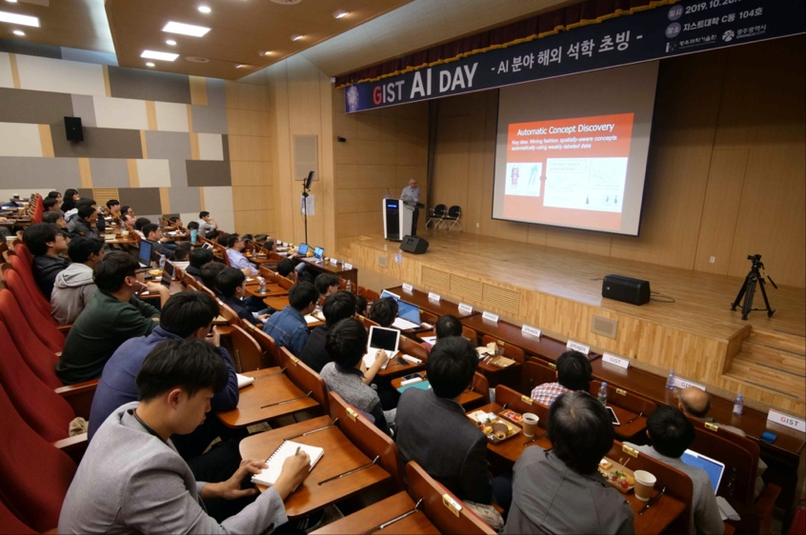
▲ 2019 GIST AI Day photo

