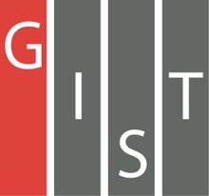
Gwangju Institute of Science and Technology

Official Press Release (https://www.gist.ac.kr/)

Section of Hyo Jung Kim Nayeong Lee
Public Relations Section Chief Senior Administrator
(+82) 62-715-2061 (+82) 62-715-2062

Contact Person Seung-soo Yoo, Administrator
for this Article Section of Public Affairs
(+82) 62-715-2025

Release Date 2020.04.11

GIST and Infoworks Co., Ltd. sign a business agreement (MoU) to create an AI-based future autonomous vehicle industrial ecosystem

□ GIST (Gwangju Institute of Science and Technology, President Kiseon Kim) and Infoworks Co., Ltd. * (CEO Hyun-Ju Park), a developer and supplier of intelligent mobility sensors and solutions, signed a business agreement (MoU) for industry-academic cooperation and ecosystem development for the future of AI-based autonomous vehicles.

* Infoworks is a company that develops and supplies intelligent mobility sensors and solutions. In January of this year, it launched 'REX Basic,' Korea's first artificial intelligence computer board based on artificial neural network (NPU). It is considered to have both hardware and software platform development capabilities.

∘ The signing of the MoU by both agencies was carried out at separate locations in accordance with the implementation of the prevention of the spread of COVID-19.

□ This agreement aims to develop and implement technologies for utilizing internal and external convergence sensors of AI-based vehicles for improving object identification * of self-driving vehicles and diagnosing failures in poor or changing natural environments.

* object identification: A key technology used in unmanned vehicles, which allows cars to recognize stop signals and distinguish pedestrians from street lamps.

∘ The main contents of the agreement include: ▲ AI-based future autonomous vehicle education, mutual exchange of human resources to improve the quality of research and education ▲ create a cooperation system such as education, joint research, and internships for AI technology development and innovation ▲ mutual cooperation for the creation of an ecosystem for the future self-driving car industry based on artificial intelligence promoted by Gwangju Metropolitan City and ▲ '4D Lidar Development and Optical Fusion Sensor Development' with effective promotion and mutual cooperation for business success.

□ GIST President Kiseon Kim said, "The agreement aims to expand AI research capabilities and develop new technologies for industry-academic cooperation to create an artificial intelligence ecosystem in Gwangju. In addition, it is expected to positively influence the regional economy through the creation and commercialization of AI-driven entrepreneurship models to create an AI-based future autonomous vehicle industrial ecosystem."

□ Meanwhile, Infoworks signed a business agreement with Gwangju Metropolitan City on March 24 to create an AI business ecosystem, including the establishment of a research center and production plant.

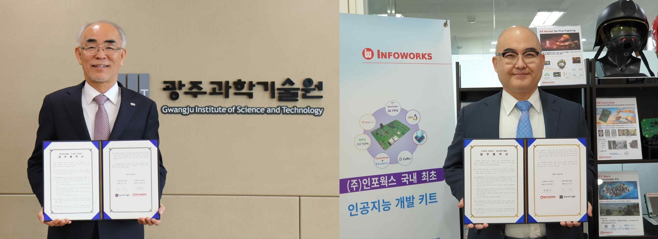
[photo] (from left) GIST President Kiseon Kim and Infoworks Co., Ltd. CEO Hyun-Ju Park

