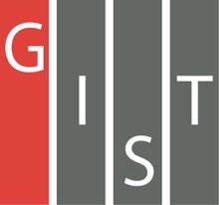
Gwangju Institute of Science and Technology

Official Press Release (https://www.gist.ac.kr/)

Section of Hyo Jung Kim Nayeong Lee
Public Affairs Section Chief Senior Administrator
(+82) 62-715-2061 (+82) 62-715-2062

Contact Person Ho-jong Kang, Administrator
for this Article Auditor Office
(+82) 62-715-2008

Release Date 2019.10.25

GIST Auditor Office gives awards for
outstanding integrity slogans

□ GIST (President Kiseon Kim) Auditor Office (Auditor Kwang-shik Shin) held an award ceremony for excellence in integrity in the main administrative building on October 24, 2019.

∘ In September, a total of 71 slogans were received by the department as part of the Integrity Slogan Contest held for three weeks under the auspices of the Auditor Office to promote the participation of members in anti-corruption and integrity policies and to raise awareness of integrity.

□ A total of eight films were selected for awards through a screening process involving the Civil Audit and Inspection and the Advisory Group on Internal Integrity, which appointed experts outside of GIST. The Grand Prize was selected as 'Clean You, Face of GIST' submitted by the International Environmental Research Institute, two excellence awards were given to the President's Office and the GIST Business Incubator, and five incentive awards were given to the Department of Chemistry, Technology Commercialization Center, Section of Budget, Section of General Affairs, and the Auditor Office.

∘ At the awards ceremony, Auditor Kwang-shik Shin was presented with a prize and an award as the head of the department and for his outstanding work. The winning slogans will be used on electronic approval documents and e-mail signatures to raise awareness of integrity.

□ Auditor Kwang-shik Shin said, "As public awareness of anti-corruption is raised in society, members of GIST as a public organization need to change their awareness of integrity and their perception of corruption. With the integrity slogans, we expect to raise awareness of integrity within the organization and spread the culture of anti-corruption."

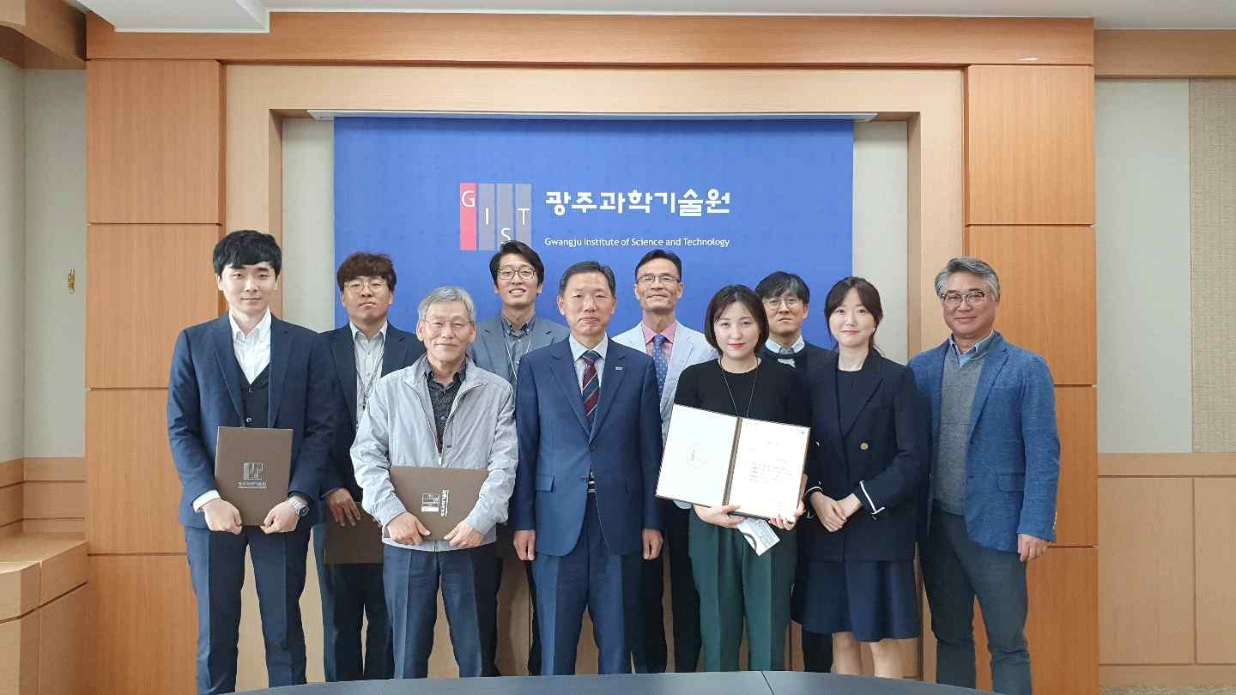
▲ [Photo] Integrity Slogan Award Ceremony: Auditor Kwang-shik Shin (third from the left of the front row) and Auditor Sam-hwa Lee (first from the right of the front row)

