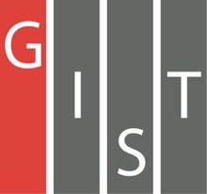
Gwangju Institute of Science and Technology

Official Press Release (https://www.gist.ac.kr/)

Section of Hyo Jung Kim Nayeong Lee
Public Affairs Section Chief Senior Administrator
(+82) 62-715-2061 (+82) 62-715-2062

Contact Person Section of Public Affairs
for this Article (+82) 62-715-2061~2063

Release Date 2019.10.29

Campus-wide "GIST Science and Culture Week" event

□ GIST (President Kiseon Kim) Science and Culture Week event will be held from November 1 to 9, 2019, to promote the spread of local science and culture.

□ GIST has prepared a variety of events that local people, middle and high school students, prospective entrepreneurs, entrepreneurs, as well as scientists and engineers can all enjoy together.

∘ On October 22, 2019, Gérard Mourou who won the 2018 Nobel Prize in physics gave a public lecture in Oryong Hall, and GIST held AI Day conference on October 26, 2019.

∘ On November 1 and 2 ▲ AI & IoT Makerton event will be held to build the foundation for commercializing creative ideas using artificial intelligence (AI) and internet of things. On November 4, the ▲ Start-up Night event for students and people interested in starting a business will be have GIST's start-up support, education programs, quizzes, DJs, and other interesting things. In addition, November 5 will have the ▲ 2019 Gwangju Startup Forum Road Show at Gist and "Start-up City, Gwangju! Embrace artificial intelligence" ▲ GIST CEO Forum will be held to hold a festival for local entrepreneurs such as students and researchers, prospective entrepreneurs and related organizations and start-up companies.

∘ On November 6 for the second time this year since May, ▲ GIST Movie Day is held. This movie day, which is held on the 2nd floor of GIST's Central Library, will play "Big Hero," featuring a robot expert and a medical robot. On November 7, ▲ Student Festival will have cultural performances, guest singers, and colorful fireworks ▲ GIST Learning Zone exchange event, on Friday, November 8th, will strengthen the solidarity of GIST members and local people ▲ cultural events ▲ sponsored night ▲ 2019 GIST Conference will be held.

∘ The Feast of Light Media Facade Show will run for three days from November 6 to 8 and will project various images on the outer wall of the GIST Central Library to provide fresh views through dynamic media performances.

∘ On November 9, the last day of the festival, the Advanced Science Golden Bell Competition, an educational program with residents' participation, will be held under the auspices of the Buk-gu Office.

□ GIST President Kiseon Kim said, "This year's 'GIST Science and Culture Week' is a medium for science and culture, providing useful programs and events for not only GIST members but also the local people to enjoy together. In the future, GIST will strive to contribute to the spread of sound scientific culture and community development through various programs for people's participation."

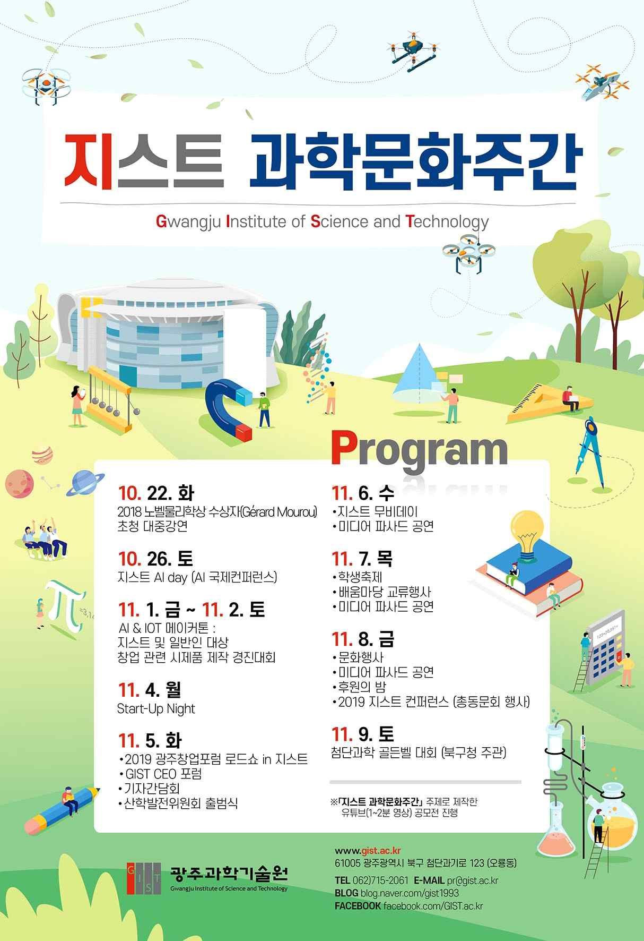
GIST Science and Culture Week poster

