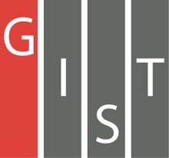
Gwangju Institute of Science and Technology

Official Press Release (https://www.gist.ac.kr/)

Section of Hyo Jung Kim Nayeong Lee
Public Relations Section Chief Senior Administrator
(+82) 62-715-2061 (+82) 62-715-2062

Contact Person Deuk-jo Kong, Senior Researcher
for this Article Artificial Intelligence Research Institute
(+82) 62-715-2934

Release Date 2020.04.13

GIST signs a business agreement (MoU) for joint research on an unmanned autonomous
driving platform

□ Gwangju Institute of Science and Technology (GIST, President Kiseon Kim) has established an organic collaboration system of research institutes, industry, and startups to revitalize the future automobile industry centered on artificial intelligence and contribute to the creation of local industrial ecosystems.

□ GIST AI Research Institute (Director Hyuk Lim), Fine Motors Co., Ltd. (CEO Jong-seok Choi), a manufacturer specializing in automobile parts manufacturing and special future vehicles in Gwangju, and Autonomous a2z Co., Ltd. (CEO Ji-hyung Han), a promising start-up for self-driving cars, signed a business agreement (MoU) for joint research on an unmanned autonomous driving platform.

∘ The MoU was recently concluded in writing at separate locations to prevent the spread of COVID-19 infections, and the main contents of the agreement include: ▲ cooperation in the field of future cars (autonomous driving and self-driving for specific purposes) based on AI, and exchange of human resources to enhance the quality of research ▲ establishing a cooperative system for education, joint research, internships, etc. for the development and innovation of AI technology ▲ mutual cooperation for the creation of artificial intelligence-based future self-driving car industry in Gwangju Metropolitan City and ▲ the research and development of autonomous vehicles for specific purpose vehicles included efficient promotion and mutual cooperation for business success.

□ Gwangju's automobile production capacity stands at 620,000 units a year, ranking it second in Korea after the 1.5 million units of Ulsan. Gwangju's automobile industry is considered the largest major industry (41.3 percent) among Gwangju's manufacturing industries, and if the finished car factory centered on electric cars is added, production diversification and quantitative growth are expected at the same time. Therefore, the expected effect through this consortium is very high.

∘ The above consortium will be developed through industry-academia convergence research and development and will be demonstrated at GIST's campus and at the Gwangju Special Economic Zone. In addition, GIST plans pilot projects for "autonomous driving patrol cars" and "unmanned courier/delivery cars" to create a safe and convenient campus.

□ GIST AI Research Institute Director Hyuk Lim said, "It is expected that this agreement will bring new vitality through AI to the traditional automobile manufacturing industry in the region, and furthermore, it is hoped that it will play a positive role in creating an artificial intelligence-based future autonomous driving industry ecosystem in Gwangju."

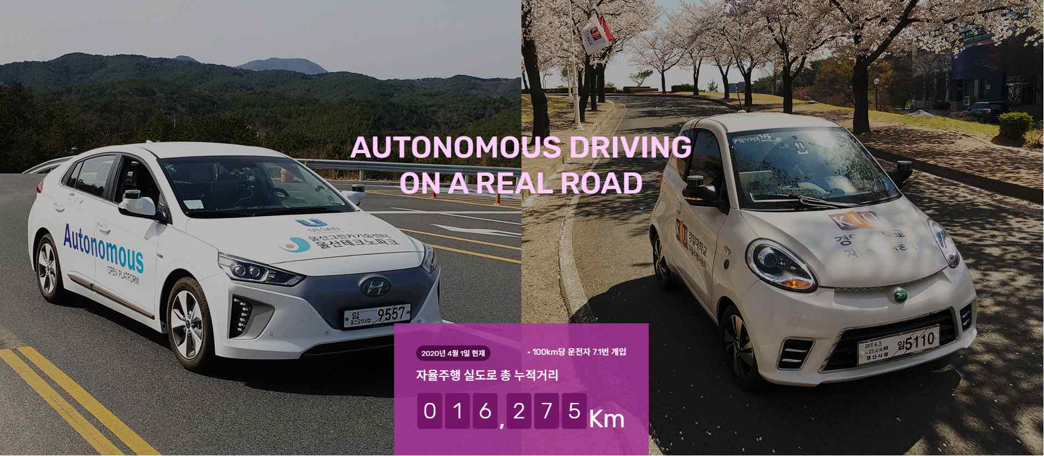
[picture] Autonomous a2z's unmanned autonomous vehicle

