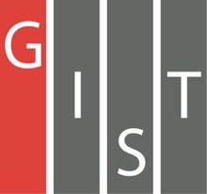
Gwangju Institute of Science and Technology

Official Press Release (https://www.gist.ac.kr/)

Section of Hyo Jung Kim Nayeong Lee
Public Affairs Section Chief Senior Administrator
(+82) 62-715-2061 (+82) 62-715-2062

Contact Person Professor Chul-Seung Park
for this Article Chair of the Organizing Committee
for the 2020 Conference of the Federation
of Korean Societies for Bimolecular Sciences
(+82) 62-715-2489

Release Date 2020.1.7

2020 Conference of the Federation of
Korean Societies for Bimolecular Sciences

□ Gwangju Institute of Science and Technology (GIST, President Kiseon Kim) will host the 2020 Conference of the Federation of Korean Societies for Bimolecular Sciences (organized by GIST School of Life Sciences Professor Chul-Seung Park) at Oryong Hall from January 9 to 11, 2020.

∘ The Federation of Korean Societies for Bimolecular Sciences is comprised of five organizations that are co-sponsoring the conference (the Korean Crystallographic Association, the Korean Society for Structural Biology, the Korean Society for Protein Science, the Korean Chemical Society, and the Korean Biophysical Society) with the Korean Biophysical Society as the main sponsor.

□ A total of 46 academic lectures will be presented at 10 symposia and will include keynote speeches by KAIST Professor Byung-ha Oh, Osaka University Professor Genji Kurisu, and POSTECH Professor Young-tae Jang.

∘ In addition, more than 80 academic posters will be presented during the event, and the luncheon seminar will introduce new technologies for biomolecule research and showcase research equipment from biomolecular science companies.

□ The first day of the conference is on January 9 and will feature opening remarks by the GIST Professor Chul-Seung Park, who is the Conference Chair as well as the Chairperson of the Korean Biophysical Society, which will be followed by ▲ KAIST Professor Byung-ha Oh's keynote speech on 'Computational Protein Design and Its Application.' Afterwards, four symposia will be held.

∘ On the next day on January 10, ▲ Osaka University Professor Genji Kurisu will give a keynote speech on 'Structural Basis for the Ferredoxin-dependent Photosynthetic Electron Transfer and ▲ POSTECH Professor Young-tae Jang will give a keynote speech on 'Strategy for Cell Discrimination using Fluorescent Probe,' which will be followed by six symposia and closing remarks by UNIST Professor Myung-soo Na who is the Chairperson of the Korean Crystallographic Association.

□ GIST Professor and Chair of the Organizing Committee Chul-Seung Park said, "This conference is a venue where various Korean academic organizations can share and review the latest research developments, and I hope this conference will promote cooperation among Korean researchers in the field of molecular-life science while providing important opportunities for them to develop multidisciplinary cooperative research in the future."

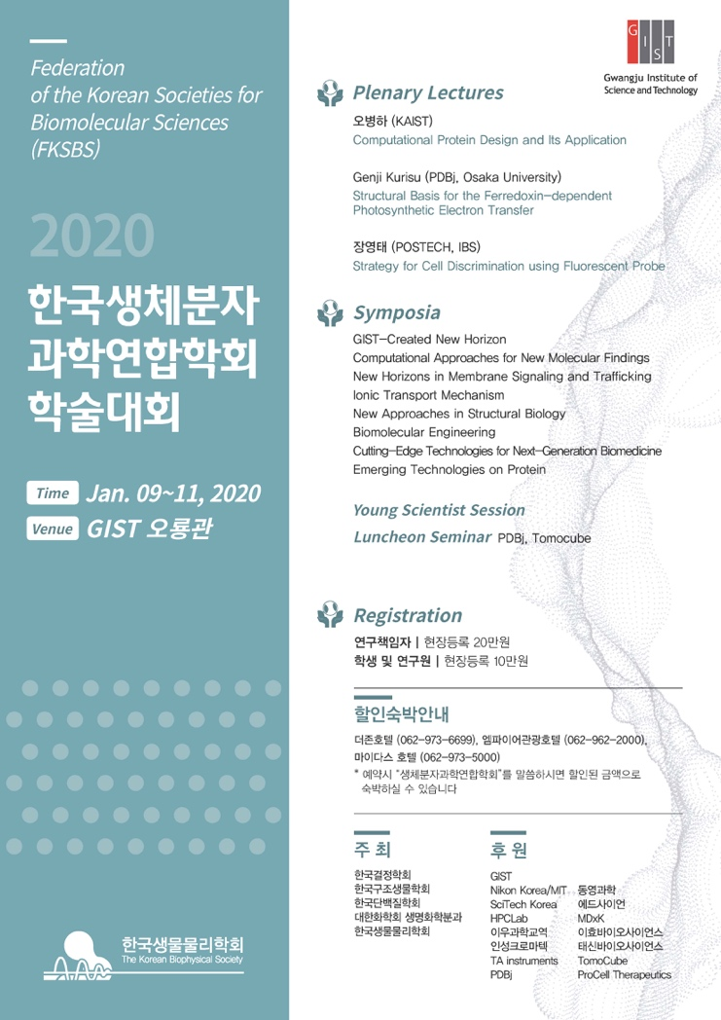
[Image] 2020 Conference of the Federation of Korean Societies for Bimolecular Sciences poster

