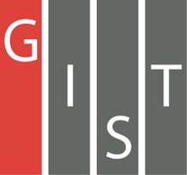
Gwangju Institute of Science and Technology

Official Press Release (https://www.gist.ac.kr/)

Section of Hyo Jung Kim Nayeong Lee
Public Affairs Section Chief Senior Administrator
(+82) 62-715-2061 (+82) 62-715-2062

Contact Person Yuna Roh, Administrator
for this Article Section of Undergraduate Administration Services
(+82) 62-715-3613

Release Date 2019.11.27

2019 GIST Infinite Challenge Project
Performance Presentations held

□ GIST (President Kiseon Kim) College on November 26 held the 2019 GIST Infinite Challenge Project Performance Presentations, which gives students a chance to freely challenge themselves in activities with the aim of "failure is ok, so give it a try."

∘ Starting with the launch ceremony for the 2019 Infinite Challenge in May, 96 GIST College students from 22 teams participated in various projects on diverse topics and announced their performance for the past six months.

□ The project, which encourages self-directed "different activities," was first launched in 2016 and marks its fourth anniversary this year.

∘ Students voluntarily form teams and select topics to apply for the Infinite Challenge Project Competition in April, and the selected teams receive an average of 2.5 million won and receive credits in the creative development course depending on the outcome of the project.

□ The HABOT (Hidden Assistant Bot) team that carried out the project in this year's "Creative Works" category were students Sung-joon Kang, Yoo-sung Nam, and Ji-seon Han who met and challenged the production of a wearable device prototype that acts as a personal assistant while worn on top of a garment. Although it tried to implement the 'HABOT' design and manufacture using Arduino Nano, it failed due to its larger-than-expected size and operating voltage.

∘ Since then, various versions of HABOT have been produced using chips used in mini-RC cars, and the HABOT team has now succeeded in making it possible to climb onto clothes. After further research, they expressed the ambition to develop technology to move freely on clothes.

□ The 'Braille Brilliant' team consisted of students Chae-Eun Cho, So-Eun Ko, Myung-Jin Kim, Se-Bin Kim, Joon-Jae Choi, and Won-Hyuk Choi. The Braille Brilliant team learned that Braille books are relatively more expensive than the ones on the market, and that their types and quantities are significantly lower. In order to improve on the inconveniences of a portable braille machine, the 'button-type bolo machine' was conceived.

∘ They also made word cards and toys for blind children using laser cutters, 3D printers, and 3D pens. To better understand the blind, they also performed volunteer work and produce a video on 'How can a typical person in society help the blind?' and promoted the video through social networking sites.

□ GIST Infinite Challenge mentor Professor Hisam Kim (Division of Liberal Arts and Sciences, economics) said, "This project is a 'self-directed, different' activity for students sponsored by the school. Not only does the content and style of the project fit the future talent of creativity, tenacity, and positivity, but it is hoped that students who have lost their competitive feel for education will be able to regain their motivation and vitality."

∘ The performance presentation for 2019 will be held at GIST Building C Room 104 with results of each teams' projects on display in the lobby from November 26 until November 27, 2019.

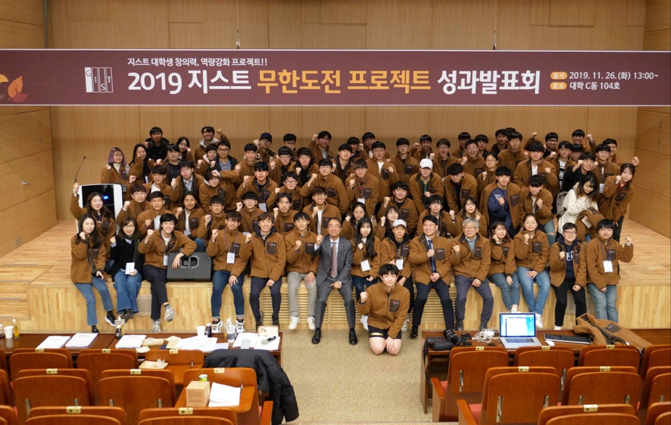
▲ 2019 GIST Infinite Challenge Project Performance Presentations group photo

