Gwangju Institute of Science and Technology

Official Press Release (https://www.gist.ac.kr/)

Section of Hyo Jung Kim Nayeong Lee
Public Relations Section Chief Senior Administrator
(+82) 62-715-2061 (+82) 62-715-2062

Contact Person Section of Public Relations
for this Article (+82) 62-715-2061~2063

Release Date 2020.03.06

GIST delivers comfort items to freshmen from
Daegu and North Gyeongsang Province

□ Gwangju Institute of Science and Technology (GIST, President Kiseon Kim) delivered letters and comfort items on March 6th to freshmen from Daegu and North Gyeongsang Province, who were placed in dormitories and quarantined following the spread of new coronavirus infections in Korea.

∘ The comfort items include snacks that can be used by freshmen who are restricted inside their dormitories during the quarantine period. GIST is also serving lunchboxes three times a day to all of the quarantined students during this time. In addition, GIST will pay close attention to the COVID-19 situation and will hold online lectures starting on March 13 as an alternative to regular classes to help prevent spread of the coronavirus.

□ Because of the numerous COVID-19 patients in Daegu and North Gyeongbuk province, GIST arranged a special bus to safely transport student from Daegu to the GIST campus in Gwangju on February 29 to prevent new infections among GIST freshmen and students who have arrived to start the semester in March.

∘ Currently, the students who were specially transported from the region are being quarantined for 14 days in a single dormitory room at GIST.

∘ GIST is a residential college where all of the students live in dormitories. As the start of the semester has been postponed for about two weeks due to the COVID-19, all of the new students from Daegu and North Gyeongsang Province are being quarantined in the dormitory and are actively being checked for fever and respiratory problems.

□ GIST President Kiseon Kim said, "We hope you understand that this is an inevitable measure to protect and maintain the educational and research environment of GIST. I would like to express my deepest gratitude for your active participation. Everyone at GIST is doing their best to ensure your safety. Hopefully, this unstable situation will end as soon as possible, so that we can enjoy springtime on campus and have a vibrant school life."

∘ Since the beginning of the COVID-19 outbreak, GIST has developed a strong response system and community guidelines for preventative measures and has deployed emergency response personnel with additional funding. In addition, thermal imaging cameras are installed in major buildings with thorough quarantines for the entire campus.

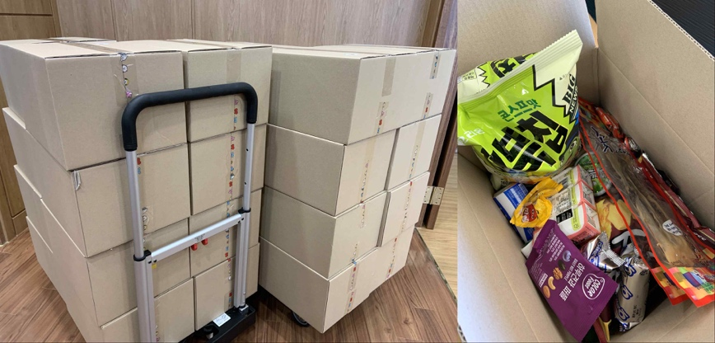
(Photo 1) Comfort items given with a letter to freshmen from Daegu
and North Gyeongsang Province who are quarantined

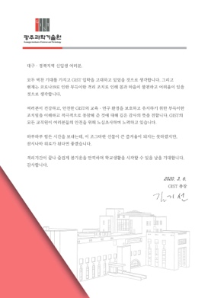
(Photo 2) Letter from GIST President Kiseon Kim
delivered with the comfort items

