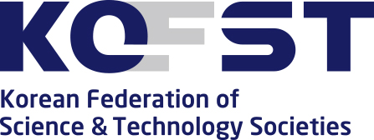

Contact for this Article Science and Culture Promotion Team
02-3420-1246

Release Date 2019.06.28

[News Release] The 2019 Korea Science and Technology Annual Conference will be held
to discuss the future of Korea

□ The 2019 Korea Science and Technology Annual Conference is hosted by Korea Federation of Science and Technology Societies (President Myung-ja Kim) and sponsored by the Ministry of Science and ICT (Minister Young-min Yoo) and the Ministry of SMEs (Minister Young-sun Park) and will be will be held at COEX in Seoul on July 4, 2019.

∘ The Korea Federation of Science and Technology Societies has been holding the annual conference since 2007 and is a venue where experts from science and technology fields can gather to discuss future visions and strategies based on topics of national interest and technological innovations.

∘ The 13th annual meeting is expected to be attended by National Assembly Speaker Hee-sang Moon, Minister Young-min Yoo of the Ministry of Science and ICT, Minister Young-sun Park of the Ministry of SMEs, as well as 3,000 science and technology experts from all over the world.

□ The theme of this annual conference is "Korea's future depends on science and technology," and it is set as a place to announce the importance of science and technology innovation both in Korea and other countries. The topics of the last two annual conferences were 'Fourth Industrial Revolution Era, Embracing Growth and Innovation' and 'Smart Technology for Creativity and Empathy.' This conference deals with the economic, socio-cultural aspects of technological innovations brought about by hyper-changes. Kim Myung-ja, president of the company, takes the opening speech of 'Industrial Revolution and Techno-Humanism' on behalf of the opening speech. President Myung-ja Kim's opening speech will focus on "industrial revolution and techno-humanism."

□ During the Science and Technology President's Forum, which was established instead of the keynote lecture, seven people including Gwangju Institute of Science and Technology President Kiseon Kim, Hanyang University President Woo-seung Kim, Ajou University President Hyung-joo Park, Sungkyunkwan University President Dong-ryul Shin, Seoul National University President Se-jung Oh, Pusan National University President Ho-hwan Jeon, and Korea University President Jin-taek Chung will discuss the next 10 years of Korea's future.

□ In the afternoon, four symposiums ① Korea's industrial competitiveness and manufacturing industry will be upgraded! ② Economic, social and cultural changes that the 4th Industrial Revolution will change. ③ Outreach Forum with People: Fine Dust National Forum and Plastic Issue Forum, ④ Good Jobs, Start up to sustainable growth! The 2019 Dasan Conference (English session) will be held on the theme of achieving sustainable development goals (SDGs) and the role of future generations.

※ Refer to attached symposium summary

∘ The Dasan Conference will be held as an open conference involving the general audience, foreign ambassadors to South Korea, overseas experts, and young scientists from home and abroad.

□ Minister Young-min Yoo of the Ministry of Science and ICT said, "The Korea Science and Technology Annual Conference, which marks its 13th anniversary this year, has drawn in-depth discussions and productive alternatives for the development of science and technology every year.I hope that it will continue to create a growth engine centered on science and technology, and to be a place for open discussions to present the future vision of science and technology."

□ President Myung-ja Kim said, "In the era of the Fourth Industrial Revolution, the role of science and technology innovation for securing national competitiveness, improving the quality of life of the people, social safety and national security is more important for sustainable development. We hope that the science and technology will contribute to opening the bright future of Korea."

□ The opening ceremony of the 2019 Korea Science and Technology Annual Meeting will be broadcast live on the festival homepage and the official official YouTube channel *, and the afternoon symposium will also be available on YouTube as a recorded video.

* Search for ‘한국과총’ on YouTube.com.

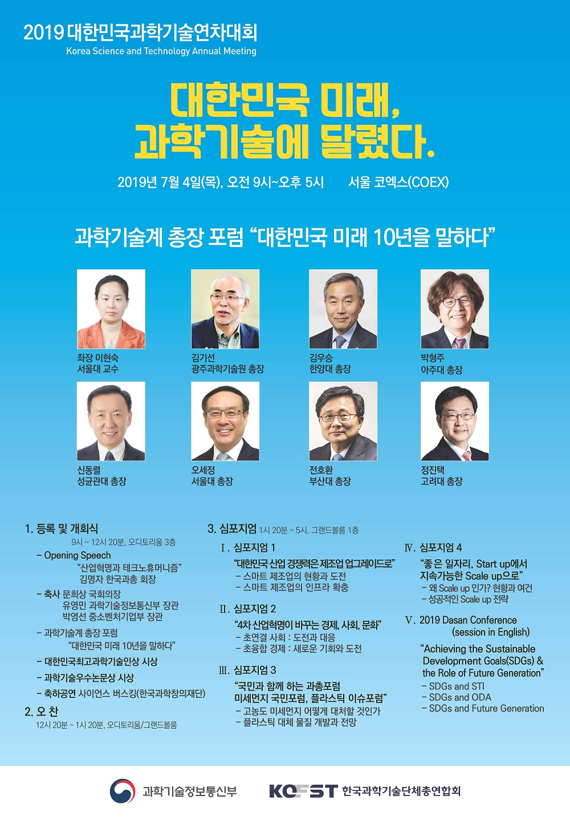
Link: http://kstam.kofst.or.kr

