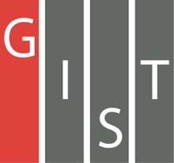
Gwangju Institute of Science and Technology

Official Press Release (https://www.gist.ac.kr/)

Section of Hyo Jung Kim Nayeong Lee
Public Relations Section Chief Senior Administrator
(+82) 62-715-2061 (+82) 62-715-2062

Contact Person Duk-jo Kong, Senior Researcher
for this Article Institute for Artificial Intelligence
062-715-2934

Release Date 2020.11.12

GIST and Intel Korea signed a business agreement
in the field of artificial intelligence

□ GIST (Gwangju Institute of Science and Technology, President Kiseon Kim) Institute for Artificial Intelligence (Director JongWon Kim) and Intel Korea (CEO Myung-Sook Kwon) signed a business agreement (MoU) on November 11, 2020, for research and development and industry-academia cooperation in the field of artificial intelligence.

∘ The agreement ceremony maintained social distancing to prevent the spread of Covid-19, and GIST and Intel Korea decided to maintain a system of mutual exchange and cooperation, such as joint participation in contests and technical information.

□ Under this agreement, GIST and Intel Korea will seek to develop national science and technology and improve the research capabilities of both institutions through cooperation in technologies centered on artificial intelligence.

∘ The main contents of the agreement include ▲ joint participation for AI-based start-up support ('Dreaming Child (AI)') competition ▲ Intel oneAPI technology cooperation ▲ Intel product support. In addition, GIST and Intel Korea plan to actively cooperate on matters necessary for mutual development and promotion of friendship.

□ Intel Korea offers a project that requires the use of artificial intelligence in the mobility (drone) industry, which has recently been in the spotlight.

∘ Based on data acquired from drones, the purpose of the project is to develop creative problem solving abilities for defining problems and improving creativity by using computer vision and related algorithms and for acquiring related knowledge related to the entire deep learning process, such as data acquisition, preprocessing, learning, and inference.

□ The "Dreaming Child AI" competition, which began in earnest in mid-October, will be held as a real-life competition based on specialized artificial intelligence projects selected from the needs of companies specializing in artificial intelligence. The total prize money is about 234 million won, making this the largest competition in Korea.

∘ The Ministry of Science and ICT is supporting this project as part of the start-up competition category for the Gwangju 'Artificial Intelligence-oriented Industrial Convergence Complex Creation Project,' which is organized by Gwangju Metropolitan City and carried out by the Artificial Intelligence Industrial Convergence Joint Business Group (Director Se-sik Lim) with GIST providing education support for start-ups by type (data, AI, management, etc.).

□ 'Dreaming Child (AI)' competition received online participant applications until October 16, and the final winners of each event will be screened through the preliminary round in mid-November and the final round in early December. Participation registration and details can be found on the Dreaming Child (AI) website (dreamai.kr).

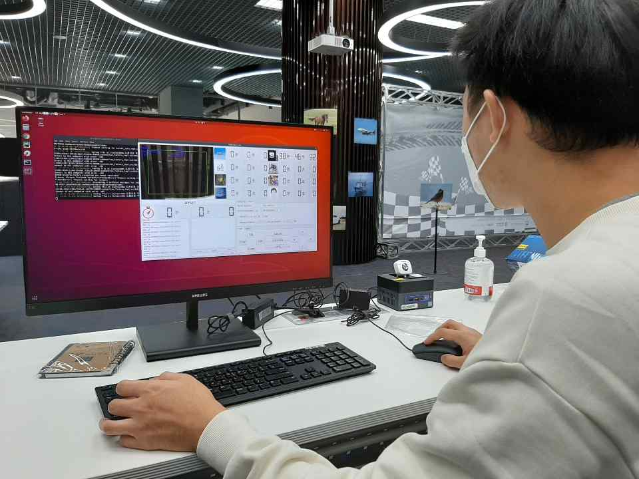
▲ GIST-Intel Korea 'Dreaming Child (AI)' photo for the preliminary
round of the artificial intelligence drone competition

