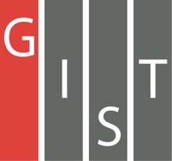
Gwangju Institute of Science and Technology

Official Press Release (https://www.gist.ac.kr/)

Section of Hyo Jung Kim Nayeong Lee
Public Relations Section Chief Senior Administrator
(+82) 62-715-2061 (+82) 62-715-2062

Contact Person Seung Su You, Administrator
for this Article Section of Public Affairs
062-715-2025

Release Date 2020.08.20

GIST signs a business agreement for the development of artificial intelligence with the Jeollanam-do Office of Education and KISTI

□ GIST (Gwangju Institute of Science and Technology, President Kiseon Kim) held a signing ceremony (MoU) for the development of artificial intelligence with the Jeollanam-do Office of Education (Superintendent of Education Seok-woong Jang) and KISTI (Director Hee-yoon Choi).

∘ This agreement ceremony was held for each institution on August 19, 2020, to produce AI science and technology specialists and promote the development of the artificial intelligence industry. The ceremony for the agreement with the Jeollanam-do Office of Education was held at GIST and was attended by President Kim Ki-seon, Superintendent Seok-woong Jang of the Jeollanam-do Office of Education and officials from both organizations. The signing ceremony with KISTI was held on the same day.

∘ The agreement with the Jeollanam-do Office of Education included: ▲ AI, science and technology specialist training program development and operation ▲ AI, science and technology experience and student career counseling cooperation ▲ academic and technical online education cooperation and digital learning cooperation were included in the main agreement with KISTI ▲ joint research for AI technology development ▲ joint use of AI data and infrastructure resources ▲ developing other AI technology support cooperation projects.

□ GIST President Kiseon Kim said, "The AI industry is a new market that the world is paying attention to in the era of the 4th Industrial Revolution. GIST will actively contribute to the development of Korea's AI industry by producing AI specialists through cooperation with the Jeollanam-do Office of Education and KISTI."

□ Jeollanam-do Office of Education Superintendent Seok-woong Jang said, "This agreement with GIST was the first step toward producing creative AI specialists in preparation for the era of the 4th Industrial Revolution. We will generously support and cooperate to train talented people who can actively cope with the AI era."

□ KISTI Director Hee-yoon Choi said, "With this agreement, the two organizations have laid a successful foothold for mutual growth and the development of the AI industry in Korea. We will do our best to secure world-class AI research capabilities through joint research with GIST and explore joint projects with GIST."

∘ Meanwhile, GIST also signed an agreement with Korea University, KAIST, and Gwangju Metropolitan City this year to develop AI fields. GIST is doing its best to secure the highest level of AI technology and produce specialists, which includes being selected as an AI Graduate School supported by the Ministry of Science and ICT.

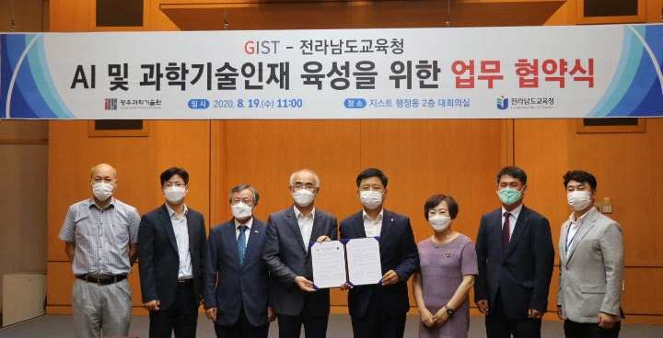
▲ GIST signs a business agreement for the development of artificial intelligence with the Jeollanam-do Office of Education. From left: Artificial Intelligence Research Institute Director JongWon Kim, Office of International and Public Affairs Dean Sung-Gyoo Park, Vice President of Public Affairs Young-jip Kim, President Kiseon Kim, Jeollanam-do Office of Education Superintendent Seok-woong Jang, Director of Future Specialists Hyun-hee Lee, Public Relations Officer Se-jong Park, and Scholarship Officer Won-ho Shin

