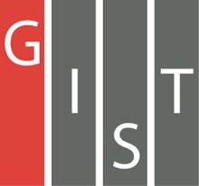
Gwangju Institute of Science and Technology

Official Press Release (https://www.gist.ac.kr/)

Section of Hyo Jung Kim Nayeong Lee
Public Affairs Section Chief Senior Administrator
(+82) 62-715-2061 (+82) 62-715-2062

Contact Person Hyun-joon Chung, Researcher
for this Article GIST Blockchain Economy Center
(+82) 62-715-3140

Release Date 2019.07.22

GIST Blockchain Economy Center signs MoU with ConsenSys, a global blockchain development company

□ GIST (President Kiseon Kim) Blockchain Economy Center (Director Heung-No Lee) has signed a memorandum of understanding (MoU) with global blockchain developer ConsenSys (CTO Ray Valdes) * for consulting, public relations, and technical support.

* ConsenSys was founded in 2015 by Joseph Lubin as a software foundry to develop decentralized software services and applications that operate on the Ethereum blockchain.

□ The MoU ceremony was held at the GIST administrative building on July 18, 2019, and was attended by GIST Vice President Jong-In Song, Professor Heung-No Lee, ConsenSys CTO Ray Valdes, managing partner Guang Zhao, Andami Development Manager, Korea ICT Convergence Association Chairman Yang-soon Baek, and MGEN CEO Min-young Park.

∘ The MoU includes cooperation on ▲ DeSecure blockchain development ▲ human resource training and investment funding ▲ development of necessary dApp applications for transportation, energy, social, and automotive fields, which are necessary for a smart city ▲ planning, operating, and promoting global block chain related events.

□ GIST Blockchain Economy Center is developing a new consensus algorithm called 'Desecure Blockchain' to solve the re-centralization problem of cryptography (bitcoin, etherium, etc.) agreement.

□ GIST Blockchain Economy Center Director Heung-No Lee said, "Through cooperation with global blockchain developer ConsenSys, we expect that intelligent sensors and blockchain technologies that have been developed by GIST will quickly spread around the world in the form of MyData, personal authentication, and popular crypto currencies."

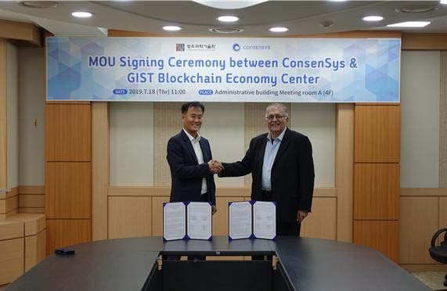
▲ GIST Blockchain Economy Center and ConsenSys MoU signing ceremony

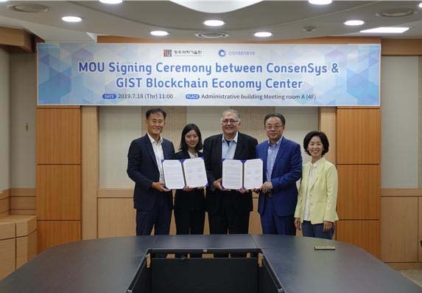
▲ GIST Blockchain Economy Center and ConsenSys MoU signing ceremony group photo

