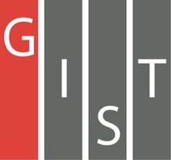
Gwangju Institute of Science and Technology

Official Press Release (https://www.gist.ac.kr/)

Section of Hyo Jung Kim Nayeong Lee
Public Affairs Section Chief Senior Administrator
(+82) 62-715-2061 (+82) 62-715-2062

Contact Person Seung-jae Lee, Administrator
for this Article Section of General Affairs
(+82) 62-715-2102

Release Date 2019.11.15

GIST hosts 26th Anniversary Ceremony

□ GIST (President Kiseon Kim) marked the 26th anniversary of the establishment of GIST during a ceremony at Oryong Hall on November 15, 2019, with a total of 200 people in attendance, including the president, vice-president, professors, researchers, and students.

∘ This ceremony was to celebrate and celebrate the 26th anniversary of the establishment of GIST and to encourage and thank GIST members for their contributions in various areas to develop the organization and to share GIST's vision for the future.

□ GIST President Kiseon Kim said, "In the next 25 years, GIST should research and develop new technologies that will lead future societies, such as artificial intelligence, and train the right people to prepare for new transitions and respond to changes. Like the slogan 'We Are GIST,' we will focus on fostering convergent science talents, economic innovation through startups, and job creation to grow into a proud and socially responsible university."

□ GIST was established in 1993 with the aim of carrying out basic and applied research for the development of advanced science and technology personnel and to revitalize Gwangju with an advanced science and industrial base. GIST started with a master's and a Ph.D. program in 1995 and then started a bachelor's program in 2010.

∘ To actively promote the artificial intelligence-oriented industrial convergence complex development project, which is currently selected as a national project with Gwangju Metropolitan City, GIST established an artificial intelligence research center, which will accelerate the fostering of the highest-quality Ph.D. talent to lead research and development.

∘ GIST is opening an AI graduate school and leading the development of the 'AI Industrial Convergence Complex' project, which is focusing on three specialized areas in the Gwangju area: healthcare, automobile, and energy. GIST is playing a role as a global technology hub through foreign-industrial cooperation and is expected to lay the foundation for fostering the national AI industry by upgrading the local industry and creating an integrated ecosystem for the AI industry.

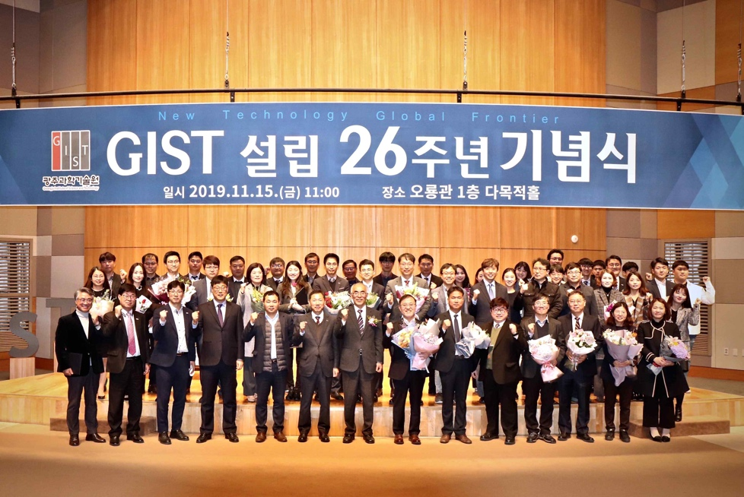
▲ 26th Anniversary Ceremony group photo

