Gwangju Institute of Science and Technology

Official Press Release (https://www.gist.ac.kr/)

Section of Hyo Jung Kim Nayeong Lee
Public Relations Section Chief Senior Administrator
(+82) 62-715-2061 (+82) 62-715-2062

Contact Person Ji-hoon Kim, Administrator
for this Article Entrepreneurship Education Center
(+82) 62-715-2793

Release Date 2020.06.17

GIST selected as a Laboratory Start-up Innovation Group for the Honam region in 2020

□ GIST (Gwangju Institute of Science and Technology, President Kiseon Kim) was finally selected as a laboratory start-up innovation group in the Honam region for the '2020 Public Technology-Based Market Connection Start-up Search Support Project.'

∘ The Laboratory Start-up Innovation Group was established to create quality jobs and contribute to innovative growth through the revitalization of laboratory start-ups centered on young researchers in the laboratory because the need to improve the economic contribution of public research results was raised due to the continuous increase in the size of the government's R&D budget.

□ The GIST Laboratory Start-up Innovation Group will actively discover and support the preliminary lab entrepreneurship team through a partnership with Honam University, and establish a virtuous cycle structure that can lead to actual entrepreneurship in connection with various startup support programs.

∘ A total of 8 teams in the Honam area were selected as the final laboratory entrepreneurship search team this year, and by the end of February 2021, they will be provided education on domestic and foreign start-ups, commercialization feasibility review, and marketability verification.

□ Director Jin Ho Kim of the Entrepreneurship Education Center at the School of Integrated Technology said, "Using the infrastructure and network of support for start-ups at GIST, we will find a competent preliminary real-life start-up team and lead the support for start-ups in the Honam region. Through professional training on the actual commercialization process in the future, we will present a successful model for fostering laboratory start-ups based on public technology research results."

□ The Laboratory Start-up Innovation Group selected by the Ministry of Science and ICT is a project to discover a total of 94 laboratory start-up teams in each region in 2020 to provide specialized entrepreneurship training to review the marketability of each laboratory and review the possibility of commercialization during the entrepreneurship search process. The application will be expanded from graduate students to post-doctoral research institutes and researchers at government-funded research institutes.

∘ The Laboratory Start-up Innovation Group, which is operated by seven universities nationwide including GIST, Korea University, Sungkyunkwan University, Sookmyung Women's University, KAIST, POSTECH, and Dongmyeong University, oversees each region, discovers a preliminary laboratory start-up team with capabilities, and conducts professional start-up education and overseas education for the selected laboratory start-up search teams.

∘ The project period of the laboratory start-up innovation team is from May 2020 to February 2021, and an annual project cost of approximately 600 million won is provided.
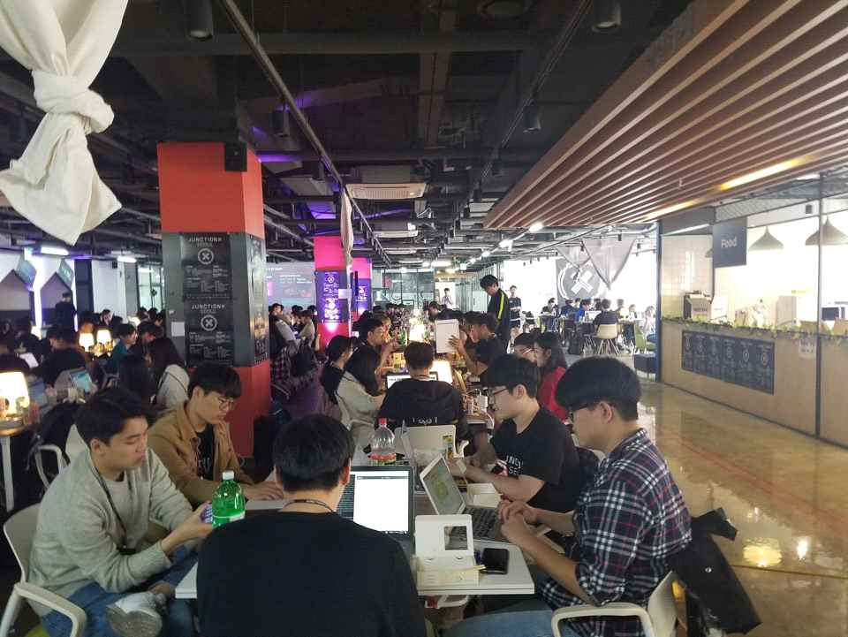
▲ 2019 GIST Entrepreneurship Education Center Junction
X Hackathon Entrepreneurship Training Camp

