Gwangju Institute of Science and Technology

Official Press Release (https://www.gist.ac.kr/)

Section of Hyo Jung Kim Nayeong Lee
Public Relations Section Chief Senior Administrator
(+82) 62-715-2061 (+82) 62-715-2062

Contact Person Deuk-jo Kong, Senior Researcher
for this Article Artificial Intelligence Research Institute
062-715-2934

Release Date 2020.07.30

GIST signs a business agreement with LG Electronics in the field of artificial intelligence

□ GIST (Gwangju Institute of Science and Technology, President Kiseon Kim) Artificial Intelligence Research Institute (Director JongWon Kim) LG Electronics Artificial Intelligence Research Center (Director Ju-Min Kim) signed a mutual business agreement (MoU) for industry-academic cooperation for research and development in the field of artificial intelligence.

∘ The MoU signing between the two organizations took place on July 30, 2020, at LG Electronics' Seocho R&D campus.

□ Under this agreement, GIST and LG Electronics plan to promote the development of national science and technology and improve research capabilities of both institutions through artificial intelligence-oriented technology cooperation.

∘ The main content of the agreement includes ▲ joint cooperation in the project to create an artificial intelligence-centered industrial convergence complex in Gwangju Metropolitan City ▲ co-participating in the field of supporting start-ups based on the 'Dreaming Child (AI)' artificial intelligence competition ▲ promotion and suggestions on the use of LG Electronics' artificial intelligence platform for start-ups in the convergence complex.

□ Through this agreement, LG Electronics plans to jointly participate in the nation's largest 'Dreaming Child (AI)' competition with GIST to conduct preliminary and final rounds in the three major specialized fields (healthcare, automobiles, and energy). The final winners of the competition through the tournament of each selected event will be given awards along with prize money.

∘ LG Electronics Artificial Intelligence Research Center (Director Ju-Min Kim) said, "Through this agreement, LG Electronics will share its ThinQ platform, which contains know-how in artificial intelligence technology, with prospective start-ups in the AI Industrial Convergence Complex, and at the same time we will work together to create new customer values using artificial intelligence in various areas."

□ The 'Dreaming Child (AI)' competition, which will start the preliminary round in earnest in October, will be a demonstration-based competition for specialized AI events selected by the needs of AI companies through a survey. The competition is expected to be the largest in Korea with approximately 234 million won in prize money.

∘ This detailed project for the Ministry of Science and ICT in the field of start-ups for Gwangju's "AI Industrial Convergence Complex Creation Project" organized by Gwangju Metropolitan City and carried out by the AI Industry Convergence Joint Business Group (Director Se-sik Lim), GIST will conduct data, AI, and start-up management education, corporate demand surveys, and competitions.

∘ After qualifying, the competition evaluates the ability to design comprehensive AI convergence services, verification of start-up and joint cooperation items, and verification of technical skills through the tournament. Selected participating teams will be given benefits such as commercialization and start-up consulting, linking support for prototype production costs, matching demand companies, and setting up start-up spaces.

∘ Artificial Intelligence Research Institute Director JongWon Kim said, "This agreement is expected to play a positive role in the start-up of the Gwangju AI Industrial Convergence Complex."

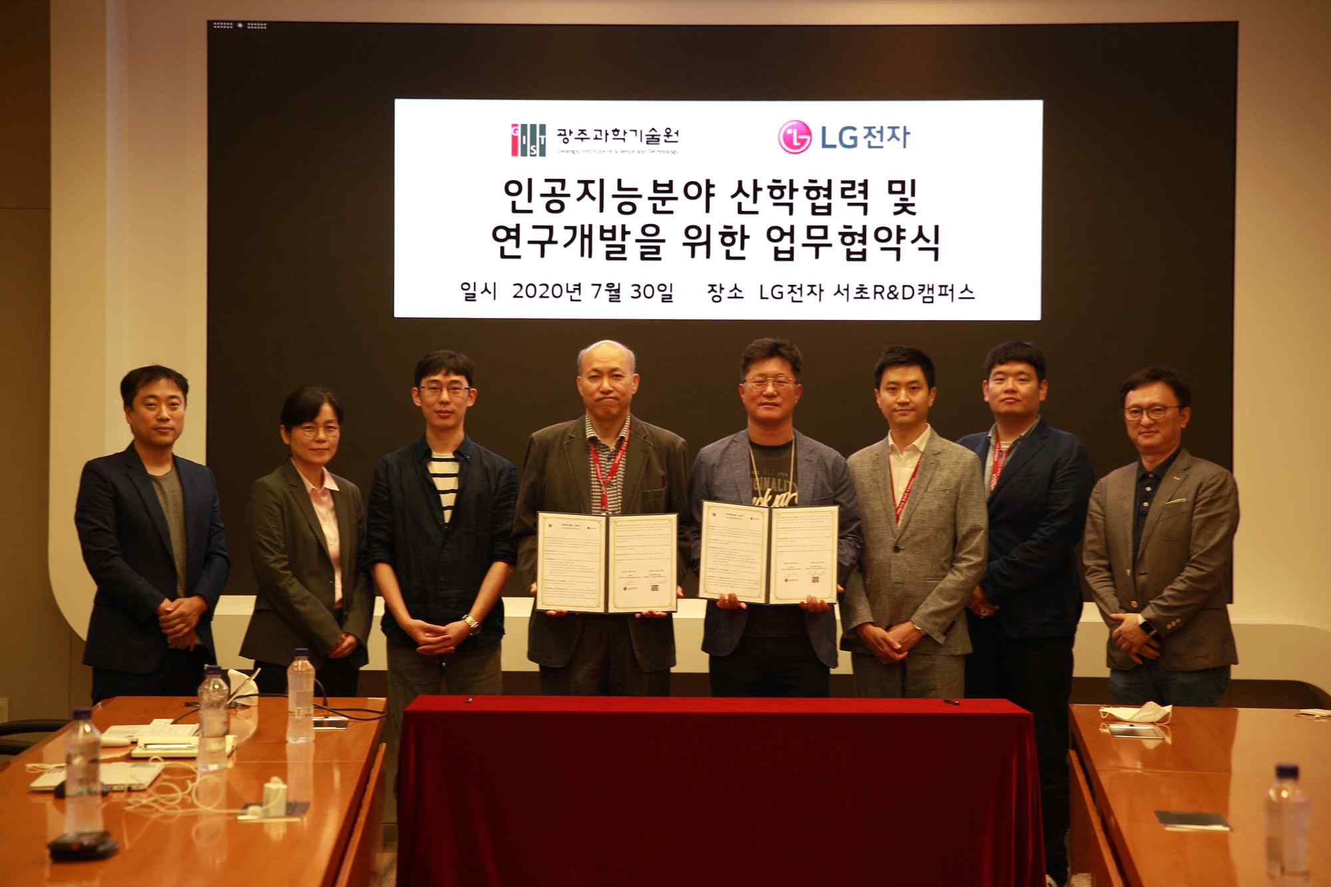
▲ Group photo of GIST-LG Electronics MoU signing

