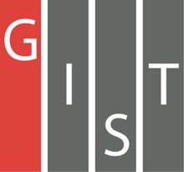
Gwangju Institute of Science and Technology

Official Press Release (https://www.gist.ac.kr/)

Section of Mi-Yeon Kim Nayeong Lee
Public Affairs Section Chief Senior Administrator
(+82) 62-715-2020 (+82) 62-715-2024

Contact Person Mina Choi, Director
for this Article GIST Academy
(+82) 62-715-2622

Release Date 2019.07.02

GIST Techno Management Business Academy holds courses at the National University of Singapore
for it 9th class of students

□ GIST (President Kiseon Kim) Techno Management Business Academy (GTMBA, Managing Professor Sung-Gyoo Park) held the 'GIST-NUS Global CEO Leadership Program' at the National University of Singapore (NUS) for two days on June 26 and 27, 2019.

∘ 34 students who are participating in the 9th GTMBA in 2019 attended the Singapore training program and discussed ways to actively cope with a rapidly changing global paradigm.

□ On the first day, Professor Alex Capri, a senior fellow at NUS Business School, gave a lecture on "Asia's Digital Economy and Global Value Trends and Trade Environment in Asia." On the second day, lectures were held on Singapore as a success model for key issue affecting China's Belt and Road Initiative * policy and Asian business and technology environment.

* China's 'New Silk Road Strategy Initiative' refers to the land area linking China and Europe and the sea route connecting Southeast Asia, Europe and Africa.

□ A student who participated in the program said, "In a rapidly changing business environment, lectures and discussions about global management strategies have helped us prepare preemptive measures for corporate management."

□ GTMBA Managing Professor Sung-Gyoo Park said, "Through the curriculum offered by the GTMBA program, I hope that participating entrepreneurs in our region will have a better understanding of the Asian economic market and the success model of Singapore so that they can pave the way for further growth for their companies in the future."

□ GTMBA opens and operates a top technology management course to serve as a hub of business leaders for business leaders to receive a systematic CEO education program. The 9th iteration of the course began this year in March and meets every Tuesday night at Oryong Hall for 25 weeks.

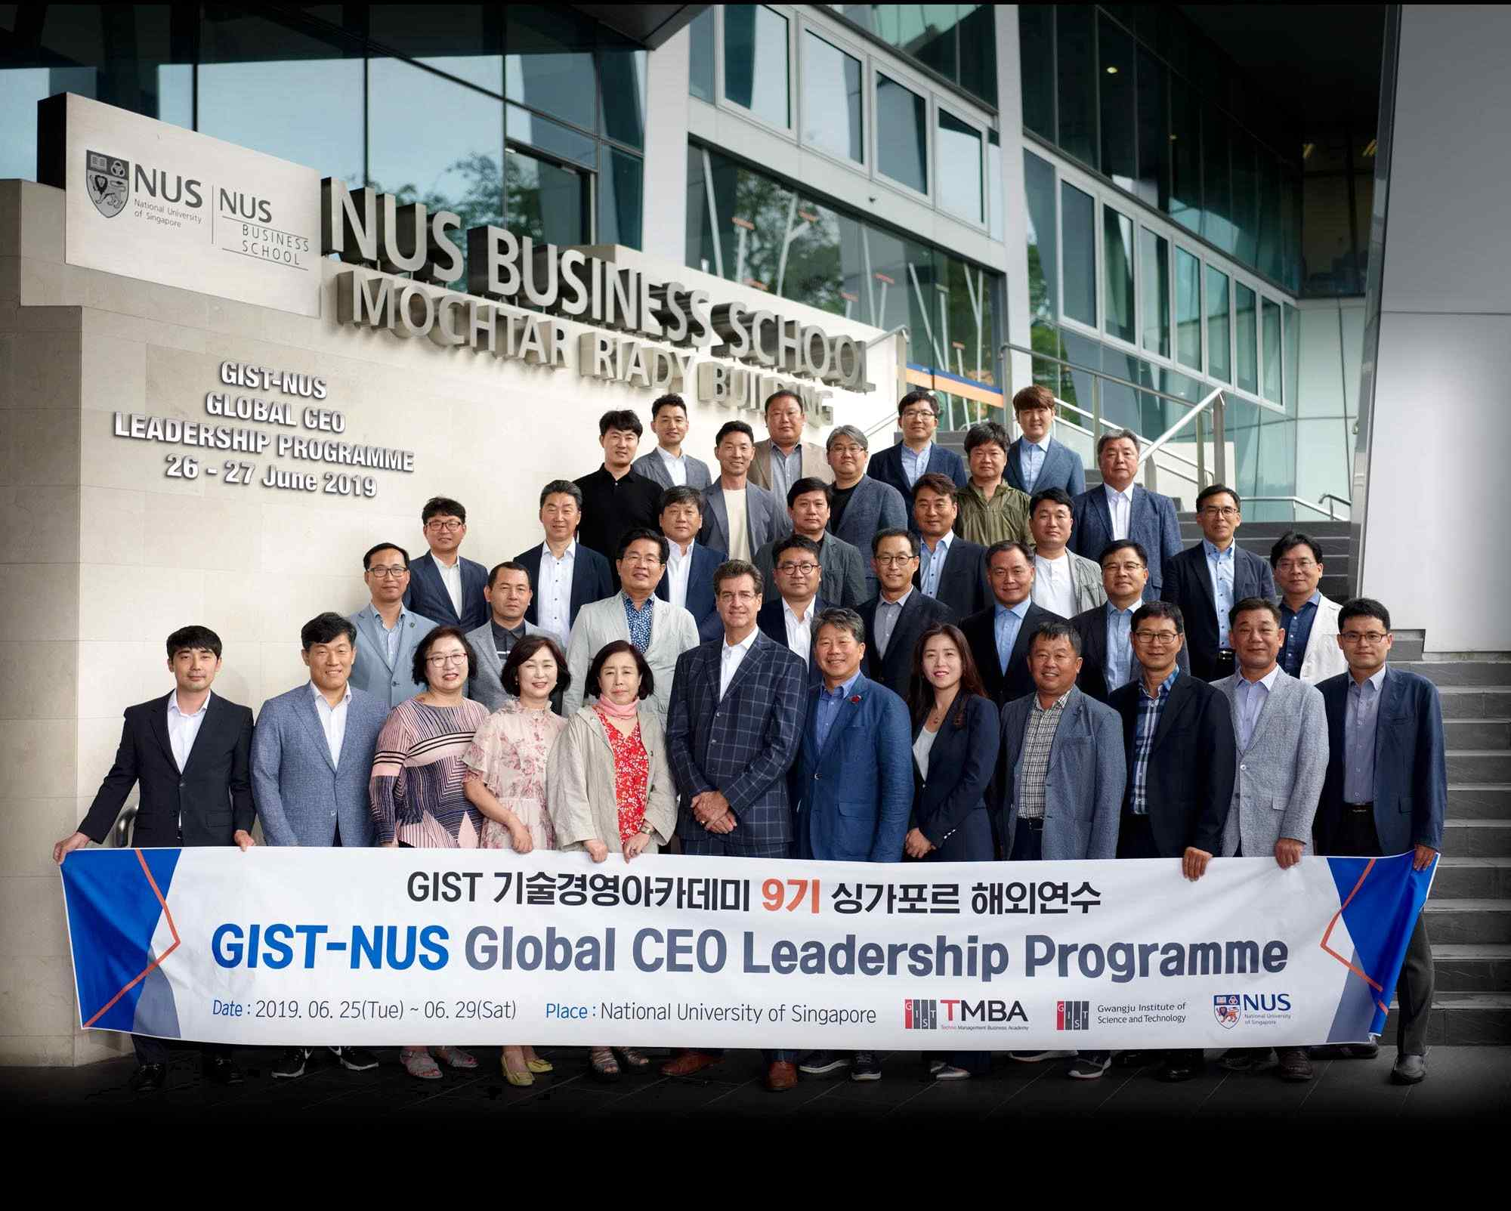
▲ The 9th overseas training session of the
GIST Techno Management Business Academy

