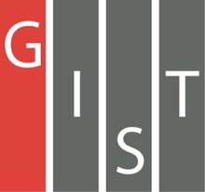
Gwangju Institute of Science and Technology

Official Press Release (https://www.gist.ac.kr/)

Section of Hyo Jung Kim Nayeong Lee
Public Relations Section Chief Senior Administrator
(+82) 62-715-2061 (+82) 62-715-2062

Contact Person GIST Section of Public Affairs
for this Article +(82) 62-715-2061~2063

Release Date 2020.06.29

Post-Corona Era "Conversion Forum 2020"

□ A meaningful forum is held in Gwangju as the whole world is in great turmoil with the COVID-19 pandemic.

∘ The 'Post Corona Age Transition Forum 2020' was designed to review the situation of the community and redefine the value of co-prosperity through new daily stories of education, technology, industry and climate environment in the post-corona era at a time when the country is undergoing a major transformation in all sectors of society due to the influence of COVID-19.

□ The forum will be co-hosted on July 2nd and 3rd by GIST (President Kiseon Kim), Chonnam National University (President Byung-seok Chung), Gwangju National University (President Do-sung Choi), the International Climate and Environment Center (CEO Won-tae Yoon), and the Presidential Committee on Policy Planning, and will be sponsored by the Gwangju-Jeonnam Regional University Presidents's Council.

∘ The forum will be held with the main theme of 'Reconstruction of Regional Values in the Post-Corna Period: New Growth and Transition' and will include △ on the first day of the event on July 2 special sessions 'Corona 19 Regional Diagnosis and Challenges,' 'Post-Corona Era Higher Education Innovation and Regional Coexistence', and 'Post-Corona Era Education Design So No One is Left Out.' △ On the second day of the event on July 3, special sessions 'Ask the President of the Post-Corona Era,' 'The Role of Science and Technology in the Post-Corona Era and Realization of a Korean New Deal,' and ' Response to Climate Crisis in the Post-Corona Era Green New Deal.'

□ In particular, the keynote presentation on the first day of the event will be presented by GIST Professor Joon Ha Kim, a presidential policy planning committee member, and Chonnam National University Professor Yang-hyun Kim under the themes of "Post-Corona Era, Crisis and Opportunity" and "Post-Corona Era, Future of University Education," respectively.

∘ In the evening of the same day, a meeting will be held between the President's Direct Policy Planning Committee and the President of Gwangju and Jeonnam University. The meeting will be attended by President Dae-yeop Cho, four policy committee members, including the president's direct policy committee chairman, Gwangju and Jeonnam regional presidents' council, International Climate Environment Center CEO Won-tae Yoon, and KEPCO Establishment Promotion Committee Chairman Eui-joon Yoon.

□ GIST President Kiseon Kim said, " COVID-19 suddenly made a lot of changes in our daily lives, such as the simultaneous economic hits and the spread of a social-distancing culture. Now is the time to explore a new direction for life after COVID-19, and we hope that this forum will be a meaningful place to redefine regional values and find new opportunities for future growth from a transitional perspective in the post-corona era."

□ For more inquiries about attending the forum, please contact the GIST PR team (062-715-2960).

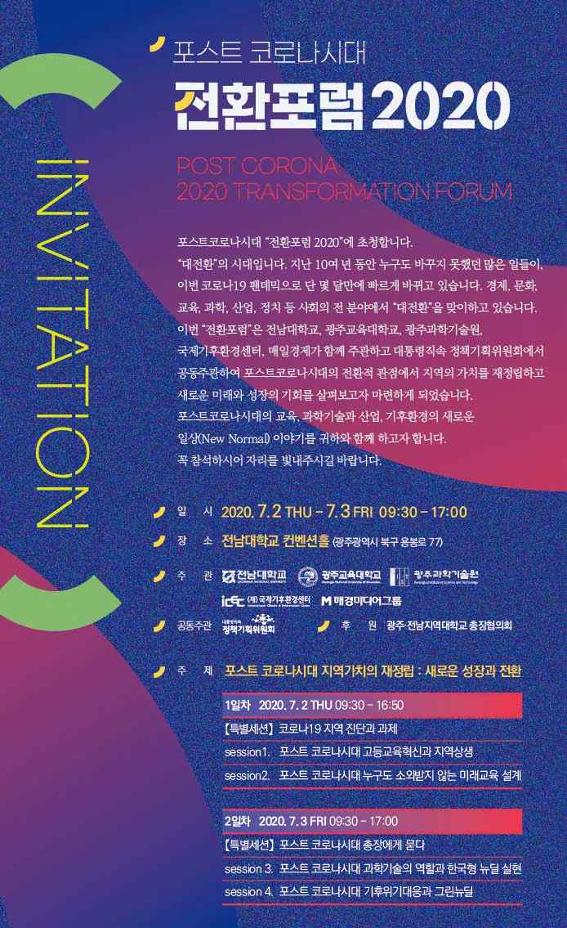

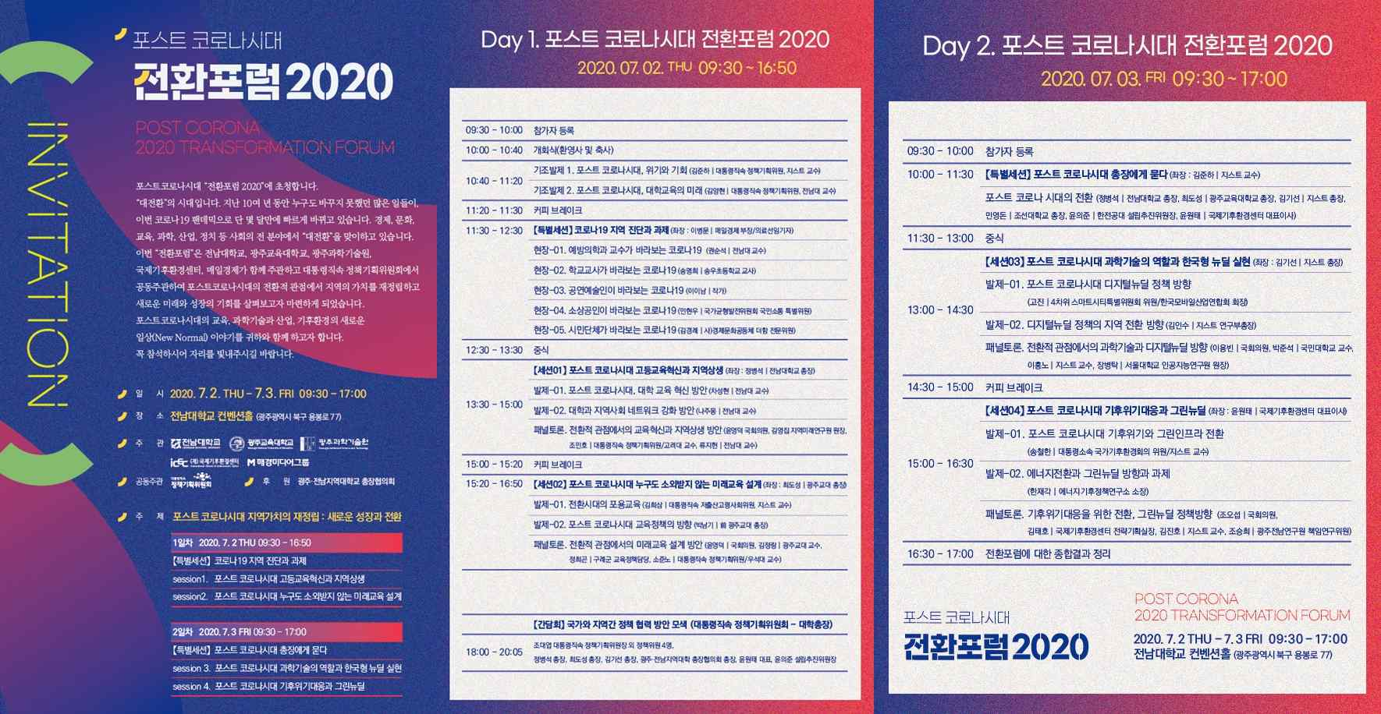

▲ Post-Corona Era Conversion Forum 2020 event poster and leaflet

