Gwangju Institute of Science and Technology

Official Press Release (https://www.gist.ac.kr/)

Section of Hyo Jung Kim Nayeong Lee
Public Affairs Section Chief Senior Administrator
(+82) 62-715-2061 (+82) 62-715-2062

Contact Person Yeo-jin Kim PM
for this Article GTI Business Support Center
(+82) 62-715-2591

Release Date 2019.10.11

GIST holds signing ceremony for the
Innopolis Campus Promotion Project

□ GIST (President Kiseon Kim) Technology Institute Business Support Center held a signing ceremony on October 8, 2019, with 23 (preliminary) start-up companies selected for the 2019 GIST Innopolis Campus Development Project for 'Supporting MVP Production' and 'Program for Product Improvement.'

∘ 2019 GIST Innopolis Campus Development Project aims to spread entrepreneurialism within the university by utilizing the innovation resources of the R&D Special District Promotion Foundation and by promoting university start-up education with actual start-ups and jobs. It is a project that induces entrepreneurial spirit by connecting prospective entrepreneur candidates, identifying entrepreneurship items, and provides follow-up support after establishment by providing technology and resources.

□ Sixteen teams for 'Supporting MVP Production' selected through courses such as Start · Jump Course, Deep Education I & II, Academy of Product Improvement, IR Contest, etc. for the 2019 GIST Innopolis Campus Development Project, and seven teams for 'Program for Product Improvement' for follow-up growth support, will receive 5 to 20 million won for support.

□ GIST Business Incubator Director Seong-geun Ki said, "It is hoped that the GIST Innopolis Campus Fostering Project will serve as a foundation for Gwangju and Jeonnam to create global companies."

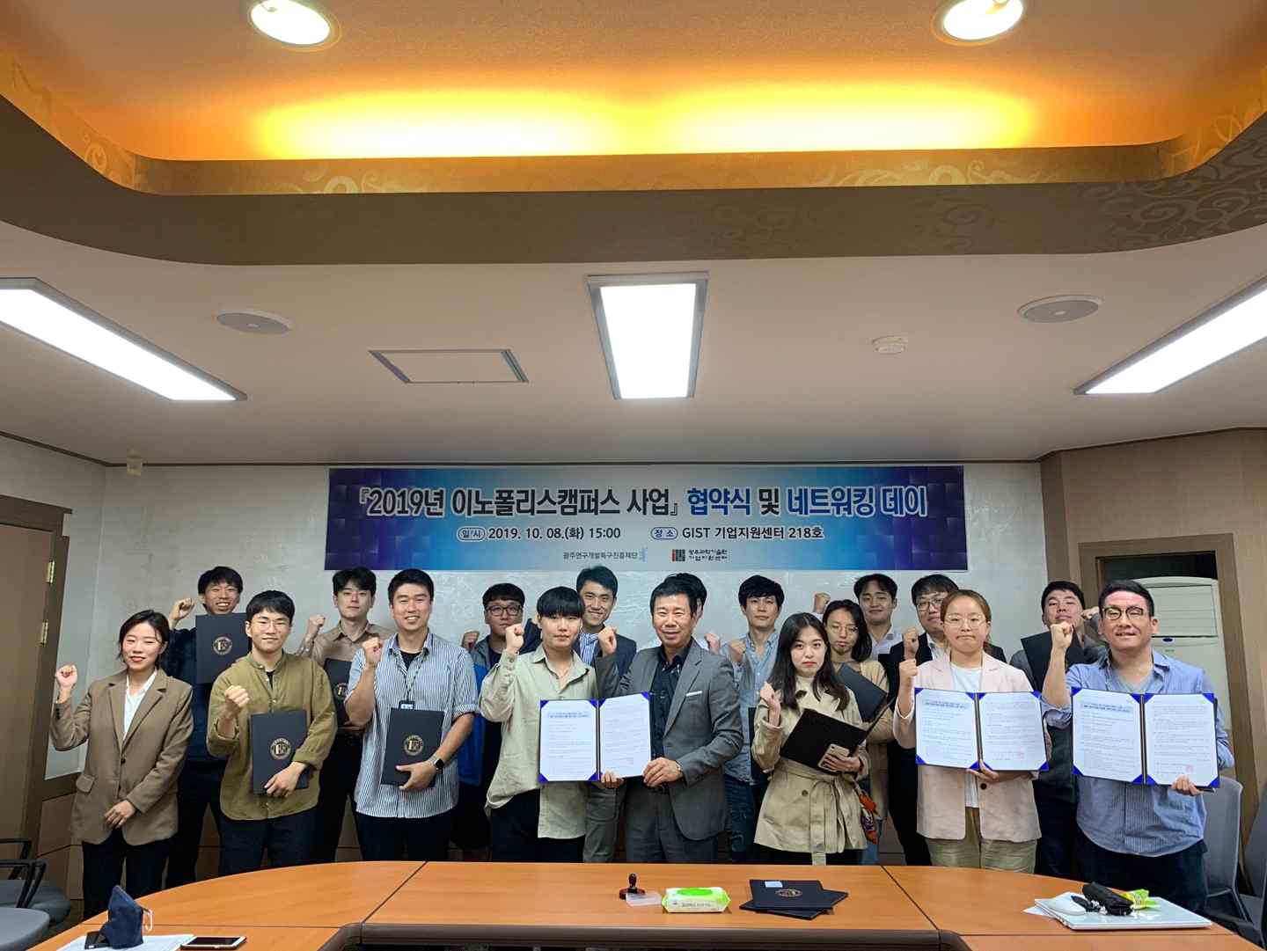
Group photo: 2019 GIST Innopolis Campus Development Project

