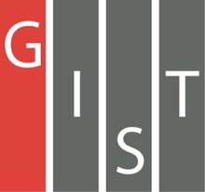
Gwangju Institute of Science and Technology

Official Press Release (https://www.gist.ac.kr/)

Section of Hyo Jung Kim Nayeong Lee
Public Relations Section Chief Senior Administrator
(+82) 62-715-2061 (+82) 62-715-2062

Contact Person Ji-eun Kim, Administrator
for this Article GIST Business Incubator
062-715-2595

Release Date 2020.08.13

GIST signs a business agreement with companies selected for the entrepreneurial support project that were found through technology start-up scouting

□ GIST (Gwangju Institute of Science and Technology, President Kiseon Kim) Technology Institute's Business Incubator (Director Sung-keun Ki) held a signing ceremony on August 12, 2020, with three companies selected as technology start-up scouts for the "Start-up Challenge Package Support Project." In the future, GIST plans to cooperate with the operation of specialized programs for corporate growth and business execution, technology development and management consulting, industry-university joint research, and will support businesses through the entrepreneurial support project.

∘ The signing ceremony was held at the GIST Business Support Center and was attended by GIST Business Incubator Director Sung-keun Ki, Genome & Company Co., Ltd., CEO Ji-soo Bae and Han-soo Park, Green System Co., Ltd., CEO Yong-young Shin, KS Optical Co., Ltd., CEO Geun-sik Kim.

□ The 2020 Start-up Challenge Package Support Project is a commercialization support project consisting of two tracks: a global linkage support project and a technology start-up scouting operation. In particular, in the field of technology start-up scouting, scouts operated by the corporate support center discover companies with promising technological capabilities through scouting activities.

∘ ▲ For the global linkage support project, 30 companies linked to Microsoft, a global company in the IT industry, were selected and a total project cost of KRW 6.15 billion won was allocated to support excellent start-up companies. ▲ The technology start-up scouts select 3 companies with support of 100 million won per company.

∘ The selected company must attract a certain amount of investment within the agreed period to meet the qualification requirements, and the role of the entrepreneurial support center is very important because it must discover companies with promising technology and marketability and even attract actual investments. In 2019, six companies were discovered and attracted an investment of about 8.6 billion won, and in 2020, three companies were discovered and attracted an investment of 50 billion won.

□ Among the companies selected in 2020 ▲ Genome & Company Co., Ltd., is a startup company of Professor GIST that researches and develops biological products that can prevent and treat diseases based on human microbiome. It is attracting investment and plans to go public this year. ▲ KS Optical Co., Ltd., is a global company with world-class patented technology for core materials of high refractive glasses, and it is attracting large-scale investments from abroad. ▲ Green System Co., Ltd., possesses original technology for completely biodegradable natural plastic materials that can solve the problem of disposable plastics and micro-plastics, and it is recognized for its post-plastic technology.

□ GIST Business Incubator Director Sung-keun Ki said, "Through active scouting activities at the GIST Business Incubator, we will find companies with high technical skills and systematically support these start-ups to grow to the next level by successfully attracting investments for them."

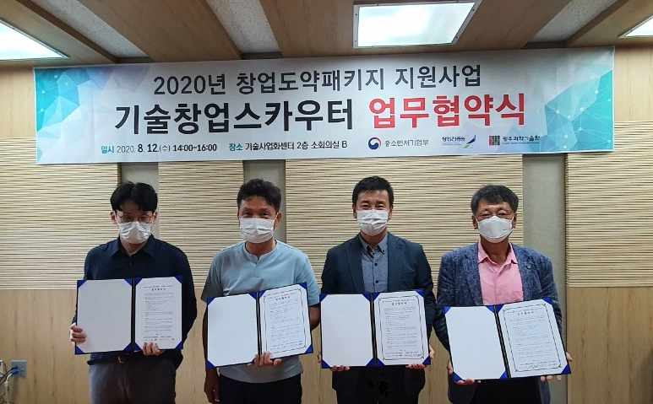
▲ From the left, officials from Genome & Company Co., Ltd., CEO of Green System Co., Ltd., GIST Business Incubator Director, and CEO of KS Optical Co., Ltd.

