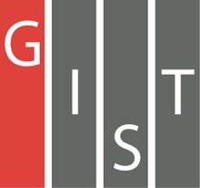
Gwangju Institute of Science and Technology

Official Press Release (https://www.gist.ac.kr/)

Section of Mi-Yeon Kim Nayeong Lee
Public Affairs Section Chief Senior Administrator
(+82) 62-715-2020 (+82) 62-715-2024

Contact Person Jin-suk Choi, Administrator
for this Article Section of Public Affairs
(+82) 62-715-2026

Release Date 2018.09.21

GIST invites children from remote islands to participate in a program to experience
science-culture

□ GIST (President Seung Hyeon Moon) – In celebration of GIST's 25th anniversary this year, the 'GIST Invitation to Children from Remote Islands' was held in cooperation with local communities in the spirit of social responsibility to help spread knowledge and experience to children from marginalized regions.

∘ In particular, this event will be held from September 19 to 20, 2018, in joint collaboration with the National Gwangju Science Museum, the Korea Energy Corporation, the National Museum of Asian Culture, the National Asian Cultural Center, and the Asian Cultural Center to promote scientific technology and cultural arts to children from Goheung * .

* Goheung has recently been classified as the most serious 'high risk of loss' in Jeonnam, which is in danger of extinction due to low fertility and an aging population. The average number of students in three of the invited elementary schools was about 15.

□ Participants during the event included 41 elementary school students and 12 teachers, and they ▲ visited research facilities at GIST and participated in special GIST Science School lectures ▲ experienced the Science Investigation Unit and BioLab Science Experience at the National Gwangju Science Museum ▲ visited the Energy Experience Hall and built a solar windmill at the Korea Energy Corporation ▲ participated in various scientific and cultural programs, including cultural experience activities at the National Asian Cultural Center/Asian Cultural Center.

□ GIST Vice President Hor-Gil Hur said, "GIST has been trying to spread scientific culture for underprivileged children in our region. We hope that these children will be able to develop their dreams and hopes without any alienation from learning opportunities through various scientific culture programs hosted by the GIST Social Contribution Team."

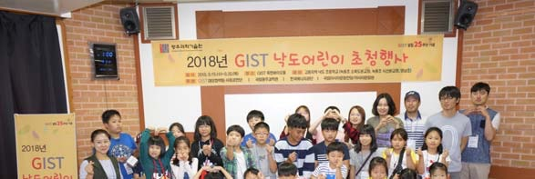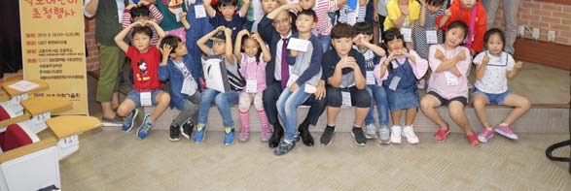
▲ Photo of students and teachers participating in the event

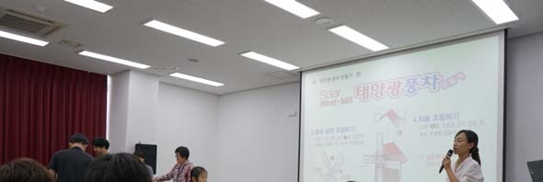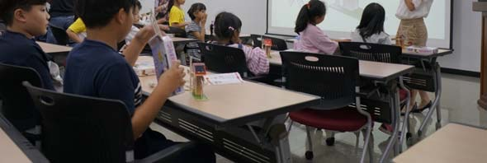
▲ Participants making solar windmills at the Korea Energy Corporation

