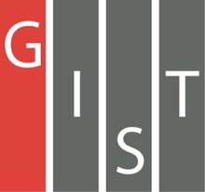
Gwangju Institute of Science and Technology

Official Press Release (https://www.gist.ac.kr/)

Section of Mi-Yeon Kim Nayeong Lee
Public Affairs Section Chief Senior Administrator
(+82) 62-715-2020 (+82) 62-715-2024

Contact Person Bo-young Sohn, Researcher
for this Article Aging-Friendly Industrial Support Center
(+82) 70-7710-4904

Release Date 2019.07.02

GIST's Aging-Friendly Industrial Support Center holds a ceremony to mark the launch of a joint project with GIST and Chonnam
NationalUniversity Hospital

□ GIST (President Kiseon Kim) – On June 28, the Aging-Friendly Industrial Support Center (Director Sung Jo Kwak, Professor in the School of Integrated Technology) held a ceremony to commemorate the launch of the "GIST-Chonnam National University Hospital" cooperation project at the Aging Friendly Industrial Support Center in Gwangju.

∘ The ceremony was attended by about 80 officials from local industries and academic associations, including GIST President Kiseon Kim, Gwangju City's Future Industrial Policy and Strategic Industries Director Chi-sun Lee, Chonnam National University Hospital Director Sam-yong Lee, Chonnam National University Hospital Chair Shin-seok Lee, Gwangju Techno Park Director Sung-jin Kim, and Gwangju Municipal Medical Center 2 Director Chang-soo Park. The ceremony included a business operation report, a welcome speech, a senior mentor group completion ceremony, and a ribbon cutting ceremony.

□ GIST President Kiseon Kim said, "Starting with today's inauguration ceremony, we hope to take a big step forward as opportunities for the aging-friendly industry in the region continues to grow. We will work with the both institutions to build a biometric data center for the elderly, to create an artificial intelligence-based demonstration center infrastructure, to create a theme park for dementia prevention, and conduct further exploration of joint research projects by researchers from the two institutions."

∘ Aging-Friendly Industrial Support Center Director Sung Jo Kwak said, "Currently, the center is preparing to move forward to promote aging-friendly industries in the era of the 4th Industrial Revolution. The center plans to pursue various cooperative projects by sharing state-of-the-art research technologies such as VR, AR, AI, and big data developed by GIST, as well as medical science research infrastructure and medical-related big data held by Chonnam National University Hospital."

□ The Aging-Friendly Industrial Support Center began construction in 2008 and finished in 2012 with the support of Gwangju Metropolitan City and the Ministry of Industry to energize aging-related industries, which is widely regarded as a new growth engine. After it's official opening in May of 2013, the center was operated exclusively by GIST was, but it has been operating jointly with Chonnam National University Hospital since 2019.

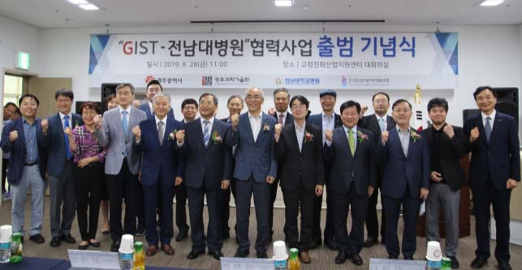
▲ Groups photo of the "GIST-Chonnam National University Hospital" cooperation project

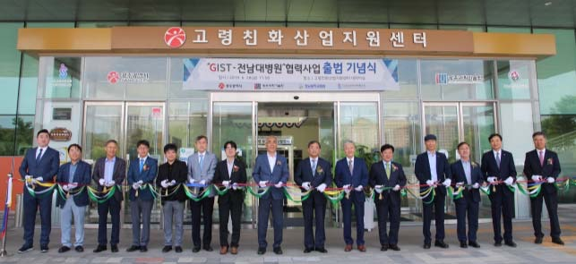
▲ Ribbon-cutting for the "GIST-Chonnam National University Hospital" cooperation project

