Gwangju Institute of Science and Technology

Official Press Release (https://www.gist.ac.kr/)

Section of Hyo Jung Kim Nayeong Lee
Public Relations Section Chief Senior Administrator
(+82) 62-715-2061 (+82) 62-715-2062

Contact Person Soo Jung Park, Administrator
for this Article Section of Public Affairs
+(82) 62-715-2022

Release Date 2020.06.26

Israeli Ambassador H.E. Chaim Choshen visits GIST

□ Israeli Ambassador H.E. Chaim Choshen visited GIST (Gwangju Institute of Science and Technology, President Kiseon Kim) on June 25, 2020, to discuss ways to promote cooperation between Israel and GIST for education, research, and start-up exchanges.

∘ GIST sends students interested in starting a business to the 'Entrerenewership & Innovation Program' run by Israel's Technion Institute of Technology every year to help them complete entrepreneurship training and acquire a sense of global and practical entrepreneurship.

□ The visiting group led by the Israeli ambassadors listened to the status of GIST student start-ups from the GIST Technology Institute (GTI), which supports start-ups and technology transfers, and visited SOS Lab Co., Ltd., a GIST student start-up developing lidar, to listen to business models and the operation status of start-up companies.

∘ In addition, time was provided to visit the Meta-Evolutionary Machine Intelligence Laboratory (Professor Chang Wook Ahn) at the AI Graduate School, which opened in March, to view research equipment and the facilities and to learn about its excellent research results.

□ President Kiseon Kim said, "In addition to committing to promote academic and human exchanges with Israel, which has abundant experience and technology, this has become an opportunity to further strengthen practical cooperation. In particular, we will contribute to the revitalization of the local economy by fostering customized start-up talents by sharing experiences in creating an ecosystem for start-ups with Israel, a world-renowned entrepreneurship nation."

□ Ambassador H.E. Chaim Choshen graduated from Hebrew University in Israel and has served as Ambassador of Israel to Korea since 2016 after serving as the Director of the Asia Pacific Department of the Ministry of Foreign Affairs, the Director of Southeast Asia of the Ministry of Foreign Affairs, and the Deputy Secretary of the Japanese Embassy in Japan.

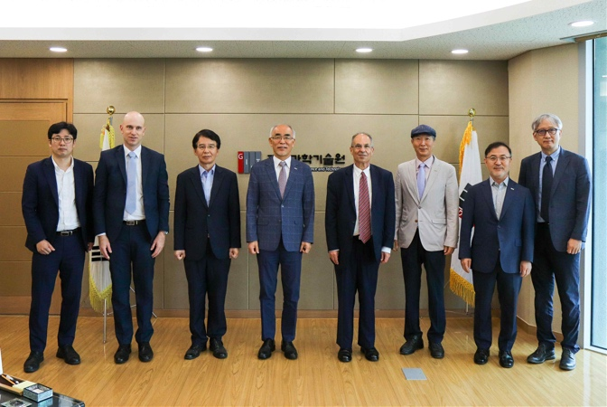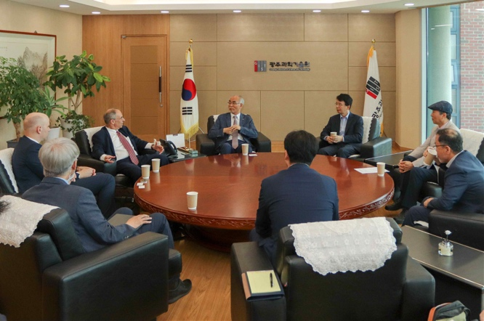
▲ Photo 1. Greeting the Israeli Ambassador at the President's office

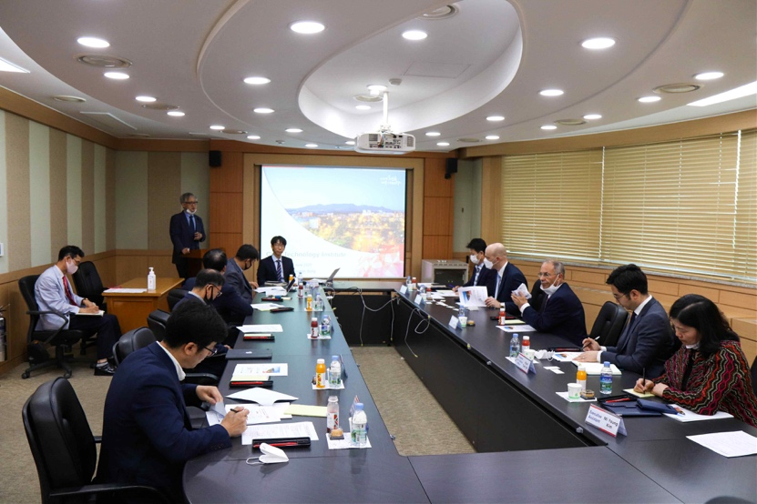
▲ Photo 2. Meeting between the Israeli Ambassador's
visiting group and GIST representatives

