Gwangju Institute of Science and Technology

Official Press Release (https://www.gist.ac.kr/)

Section of Mi-Yeon Kim Nayeong Lee
Public Affairs Section Chief Senior Administrator
(+82) 62-715-2020 (+82) 62-715-2024

Contact Person Professor Gi-hoon Lee
for this Article GIST Center for Security Science and Technology
(+82) 62-715-5208

Release Date 2018.12.31

GIST signs 'Military Science and Technology Agreement' with the Army School of Infantry'

□ GIST (President Seung Hyeon Moon) has signed an agreement with the Army School of Infantry (Dean Man-ki Kim) on December 28, 2018.

□ In accordance with the agreement, GIST and the Army School of Infantry will conduct joint research and development of cutting-edge science and technology, including laser and electronic warfare, and will participate actively in academic activities held by each organization.

∘ In addition, the two organizations are planning to promote human exchanges for advice on policy development, along with training for master's and doctorate degrees along with working-level training to foster professionalism in army personnel.

□ President Seung Hyeon Moon said, "From the agreement, we expect that the two organizations will set up a cooperative research center, which will be a valuable opportunity to create innovative best practices for civil and military research cooperation for national security."

□ GIST is a research organization that represents Korea's security, science and technology field and has established and operated the GIST­ Center for Security Science and Technology at the end of 2016 to actively cooperate with domestic and international organizations.

∘ In 2016, GIST was appointed as a specialized research institute by the Defense Agency in the field of electronic warfare, high-performance laser, next-generation energy, military communications and networks. GIST has has specialized laboratories, such as the Advanced Photonics Research Institute (APRI) specializing in lasers. In November 2018, 40 officers from the army, navy and air force participated in a training program for defense equipment.

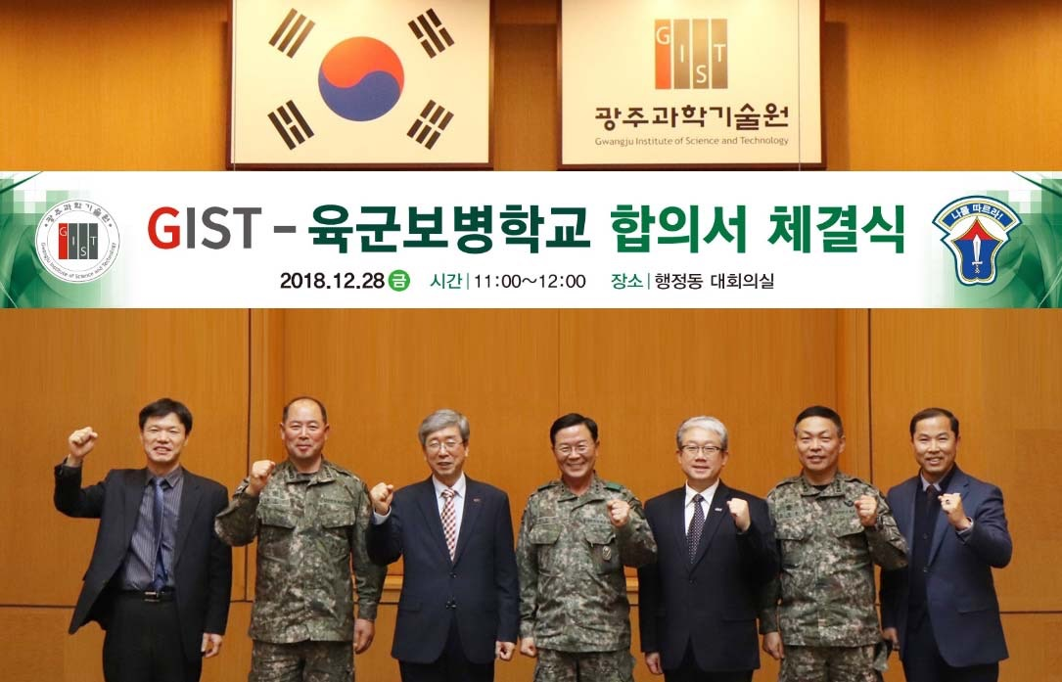
▲ From left: GIST Center for Security Science and Technology Director Hyyong Suk, Administrative Director of the Army School of Infantry Colonel Jong-soon Baek, GIST President Seung Hyeon Moon, ç, International and Public Affairs Dean Yong Chul Kim, former Director of the Army School of Infantry Colonel Eung-jo Do, and GIST Center for Security Science and Technology Professor Gi-hoon Lee

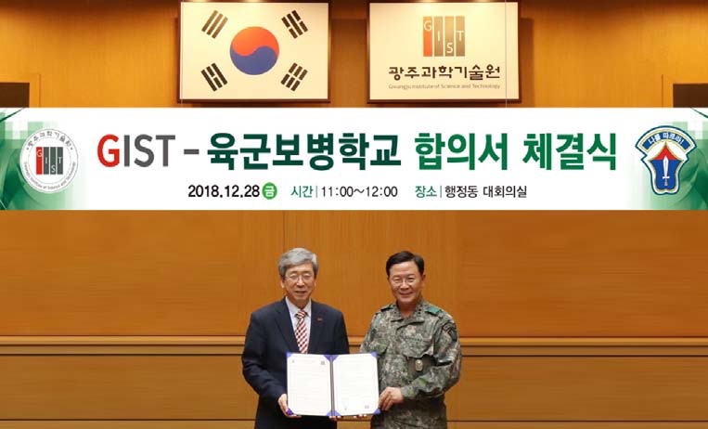
▲ GIST President Seung Hyeon Moon and GIST President Seung Hyeon Moon

