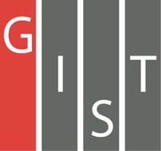
Gwangju Institute of Science and Technology

Official Press Release (https://www.gist.ac.kr/)

Section of Hyo Jung Kim Nayeong Lee
Public Affairs Section Chief Senior Administrator
(+82) 62-715-2061 (+82) 62-715-2062

Contact Person Seung-yoon Lee, Administrator
for this Article Artificial Intelligence Research Institute (+82) 62-715-6852

Release Date 2019.10.24

GIST to host AI DAY (International
Conference on Artificial Intelligence)

□ GIST (President Kiseon Kim) Artificial Intelligence Research Institute (Director Hyuk Lim, School of Electrical Engineering and Computer Science professor) will host the 2019 GIST AI DAY event on October 26, 2019, at GIST College C-104.

∘ This event includes international experts in AI, such as Professor Larry Davis (University of Maryland), Researcher Ming You Liu (Anbi Dia), Professor Anjo Kanazawa (UC Berkeley), Professor Philip Isola (MIT), and Dr. Mohammed (XNOR.AI). GIST Professors Hae-Gon Jeon, Kang Il Kim, and Prof. Jonghyun Choi will attend and discuss the latest research trends and technologies in the field of computer vision, which is an area of artificial intelligence.

□ GIST Artificial Intelligence Research Institute Director Hyuk Lim said, "This AI DAY event will be an in-depth meeting with world-class AI scholars to discuss the latest technologies and future prospects in the rapidly evolving field of computer vision. This International Conference on AI will serve as the basis for future cooperation for the creation of AI Industrial Convergence Complex."

□ GIST is preparing to open the AI Graduate School in 2020 to foster global AI talent and is scheduled to operate as a five-year integrated master's and doctorate program for AI software, hardware, advanced learning, technology demonstrations, and entrepreneurship-oriented field research based on empirical data and infrastructure.

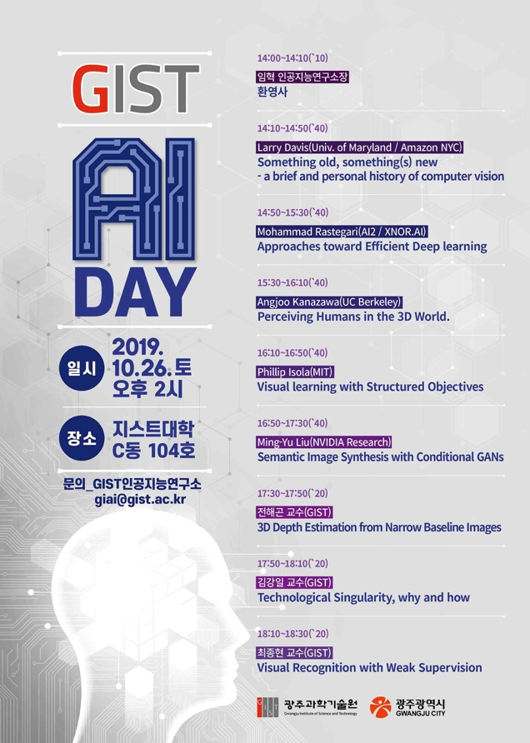
GIST AI DAY poster

