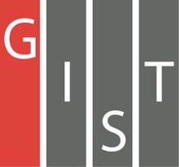
Gwangju Institute of Science and Technology

Official Press Release (https://www.gist.ac.kr/)

Section of Mi-Yeon Kim Nayeong Lee
Public Affairs Section Chief Senior Administrator
(+82) 62-715-2020 (+82) 62-715-2024

Contact Person Yong-hyuk Choi, Administrator
for this Article Section of Public Affairs
(+82) 62-715-2025

Release Date 2018.09.19

GIST signs an industry-academic exchange agreement to spread scientific culture
and revitalize local economy

□ GIST signed an industry-academic exchange agreement to promote the local economy and spread the scientific culture by establishing an integrated system of excellent scientific, industrial, and research resources in the region.

∘ This agreement was signed on September 19, 2018, in the Gwangju Buk-gu Office, with participation from 11 industry-academic related organizations, including GIST, Advanced Industrial Managers' Council, Bonchon Industrial Complex, Gwangju Information Culture Industry Promotion Agency, Korea Industrial Park Gwangju Jeonnam Regional Office, Gwangju R&D Special Zone, Gwangju Techno Park, National Gwangju Science Museum, Eastern Education Support Agency, and the Gwangju Jeonnam KOTRA Support Team.

□ Major provisions of the agreement includes ▲ creation of 4th Industrial Revolution mini-cluster ▲ operating science programs for local residents ▲ support for strengthening the competitiveness of SMEs.

∘ 30 SMEs and Gwangju Technoparks will build a mini-cluster to support local companies engaged in AI, AR, VR, and drone technologies that will lead the 4th Industrial Revolution, and they will support technologies such as production and industrial property rights.

∘ In addition, the 11 organizations agreed to actively cooperate in establishing a good environment for enterprises, such as consulting and supporting businesses, while attracting and exploring joint exchange and cooperation projects such as government joint public works projects and science programs for new industrial activity.

□ In November, there will be a variety of science experience programs from GIST, the National Gwangju Science Museum, and the Eastern Education Support Agency, such as 'Leave Science Excursion' and 'Visit Neighborhood Science Class.'

□ GIST Vice President Hor-Gil Hur said, "Through this agreement, we will establish an efficient industry-academic cooperation network based on GIST's outstanding research capabilities to enhance the image of high-tech and academic cities in the region and expand scientific culture."

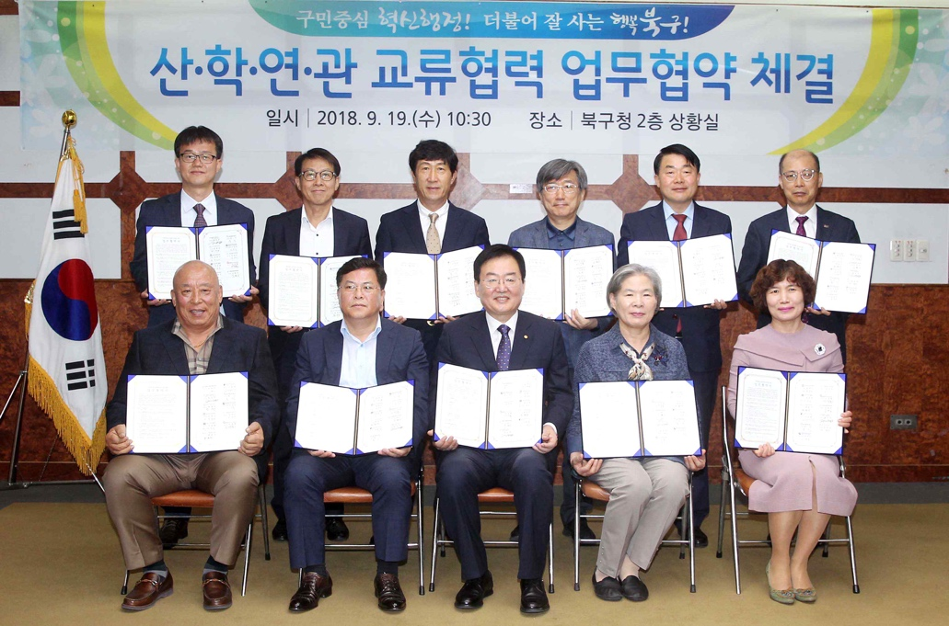
▲ On September 19, a total of 11 organizations, including GIST,
signed the industry-academic exchange agreement

