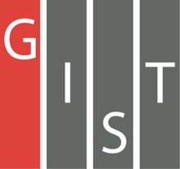
Gwangju Institute of Science and Technology

Official Press Release (https://www.gist.ac.kr/)

Section of Hyo Jung Kim Nayeong Lee
Public Relations Section Chief Senior Administrator
(+82) 62-715-2061 (+82) 62-715-2062

Contact Person Tae-wan Kim, Administrator
for this Article Business Support Center
062-715-6302

Release Date 2020.12.09

GIST Business Support Center hosts joint start-up competition for science and technology universities

□ GIST (Gwangju Institute of Science and Technology, President Kiseon Kim) successfully held the 7th annual start-up competition on December 4, 2020, for the five science and technology specialized universities.

∘ To prevent the spread of Covid-19, this competition was conducted online for investors interested in investing with undergraduates at the five specialized universities of GIST, KAIST, DGIST, UNIST, and POSTECH.

∘ In particular, under this year's theme of' Beyond the Pandemic!', discussions were held on the direction of development of student start-up culture, how to proceed with existing student start-ups, and continuing start-up technological achievements after Covid-19.

□ The opening remarks were delivered by GIST Science and Technology Application Research Center Director Woo-jin Park, and then the GIST student start-up company SOS LAB CEO Ji-sung Jeong gave a special lecture and talk on start-ups. A start-up talk concert was given by employees of the secretariat of Jung Xun X Seoul, which leads the Korean student start-up culture.

∘ In the afternoon, a competition was held in earnest by the representative teams of each university to introduce technology start-up ideas. From April to October of this year, each university held its own preliminary contest. The the two best teams from each university were selected, so a total of ten technology stat-up teams presented their business plans and participated in the final competition.

□ The grand prize of this year's final contest was awarded to the KAIST Aldeva Team (CEO Jin-oh Kim), and the excellence prize was awarded to the GIST Hello Healthy Team (CEO Ho-yeon Lee and Hyeong-jun Jang) and the DGIST DG Care Team (CEO Seung-sun Yoo). The team that won the excellence award was awarded 2.5 million won in start-up capital and the GIST Research Group President's Award.

□ The GIST Hello Healthy Team (CEO Ho-yeon Lee and Hyeong-jun Jang) won the excellence award and realized their idea through the 'GIST Start-up Idea Contest' (2020 Winner Team) and the the 'Mock Startup Program (GSS). If strong business models and items are verified, they want to challenge technology start-ups.

∘ CEO Ho-yeon Lee and Hyeong-jun Jang said, "Through this competition, it was a great opportunity to measure the level of technology start-up teams at other universities, to have opportunities for teamwork with other universities through mutual exchanges, and to directly propose our ideas to the investment review department to verify the business details."

□ GIST Business Support Center Director Byung-kwan said, "In the midst of the worsening Covid-19 situation, we did our best to protect students and prevent infections so that the contest, which is the venue of a festival between specialized universities in science and technology, can be safely completed. We will spare no effort to ensure that this meaningful event, which marks its seventh anniversary, will continue in the future."

□ competition will trigger a competition of good faith among universities specializing in science and technology. Starting with the first event in 2014 to discover and support excellent technology start-up teams, universities specializing in science and technology alternate hosting this event every year.

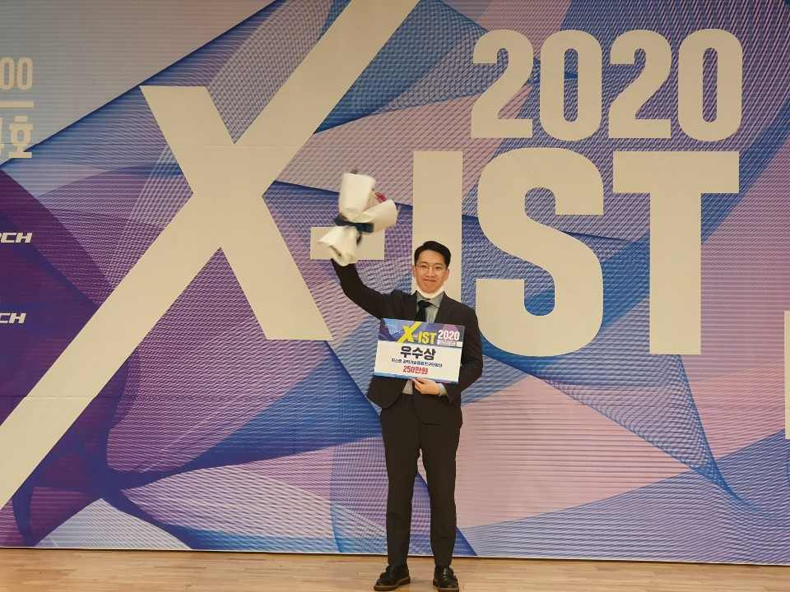
▲ Excellence award recipient: GIST Hello Healthy Team,
Co-CEO Ho-yeon Lee (Ph.D. course in chemistry)

