Gwangju Institute of Science and Technology

Official Press Release (https://www.gist.ac.kr/)

Section of Hyo Jung Kim Nayeong Lee
Public Affairs Section Chief Senior Administrator
(+82) 62-715-2061 (+82) 62-715-2062

Contact Person Professor Gi-hoon Lee
for this Article GIST Center for Security Science and Technology
(+82) 62-715-6841

Release Date 2019.10.02

GIST hosts seminar with the Army Infantry School on science and technology convergence for future combat development

□ GIST (President Kiseon Kim) hosted a seminar with the Army Infantry School (Director: Army General Man-gi Kim) to discuss ways to innovate the military's state-of-the-art science and technology development structure with civilian-military cooperation.

∘ The seminar was held on October 2, 2019, at GIST Oryong Hall and hosted by the Dean of Research In S. Kim with more than 150 participants from each institution attending, including Army General Man-gi Kim who is the Director of the Army School of Infantry, to discuss the results of the collaboration between GIST and Army School of Infantry to improve future infantry power.

□ This seminar presented the concept of Reachback Technology *, a large-scale command-and-control system design and the associated technical requirements.

* Reachback Technology: support technology to remotely control and operate units, equipment, and materials by screens from a rear command post

∘ Additional topics were also discussed: ▲ concept and development trend for the research on the Warrior Platform for infantry in the future ▲ the need to create a consortium to develop the infantry Warrior Platform ▲ GIST advanced research institutes with infantry-related technology had presentations and discussions with private companies regarding the future development direction of unmanned communications systems powered wirelessly using lasers.

□ GIST Dean of Research In S. Kim said, "A new approach is needed to embrace the rapidly changing trends of science and technology development, such as shortening the technology development life cycle and accelerating the convergence of high-tech technologies in the era of the 4th Industrial Revolution. I hope that this 'model of research cooperation between private research institutes and the military' army will be an exemplary case of civilian and military research cooperation that can be gradually shared among all research institutes in Korea."

□ GIST was selected as a specialized research institute in 2016 by the Defense Agency in four areas: high-performance laser, electronic warfare, military communication and networks, and next-generation energy. In addition, GIST has the Advanced Photonics Technology Research Institute (APRI), which is a world-class laser research institute.

∘ Since July, GIST researchers and active duty soldiers, along with the Army Infantry School, were working together to create the actual requirements needed for future infantry forces, and GIST Center for Security Science and Technology (Director Kyi Hwan Park of the School of Mechanical Engineering) has recently started operations.

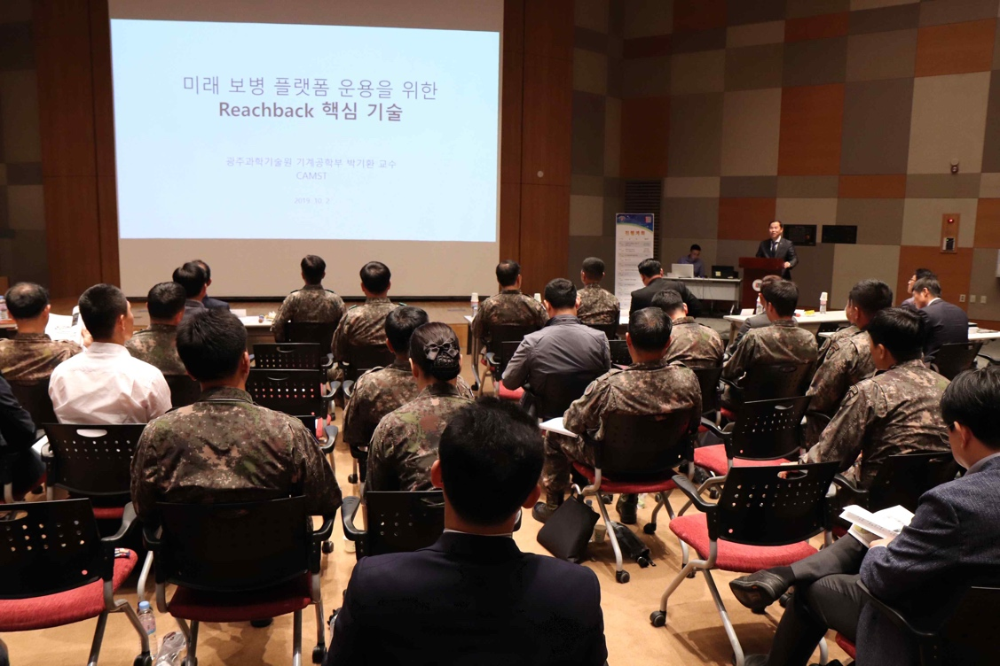
▲ Science and Technology Convergence for Future Combat Development Seminar photo

