Gwangju Institute of Science and Technology

Official Press Release (https://www.gist.ac.kr/)

Section of Hyo Jung Kim Nayeong Lee
Public Affairs Section Chief Senior Administrator
(+82) 62-715-2061 (+82) 62-715-2062

Contact Person Shin-ho Kang, Team Leader
for this Article Gwangju Senior Technology Center
(+82) 70-7710-4903

Release Date 2019.10.17

GIST installs self-developed walking analysis
system at the Gwangju Veterans Hospital

□ GIST (President Kiseon Kim) – The Gwangju Senior Technology Center held an even at the Gwangju Veterans Hospital (Director Jae-hyu Kim) celebrated the "Artificial Intelligence Joint Walking Analysis" to lead the development of artificial intelligence healthcare technology during the 4th Industrial Revolution era.

∘ For the "Artificial Intelligence Joint Walking Analysis," will set up its own walking analysis system at the Gwangju Senior Technology Center and the Gwangju Veterans Hospital. By measuring the data of the 25 joint position values of walkers passing through the installed road, the length of stride, front/left/right balance of the gait, left/right balance of the body, and gait speed are compared and analyzed. This results in meaningful results that can be used to construct an AI healthcare system that checks and preemptively advises on health conditions.

□ Research will be conducted from the commemoration event until December 2020. If the data is analyzed through artificial intelligence technology, it will not only predict and respond to senile diseases by the person's steps, but also the analysis of fall and dementia-related risks for the elderly and the establishment of a customized rehabilitation system.

□ GIST President Kiseon Kim said, "Securing data with a clear purpose is a pilot project for the Gwangju AI Innovation Cluster project, and will show that AI-healthcare can be a successful growth engine. In the future, we will continue to pay attention to the spread of research results developed by GIST in the fields of automobiles, energy, cultural contents, national defense and maritime, to promote AI-based startups and R&D."

∘ Gwangju Veterans Hospital Director Jae-hyu Kim said, "Through joint research with GIST, we hope that both institutions will take a step forward as leading institutions in the 4th Industrial Revolution in the field of artificial intelligence and medical care."

□ GIST started construction of the Gwangju Senior Technology Center in 2008 with the support of Gwangju Metropolitan City and the Ministry of Industry to revitalize the pro-aging industry, which is attracting attention as a new growth engine. Since its opening in May 2013, it was operated solely by GIST until last year. However, from 2019, GIST has formed a consortium with Chonnam National University Hospital and social cooperatives for the aging, leading the research and development and commercialization of industrial-medical cooperation in the AI-medical field.

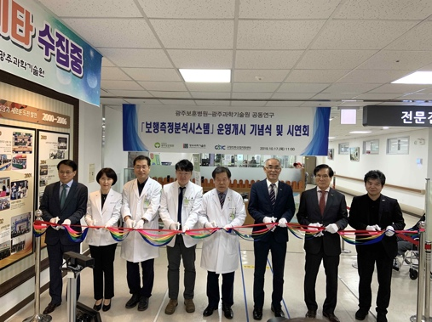
▲ [Photo 1]: "Artificial Intelligence Joint Walking Analysis" tape-cutting ceremony

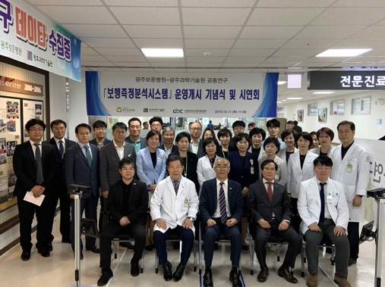
▲ [Photo 2]: "Artificial Intelligence Joint Walking Analysis" group photo

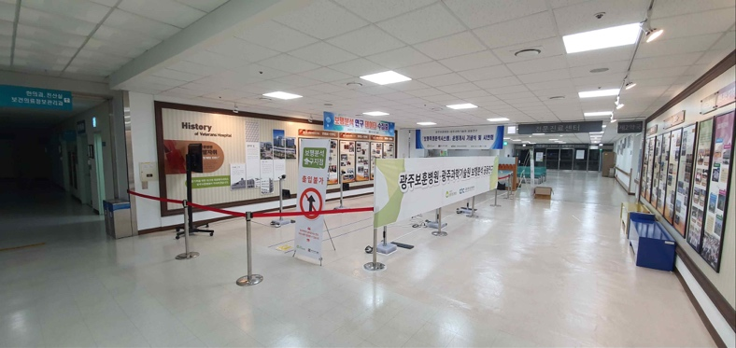
▲ [Photo 3]: Location of joint research system for walking analysis in the Gwangju Veterans Hospital

