Gwangju Institute of Science and Technology

Official Press Release (https://www.gist.ac.kr/)

Section of Hyo Jung Kim Nayeong Lee
Public Relations Section Chief Senior Administrator
(+82) 62-715-2061 (+82) 62-715-2062

Contact Person Ji-hye Park, Administrator
for this Article Section of Graduate Admissions
062-715-3952

Release Date 2020.09.28

GIST Graduate School hosts online Open Lab

□ GIST (Gwangju Institute of Science and Technology, President Kiseon Kim) Graduate School held an online Open Lab to promote the second round of admissions for the 2021 Spring Semester.

∘ To prevent the spread of COVID-19, the Graduate School Open Lab was conducted online on using Zoom by seven departments, including the School of Materials Science and Engineering, School of Mechanical Engineering, School of Life Sciences, Department of Physics and Photon Science, Department of Chemistry, Department of Biomedical Science and Engineering, and the School of Integrated Technology. The online Open Lab for the School of Electrical Engineering and Computer Science, School of Earth Sciences and Environmental Engineering, and the Artificial Intelligence Graduate School will be held on October 5 (Monday).

∘ Each GIST Graduate School laboratory was well-received by the prospective applicants with the introduction of excellent faculty and research fields, Q&A time, and interviews with professors.

□ The period for the second round of GIST Graduate School admissions for the 2021 Spring Semester is from October 8 to 21, and applications are available online (https://www.gist.ac.kr/uadm/). The announcement of the final successful candidates is scheduled for December 11.

□ Office of Admissions Dean Keun-Young Kim said, "By attracting talented students to every graduate program, including the newly established Artificial Intelligence Graduate School, we can expect to enhance research competitiveness and improve the research environment. If you are a student who is interested in the master's or doctoral programs at GIST, I hope that this online Open Lab event will help you decide your career path."

□ GIST, which marks its 27th anniversary this year, has been strengthening itself as a research-oriented university and was ranked fourth in the world by QS World University Rankings for 2020 in the category of 'citations per faculty.'

∘ GIST provides various benefits such as full tuition exemption of payments and subsidies for meals to help support master's and doctoral students into becoming future scientists and engineers. Graduate students will receive full payment while attending school, and every month they will receive a certain amount for tuition, school meal subsidies, and individual research incentives.

∘ Also, students with excellent admission grades are selected for "Presidential Scholarships" and receive an additional 1.5 million won per semester. In addition, students who enter the Ph.D. program after entering the state-funded or science institute scholarship program can be incorporated as specialized research personnel within the scope of the quota of the Military Manpower Administration.

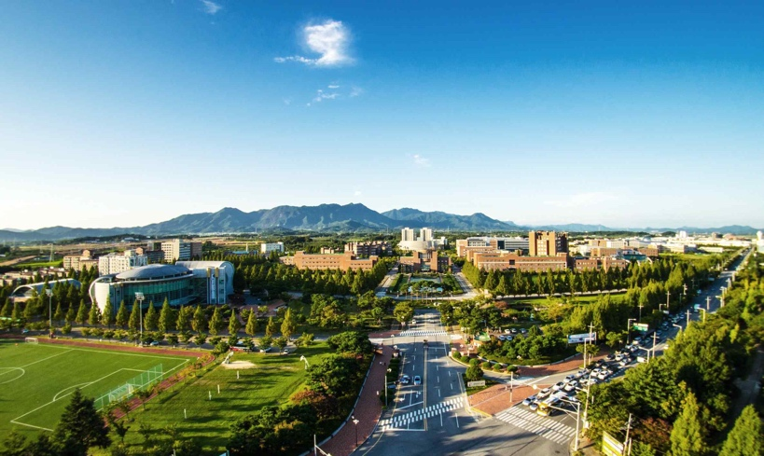
▲ Photo 1. GIST

