Gwangju Institute of Science and Technology

Official Press Release (https://www.gist.ac.kr/)

Section of Hyo Jung Kim Nayeong Lee
Public Relations Section Chief Senior Administrator
(+82) 62-715-2061 (+82) 62-715-2062

Contact Person Hyejin Lee, Administrator
for this Article Section of Public Affairs
062-715-2026

Release Date 2020.07.31

GIST Social Contribution Team holds online invitation event for future scientists

□ GIST (Gwangju Institute of Science and Technology, President Kiseon Kim) Social Contribution Team (Office of International and Public Affairs Dean Sung-Gyoo Park) held an 'Online Invitation Event for Future Scientists' for elementary school students living on islands before summer vacation starts in order to contribute to the community and strengthen cooperation.

∘ The invitational two-day science-culture event was converted into an online event because of COVID-19, and this event was promoted to support a total of 70 students at schools from Haenam Valley Elementary School and Goheung Pungyang Elementary School so that they can continue to learn from science books and video education programs produced by the GIST Learning Zone.

□ The GIST Learning Zone is a knowledge sharing volunteer activity in which GIST students visit a local children's centers and perform after-school activities. Currently, it is conducted as a real-time, online learning event due to COVID-19.

∘ This time, video contents such as science kit experiment videos and science series produced by GIST learning mentors were actively supported for online education of Haenam Valley Elementary School and Goheung Pungyang Elementary School students.

∘ In particular, the school provided cartoon-based textbooks and science experiment kits for students to experience and understand the scientific principles.

□ GIST Social Contribution Director Sung-Gyoo Park said, "We hope future scientists will develop their dreams and desires to become scientists through this online event. In the future, GIST Social Contribution Team will lead the development of community science education culture and lead the education of students."

∘ A science teacher at Haenam Valley Elementary School said, "Although the science experiment activities were conducted in each classroom in the aftermath of COVID-19, it was a valuable opportunity for children to experience science through various experiments."

□ The GIST Social Development Team is actively engaged in various projects to support the local community, including: GIST Science Outreach Program (GSOP), GIST Science School, science book donations, the Hope Water Purifier, Global Science Camp (international), Science Camp (domestic), GIST Science Outreach Program, and ICT Volunteer program.

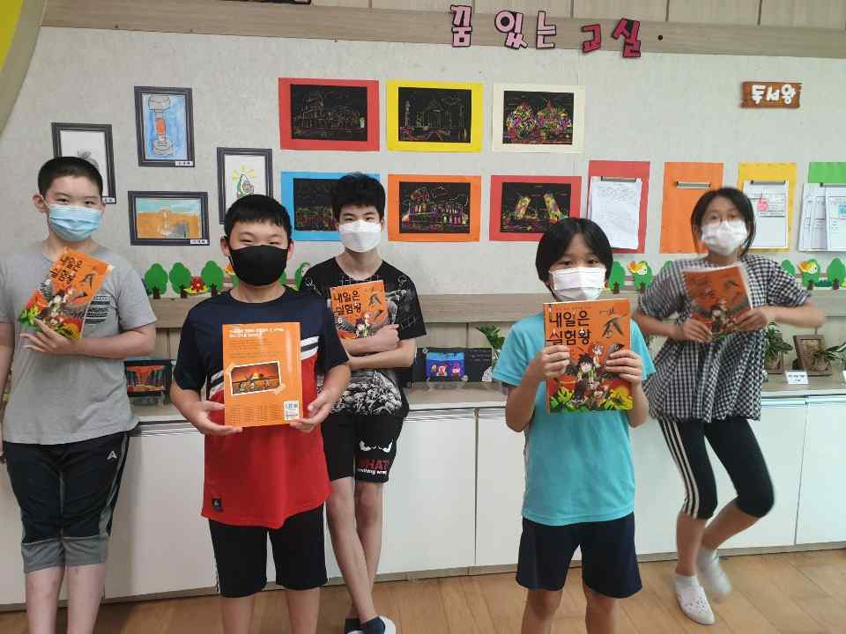
▲ GIST donates science books to Haenam Valley Elementary School

