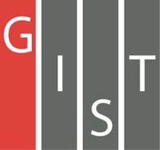
Gwangju Institute of Science and Technology

Official Press Release (https://www.gist.ac.kr/)

Section of Hyo Jung Kim Nayeong Lee
Public Affairs Section Chief Senior Administrator
(+82) 62-715-2061 (+82) 62-715-2062

Contact Person Public Affairs Team
for this Article (+82) 62-715-2061~2063

Release Date 2019.11.11

[GIST Science and Culture Week] Held a variety of events to spread scientific culture and create an atmosphere for communication and empathy

□ GIST (President Kiseon Kim) successfully held various scientific and cultural events with the participation of local people from November 1 to 9, 2019.

∘ To promote GIST's role in nurturing talented scientific minds and to promote scientific culture that is beneficial to the community and to spread compassion, communication, and growth throughout the region, GIST members held a variety of events with the local community.

□ With the successful conclusion of this year's event, GIST will host more programs and scientific and cultural events to create a happy future with technology and unite the region with communication, happiness, and growth.

∘ For the start of the event, on November 1 and 2, a conference was held to build the foundation for creative idea commercialization using artificial intelligence (AI) and the internet of things (IoT) ▲ AI & IoT Makerton event was held on November 4th for students and the public interested in starting businesses ▲ GIST held a startup night event on November 5 to present educational and support programs for startups ▲ 2019 Gwangju Startup Forum Roadshow at GIST event under the theme of "Startup City, Gwangju! Embrace artificial intelligence." ▲ The GIST CEO Forum was held for local entrepreneurs such as students and researchers, prospective founders, related organizations and startup companies could gather in one place.

∘ The Feast of Light ▲ The Media Facade Show, the largest in Gwangju, provided viewers with a unique attractions by creating a dynamic media performance that was projected on the outer wall of the Central Library over three days from Wednesday to Friday, which was produced by GIST Korea Culture Technology Institute with its own technology. The Media Facade Show provided fresh sights of the GIST's past, present, and artificial intelligence with about 7 minutes of video.

∘ November 6 ▲ GIST Movie Day, which was held on the second floor of the Central Library along with pre-arranged events such as face painting and prize drawings, showed the animated science film "Big Hero," which was attended by more than 300 people, including students, children, and families.

∘ November 7 ▲ Student Festival ▲ GIST Learning Zone Exchange Event were held. The Student Festival had concerts by GIST students, invited singers, and fireworks. More than 200 people participated in the GIST Learning Zone Exchange Event, including 16 local children's centers and their students along with the GIST student volunteers.

∘ November 8 ▲ Cultural Events ▲ Sponsorship Night ▲ 2019 GIST Conference (alumni event) were held. At the cultural event, the male quartet Forestella performed at an outdoor stage, which was attended by about 1,000 people. On the sponsorship night, 80 people including GIST supporters, regional CEOs, and GTMBA graduates attended the event to strengthen GIST's relationship with the community. About 300 alumni and students attended the GIST Conference, an event held by the alumni association to discuss and build ties for community development and included lectures from guest speakers as well as awards for alumni.

∘ November 9 ▲ Golden Bell Science Competition hosted by the Buk-gu Office was held at the GIST Gymnasium. 108 teams of 4th and 6th grade students and parents from Buk-gu elementary schools participated in two groups, and the participants were tense and enthusiastic to win the honor of the Golden Bell. The second Golden Bell honor was given to Eui-hyun Park, a sixth grader at Ilgok Elementary School.

□ GIST President Kiseon Kim said, "This year was the first 'GIST Science and Culture Week,' and it was made more meaningful because it included informative programs and events that could be enjoyed together by both GIST members and the local community. Going forward, GIST will continue to contribute to the spread of a scientific culture as well as community development through various community participation programs."

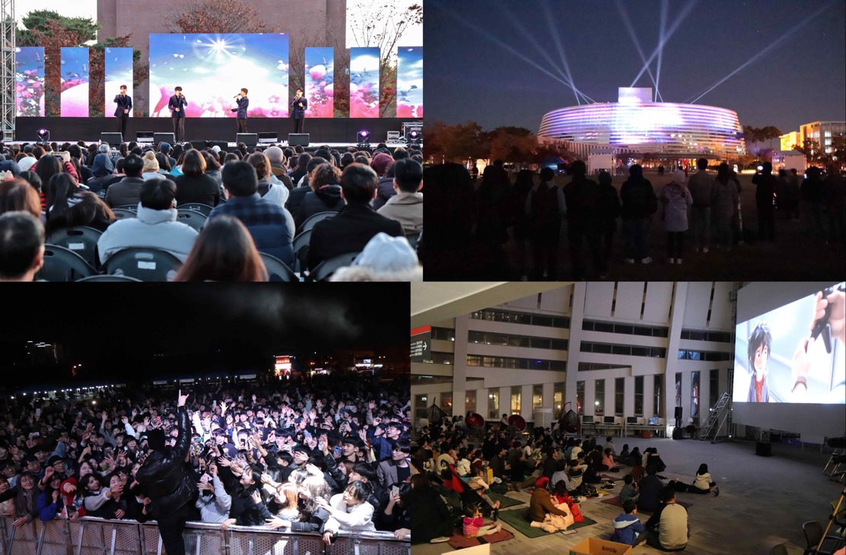
▲ [Clockwise from the top left] GIST Science and Culture Week: Forestella Cultural Event performance, Media Facade Show, GIST Movie Day, and Student festival

