Gwangju Institute of Science and Technology

Official Press Release (https://www.gist.ac.kr/)

Section of Mi-Yeon Kim Nayeong Lee
Public Affairs Section Chief Senior Administrator
(+82) 62-715-2020 (+82) 62-715-2024

Contact Person Seo-Young Kang, Administrator
for this Article International Environmental Research Institute
(+82) 62-715-3393

Release Date 2018.07.19

GIST International Environmental Research
Institute introduces the GIST Hope Water Purifier

□ GIST (President Seung Hyeon Moon) – The International Environmental Research Institute (IERI, Director In Seop Chang) participated in the '2018 Korea Climate Technology Competition' in Seoul from July 18 to 20, 2018, and introduced the 'GIST Hope Purifier,' a non-electric water purification system based on a gravity driven membrane to supply clean drinking developing country support affected by global warming.

□ The '2018 Korea Climate Technology Competition,' sponsord by the Ministry of Science and ICT, the Green Technology Center, the Korea Research Institute of Chemical Technology, and the National Research Foundation of Korea, is meant to promote various research results and innovative R&D achievements, explore global markets, and share information.

∘ On the first day, GIST Professor Joon Ha Kim (former director of IERI) of School of Earth Sciences and Environmental Engineering gave a lecture on the development of the climate industry and popularization of climate technology. He was awarded by the Ministry of Science and ICT in recognition of his contributions.

∘ Professor Joon Ha Kim said, "With this award, I will do my best to strengthen cooperation with climate technology based on global technology, and I will lead the popularization of future climate technology by expanding the area of climate industry to various academic fields."

□ The 'GIST Hope Water Purifier' introduced in this competition is the result of research carried out with the support of IERI. Starting from Cambodia in 2006, the purifier uses a gravity driven membrane to purify water and has supported developing countries with insufficient drinking water.

∘ The purifier can remove particulate pollutants and germs present in the water with high efficiency, and it can be used continuously for at least 10 years without special maintenance, making it easy for local people to use.

∘ The GIST water purifier is a customized small-scale water treatment system that can be applied to the current situation such as filtering, disinfecting, and removing pathogenic microorganisms and heavy metals. It has been selected as one of the 15 most promising technologies by the Ministry of Science and ICT.

□ IERI Director In Seop Chang said, "The Korea Climate Technology Competition was a great opportunity to present the promising technology of a global technology such as 'GIST Hope Water Purifier' to visitors. GIST will continue its efforts to maximize the benefits to the world through support with the water purifier project and to help resolve climate change problems in the Asia-Pacific region."

□ GIST IERI is a global research institute for proactive response to environmental and climate change, including research and education on sustainable environmental technologies, and provides education and international cooperation to improve human welfare through environmental management and sustainable development in developing countries.

▲ Dr. Su-il Gang of the Ministry of Science and ICT explains the GIST Hope Water Purifiers during 018 Korea Climate Technology Competition

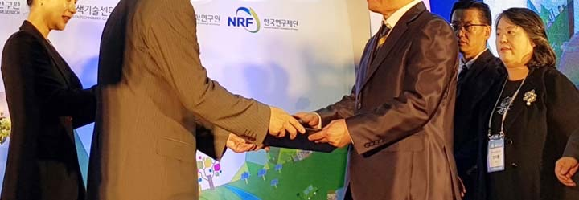
▲ GIST Professor Joon Ha Kim receives an award from the Ministry of Science and ICT for his contribution to the development of climate industry and popularization of climate technology through domestic and overseas cooperation

