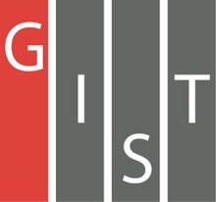
Gwangju Institute of Science and Technology

Official Press Release (https://www.gist.ac.kr/)

Section of Mi-Yeon Kim Nayeong Lee
Public Affairs Section Chief Senior Administrator
(+82) 62-715-2020 (+82) 62-715-2024

Contact Person Nayeong Lee, Senior Administrator
for this Article Section of Public Affairs
(+82) 62-715-2024

Release Date 2019.04.17

GIST AI research achievements will be shown
at the 2019 Korean Science Festival

□ GIST's (President Kiseon Kim) top science and technology research achievements will be displayed at the 2019 Korea Science and Technology Festival.

∘ Two of GIST's most outstanding research achievements in the field of artificial intelligence will be exhibited at the Korean Science Festival in the Seoul from April 19 to 23.

□ The Korean Science Festival is the nation's largest science and culture festival and has been held for 22 years since 1997. Last year's Korean Science Festival was held in August, but this year it will be held in April.

∘ The motto for this year's science festival is 'Spring of Science, Flowing in the Heart of the City!' The festival introduces the best science and technology achievements of Korea to the people and is composed of various science and culture programs that can enjoy and experience science in everyday life.

□ The 2019 Korea Science Festival will be held in various locations in downtown Seoul for five days from April 19 to 23.

∘ The festival will be held at Heungnyemun Square in Gyeongbok Palace on April 19 (Friday) for an hour at 7 p.m. and will feature GIST's "Experience of Self-driving Cars" (Professor Seung Jun Kim of the School of Integrated Technology) in GIST's Convergence Technology System) and "Artificial Intelligence Dreamland Experience" (Professor Kyoobin Lee of the School of Integrated Technology), allowing visitors to directly experience these achievements.

∘ Anyone can participate in the exhibitions offered by the Korean Science Festival for free.

□ GIST's Dean of International and Public Affairs Sung-Gyoo Park said, "I am delighted to be able to introduce GIST's excellent research achievements to the public in a fun and relaxed atmosphere in the city center of Seoul. This science festival is an ambitious event where I hope that people can personally experience the latest science and technology that affects our everyday lives."

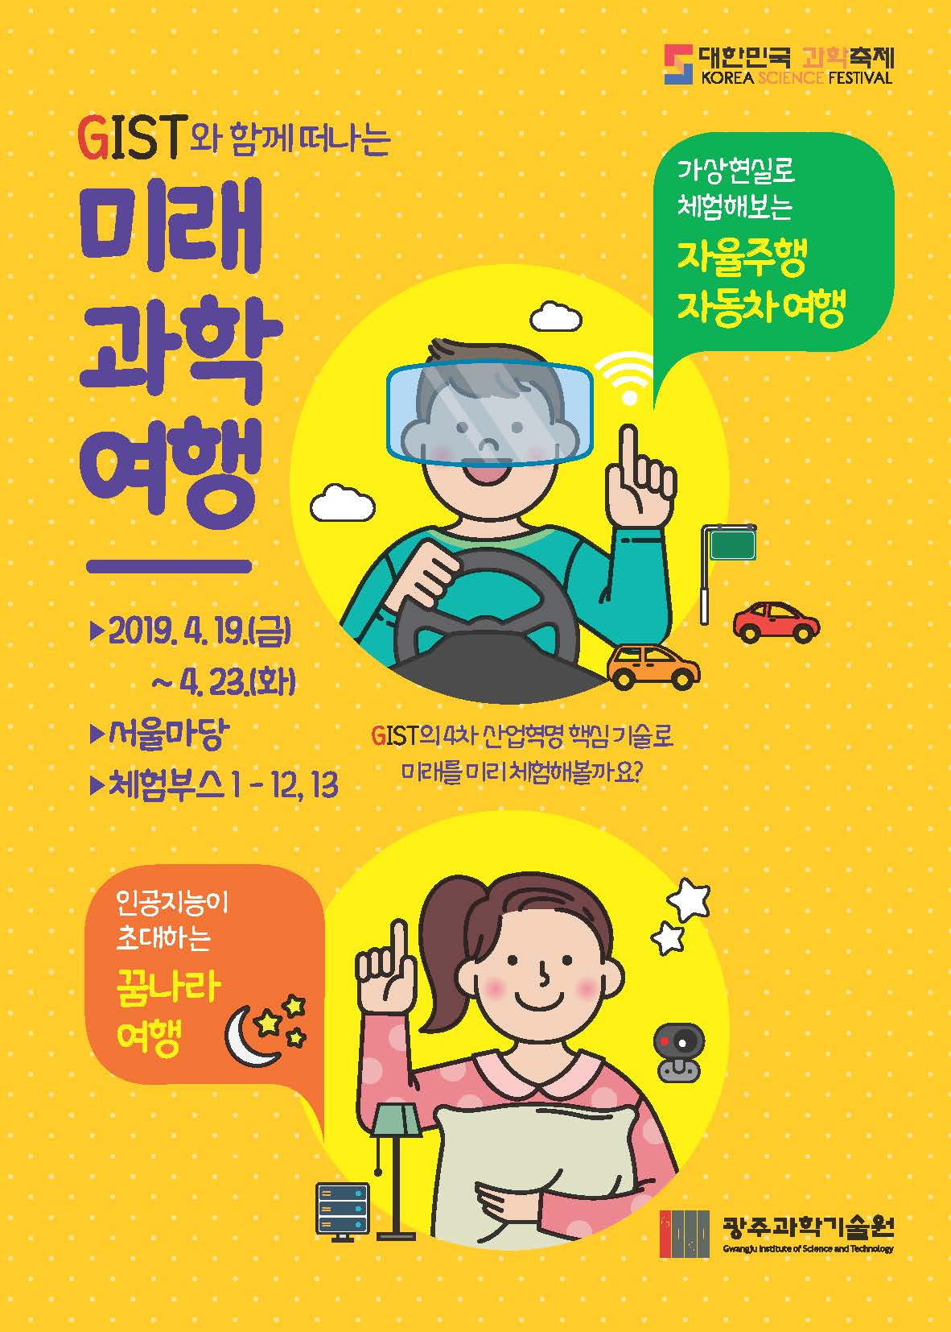
2019 Korean Science Festival

