Gwangju Institute of Science and Technology

Official Press Release (https://www.gist.ac.kr/)

Section of Hyo Jung Kim Nayeong Lee
Public Relations Section Chief Senior Administrator
(+82) 62-715-2061 (+82) 62-715-2062

Contact Person Section of Public Affairs
for this Article 062-715-2061~2063

Release Date 2020.07.24

GIST Infinite Challenge Project wins the grand prize at the Wise Water Circulation Competition hosted by the Seoul Metropolitan Government

□ GIST (Gwangju Institute of Science and Technology, President Kiseon Kim) undergraduate students participated in GIST Infinite Challenge Project, which represents the educational philosophy of "It's OK to fail. I'm going to give it a try!" and performed well in the final presentation for the the "Welcome Water Circulation Contest."

∘ The 'FLY' team participating in the GIST Infinite Challenge Project consists of ▲ 'Butter Fly' (Group Leader Dong-young Kim, a chemistry major, and Division of Liberal Arts and Sciences students Joo-min Park, Hee-jun Seo, Min-seo Lee, and Young-beom Heo) and ▲ 'Team Fly' (Group Leader Song-ju Ko, a mechanical engineering major, and Division of Liberal Arts and Sciences students Seung-chan Kang and Ji-min Lee, and electrical engineering and computer science major Joo-chan Lee teamed up for this competition and respectively won the grad prize and excellence prize.

□ The ultimate goal of the 'FLY' Infinite Challenge team was to create an independent film with minimal assistance in all aspects of filming, including planning, shooting, and editing. However, since there was no professional video knowledge, it was necessary to gain knowledge by making videos.

∘ The two teams decided to deal with "Heat Island Phenomenon," one of the main causes of abnormal weather conditions in the city, in order to produce video clips that can promote Seoul's water circulation policy and also explain how abnormal weather conditions can be eased.

∘ The 'FLY' Infinite Challenge team set the themes of ▲ Butter Fly: "Save the City from a Crisis with Seoul's Water Circulation Policy!" and ▲ Team Fly: "A Midsummer Night's Dream" that created a disaster scenario that could occur if water circulation was interrupted.

□ Group Leader Dong-young Kim of 'Butter Fly,' which won the grand prize, said, "This video is more meaningful in that it was the first complete film produced by FLY, and the team's efforts were recognized. As the first step toward the final goal, we look forward to new challenges and to fly high just like the name of our Fly team."

∘ Group Leader Song-ju Ko of the 'Team Fly,' which won the excellence award, said, "While preparing for the competition, it was a valuable opportunity to think about the importance of water circulation, and above all, I was able to get good results because I worked well with my team members."

□ GIST has been operating the GIST Infinite Challenge project since 2016 so that students can develop creativity and problem-solving skills by repeating challenges, failures, and successes through opportunities to discover new possibilities, rather than traditional education in the classroom. Encouraging original, self-directed 'different' projects help students not only lay the foundation for learning more through various challenging activities but also gives students a chance to discover new potential by experimenting with their ideas and challenges autonomously and creatively.

∘ Meanwhile, the award ceremony of this competition was held online on July 23, 2020, and ▲ a total of 3 million won was awarded ▲ the grand prize winner received 2 million won and the Seoul's Mayor's Award ▲ the excellence prize winner received 1 million won and the Seoul Mayor's Award were awarded respectively. The award will be announced on the Seoul Metropolitan Government's website, and the prize-winning film will be screened at the "2020 Seoul Water Circulation Symposium" to be held on July 24, 2020.

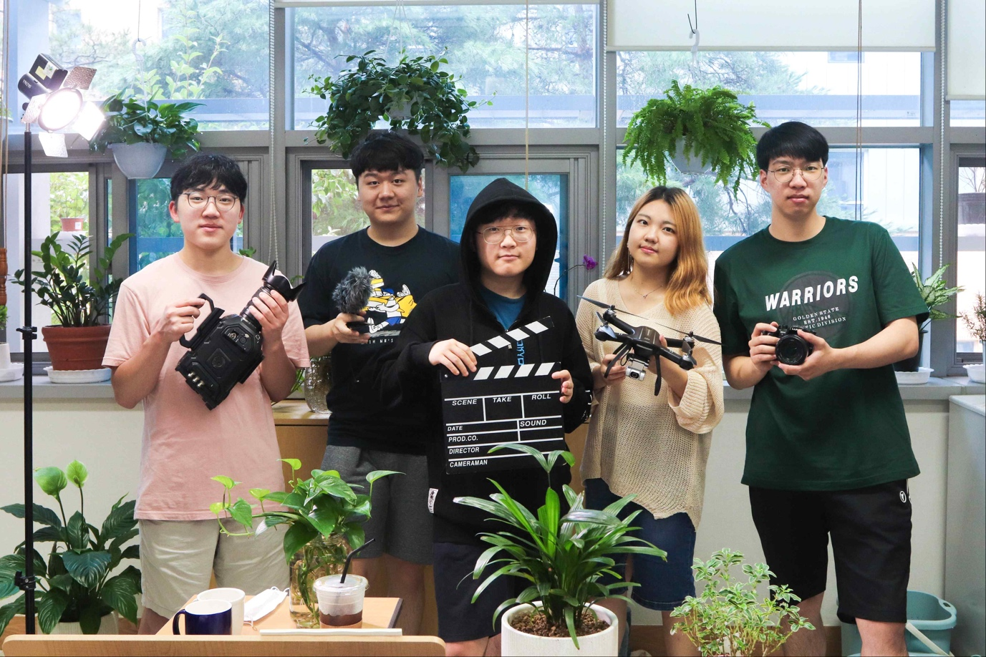
▲ The "Butter Fly" team members who won the grand
prize at the Wise Water Circulation Competition

